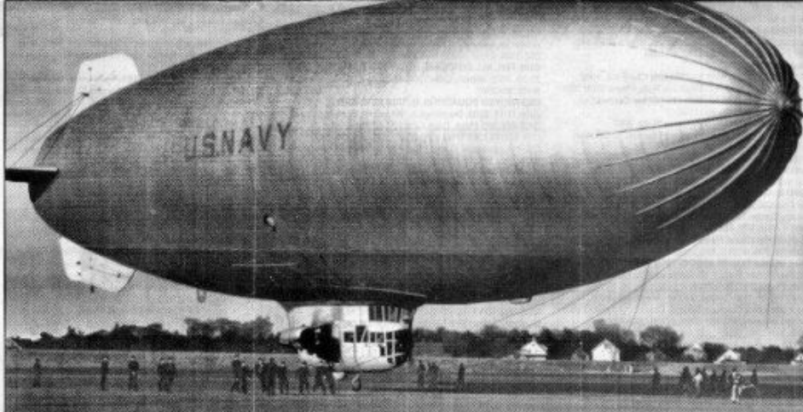
My Father the Blimp Pilot
When I began this interview in July, my father, Robert Francis Buche, prefaced his remarks with the disclaimer that, unlike so many of his fellow servicemen, he did nothing heroic in World War II. “But,” he added, “I think some of the information I have will be interesting to you and your brothers and sisters.” I think that the readers of the Veterans History Project will also find his account informative.
Robert earned his private pilot’s license in the reserve program at the University of South Dakota in 1941. He applied for the USN Air Corps but because he couldn’t receive immediate enrollment and wanting to fly for the War effort, he hitchhiked to Canada to join the Royal Canadian Air Force. After passing his physical and awaiting the swearingin ceremony, he was talking with young Canadians in the waiting room. They told him stories of combat fighters in Europe and disclosed the fact that the average life expectancy of the RCAF fighter pilots was less than five minutes. When the recruiter asked if he had informed his parents of his decision and he replied that he had not, therecruiter suggested he take the weekend to travel back to South Dakota and inform them.
His parents denied permission and before he could rebel, he received notice that if he would join lighter-than-air and fly blimps, the USN Air Corps had an immediate opening for him. In January of 1942 he was ordered to St. Louis at Lambert Field Naval Air Station and trained in airplanes. March 1, 1942, he was ordered to Lakehurst, New Jersey for LTA training which he completed in July of 1942 and was attached to the training command as a flight instructor, one of only 1200 blimp pilots in the War effort.
He remained there until September of 1943 and was married to my mother, Dorothy Fritz, in the interim.
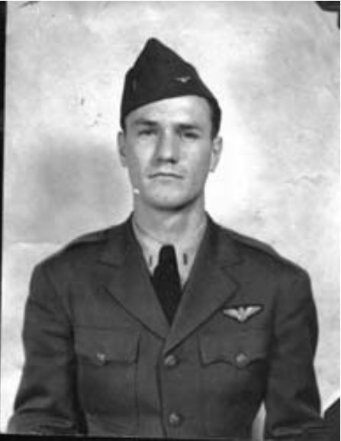
My father as a young ensign in 1942
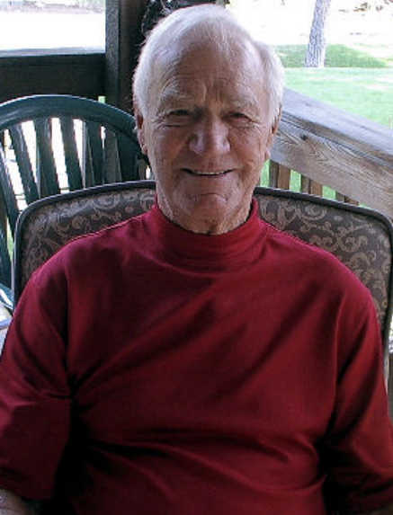
My father as he looks today
One of his students was a lawyer named Greg Bauitzer, who was an attorney to the Hollywood stars. Playing bridge one night with Dad, Greg received a phone call from Rita Hayworth. Impressed though they were, they still had one more surprise. When Dad would return to Lakehurst, Mom would wave to him from the pier near their house.
When on an instruction flight with Greg one day, Greg asked if that was his wife. Dad replied that she was and her name was Dorothy. Greg laughed and said that was his wife’s name also – Dorothy Lamour.
Dad was then deployed to the naval air station at Santa Ana, California, and remained there for the duration of the war as a command pilot for ZP 31 blimps. He also instructed in free ballooning which was like hot air ballooning but inflated with hydrogen. In case an engine was lost, the blimp became a free balloon. He performed mostly utility work but did some escorting of cargo ships. On the east coast during the early part of the war, submarines were picking off our cargo and especially our oil tankers. Blimp convoys were to escort the cargo ships and tankers in an effort to avoid subs sinking them. These blimps’ top speed was 80 knots (90 mph) and the K ships as pictured below were roughly 90 feet high and 300 feet long, containing 420 thousand cubic feet of helium. As far as Dad knows, we never lost a ship accompanied by a blimp. He logged over 3000 hours flying blimps.
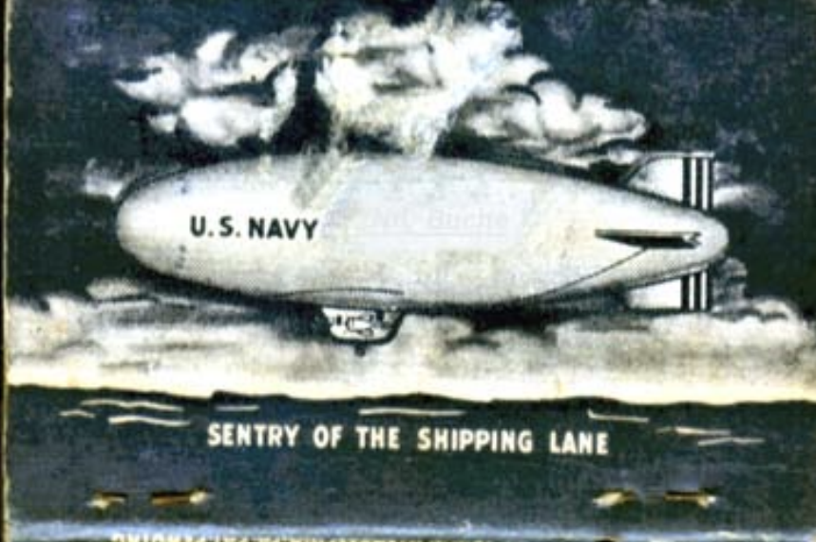
K-ship on anti-submarine patrol in Atlantic.
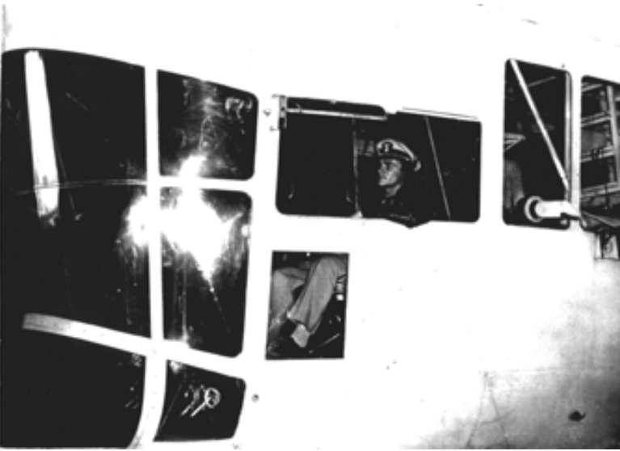
Lt. Robert Buche at the controls.
When the War ended, sound was rigged up in the blimps and they would welcome home the troops returning into San Diego harbor. Frances Langford sang to the troops as they returned. At this time, Dad was offered the choice of flying her around or taking his discharge. He and my mother were very anxious to return to South Dakota – he took the discharge.

