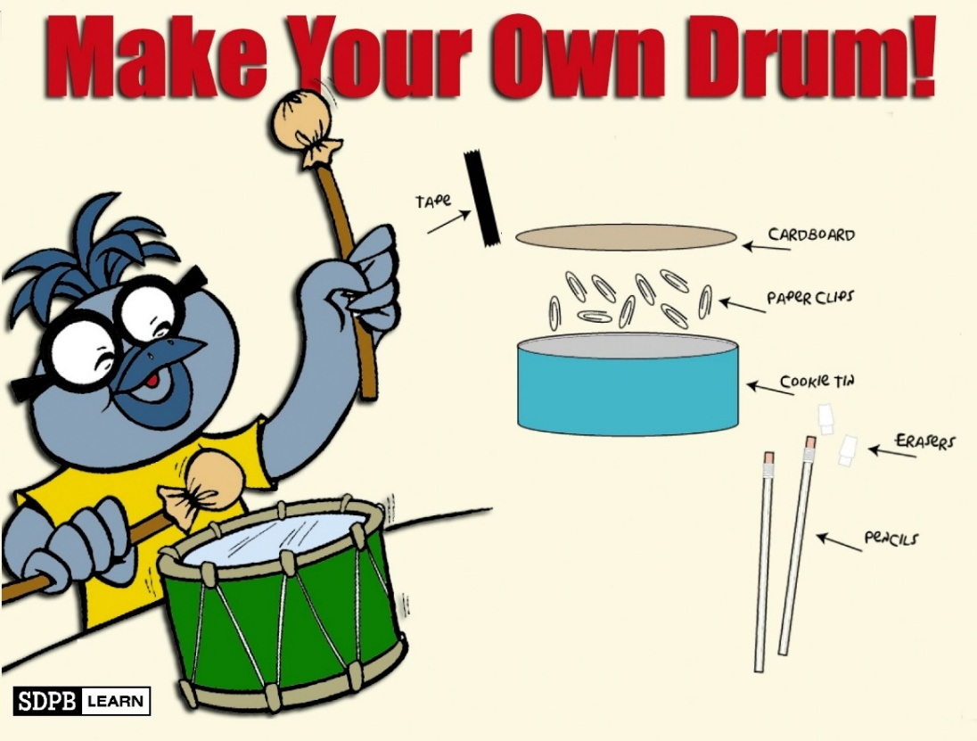

Directions:

What you need:
- Cookie tin
- Paperclips
- Tape
- Cardboard
- 2 unsharpened pencils
- 2 pencil top erasers

What to do:
- Trace the bottom of the tin onto a piece of cardboard and cut it out.
- Place the tin upside down on the table.
- Put several paperclips on the bottom of the tin.
- Place the cardboard over the paperclips and tape securely to the tin.
- Decorate your drum.
- Put erasers on pencils and use them as your drumsticks.
- Have fun!


