**Dakota Pathways: Stories From the Skies (large print)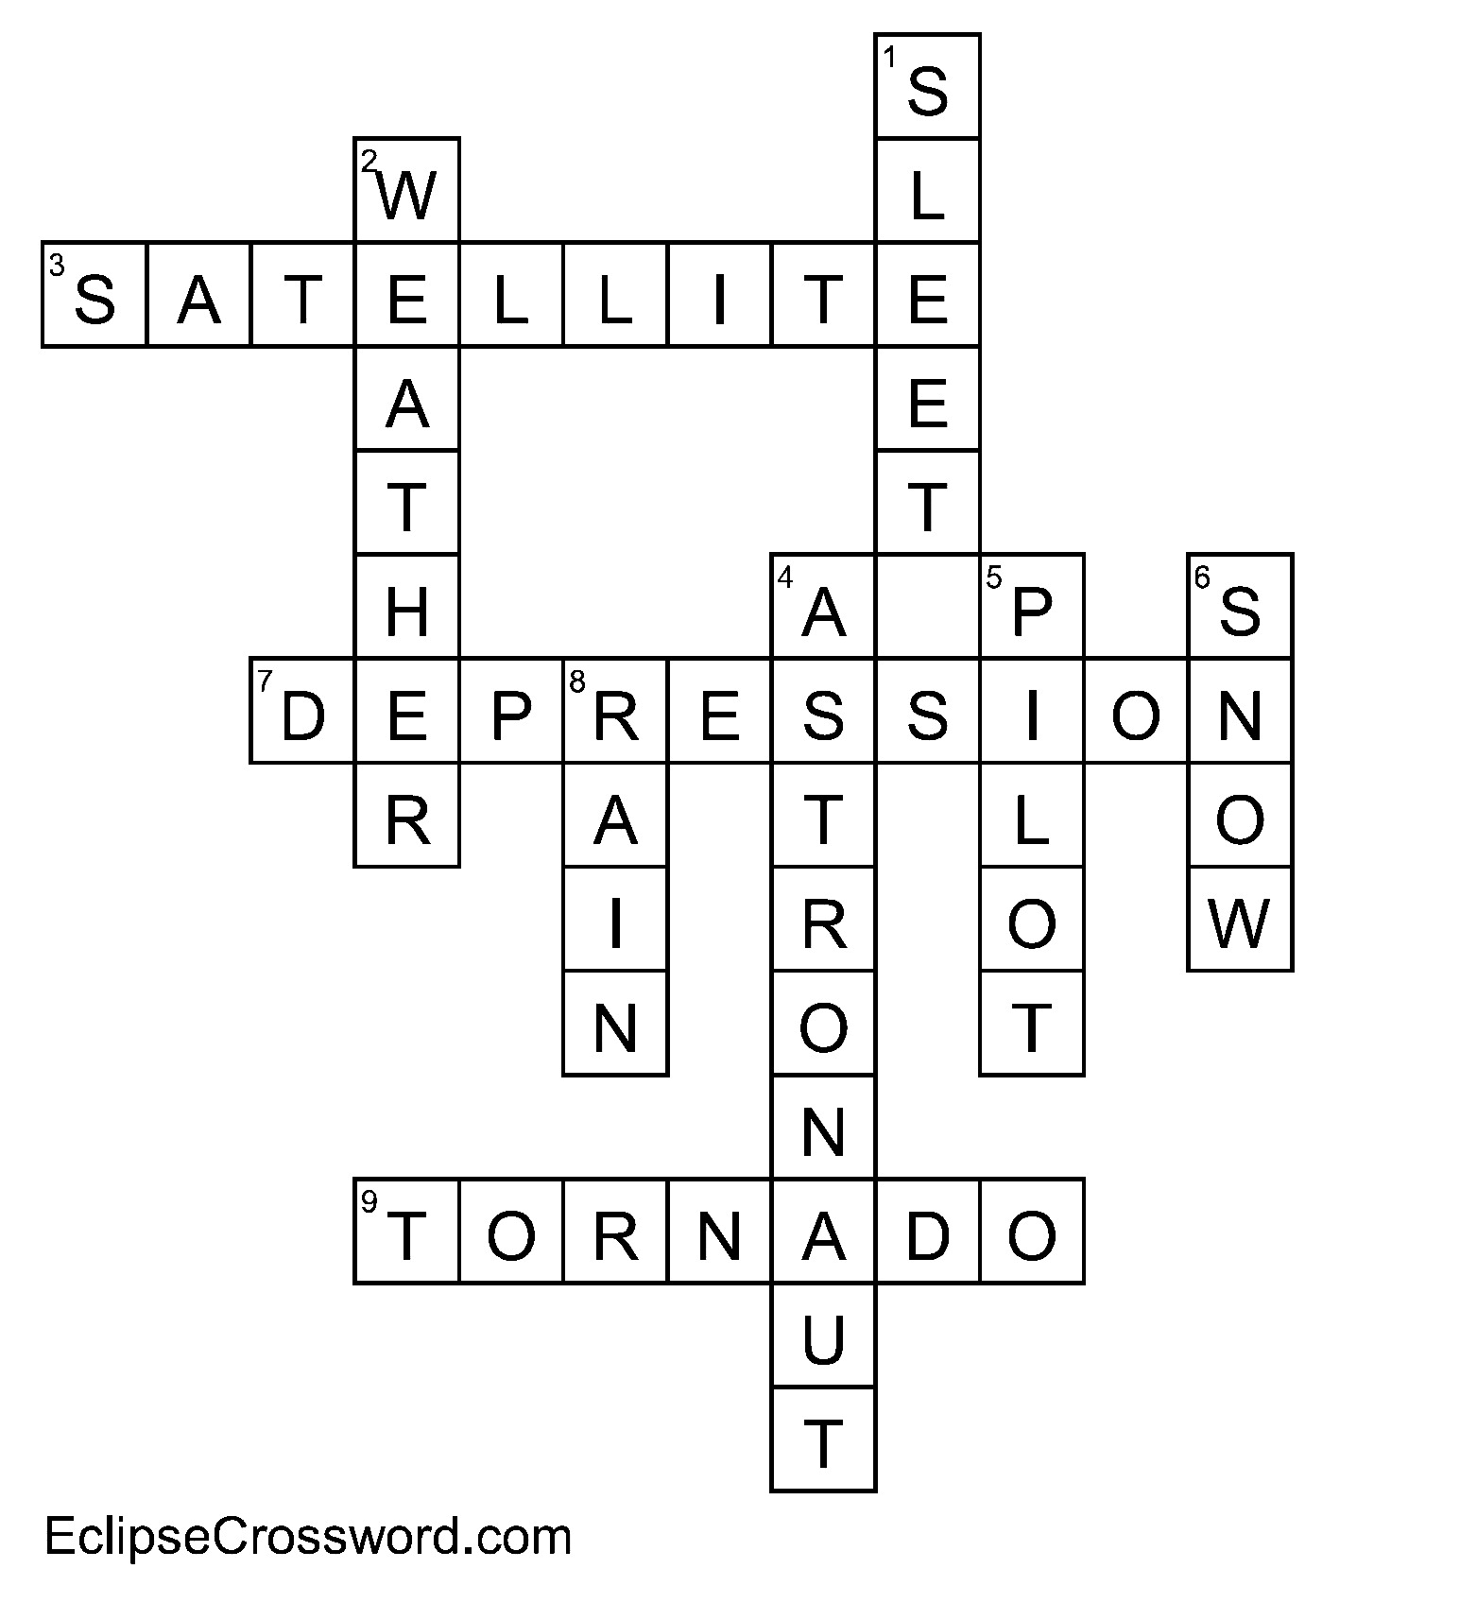Across**

3. Manmade object intended to orbit the earth or other celestial body – **Satellite**

7. Drastic decline in national economy with symptoms like high unemployment, falling prices and decreased business action – **Depression**

9. Violent funnel-shaped thunderstorm with rotating high-speed air, reaching speeds of hundreds of miles per hour – **Tornado**

**Down**

1. Frozen or partly frozen rain - **Sleet**

2. Description and measurement of atmospheric conditions—temperature, air pressure, humidity, wind speeds, etc. – **Weather**

4. Person who can pilot a spacecraft - **Astronaut**

5. A person who operates the flying controls of an aircraft – **Pilot**

6. Precipitation in the form of small white ice crystals - **Snow**

8. Water falling in drops condensed from vapor in the atmosphere – **Rain**