William F. Vermillion Obituary
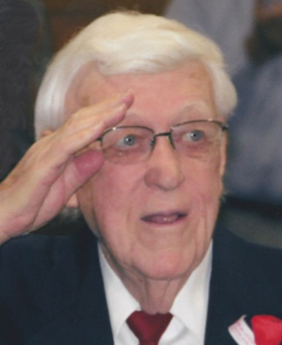
William F. Vermillion was born July 19, 1920, in Westfield, Iowa to William T. and Ethel (Sprague) Vermillion. He died Monday, January 12, 2015, at Bethesda of Beresford at the age of 94 years. He attended rural school until moving to Elk Point, SD while in the third grade. Bill completed his schooling, graduating from Elk Point High School in 1937. He worked at Council Oak Store in Elk Point prior to entering the Army Air Force in early 1942. Bill received his radio training at Sioux Falls Air Base and served as radio operator/ gunner on a B-26 Marauder bomber. He was shot down on his 30th mission in February 1944 and was a German prisoner of war for 15 months. Following his discharge in September 1945 he married Fern Frederickson on November 2, 1945. Bill moved to Beresford, SD October 1, 1945, as manager of Council Oak Grocery Store. He also worked for Reed Sales Grocery Wholesale for many years. In 1955 Bill was Beresford's first city mail carrier. In 1959 he joined First National Bank and retired in 1979. He and his wife, Fern, then operated a ladies ready-to-wear store, Fern's Fashions, in Beresford; that store burned in February of 1986. October 1, 1989, he started working part-time at Farmers State Bank and worked until 1996. Bill is a life member of the American Legion, VFW, Disabled American Veterans and the American Ex- P.O.W. He is a charter member of the Beresford Lions Club, a member of the Beresford Masonic Lodge where he served as Master for several years and a member of Beresford Zion United Methodist Church. Survivors include his wife of 69 years, Fern Vermillion; brother, Glen Vermillion and his wife of Florida; and many nieces and nephews. His parents, four brothers, three sisters and his 11-year-old son, Neal Frederick Vermillion preceded him in death. Funeral services with military honors will be 2PM Friday, January 16, 2015, at Beresford Zion United Methodist Church. Visitation will be 4-8PM Thursday at the church with the family present from 5-7PM and a prayer service at 7PM.

Link to original obituary.

