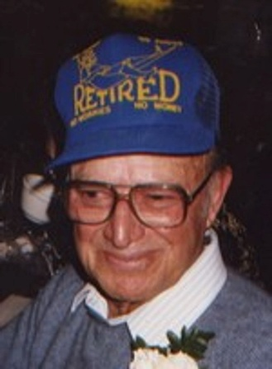
Joseph Bren
March 17, 1922 – October 3, 2009
Joseph Bren, 87, of Wagner
Joseph Bren, 87, of Wagner died Saturday, Oct. 3, 2009 at the Good Samaritan Society in Wagner in his sleep. Funeral Mass will be celebrated 10:30 AM, Saturday, Oct. 10, 2009 at St. John's Catholic Church in Wagner. Burial is in the church cemetery, rural Wagner with military honors. Visitation will be Friday from 9 AM until 5 PM at the Crosby-Jaeger Funeral Home in Wagner. Rosary/wake services will be 7 PM, Friday at the church.
Joseph (Joe) Frank Bren was born March 17, 1922 in Ogema, Minnesota to Francis (Paul) and Frank Bren.
Joe attended grade school while his family lived in Minnesota. After moving to South Dakota Joe went to work to help out his family as so many did during the depression. In 1942 he enlisted in the United States Army. While in the Army he was a tank mechanic assigned to the 12th Armored Division. Joe was in a reconnaissance squadron coined the "hellcats" and served 3 years in Germany and France. After victory in Europe, he came back to Wagner and married Betty (Elizabeth) Hoyer on January 26, 1948 at St., Johns Catholic Church. Betty and Joe were the parents of 9 children. Joe worked at Honke Chevrolet for 30 years as a mechanic and parts manager. After retiring from that he worked with the US Post Office as a rural letter carrier for a total of 25 years.
Joe was a member of St. Johns Catholic Church, The Knights of Columbus, The American Legion, and Veterans of Foreign Wars. Joe will be remembered for his love of his family, his ability to tinker and fix anything, his storytelling to his children and grandchildren, card playing, and his beloved roses.
Thankful for having shared his life are his sons, James (Jim) and wife Teresa of Scappoose, OR; Robert (Bob) and wife Cindy of Gillette, WY; 6 daughters Cheryl and husband Jack Anderson of Clever, MO; Kathy Bren of Parker, CO; Jeanne Bren of Lake Andes; Janette Westendorf, Pamela and husband Gary Carda, all of Wagner; Patricia Abdouch and Dick Fuchs of Pickstown; and his sister Blanche Medricky of Dante. He is survived by his 20 grandchildren, 14 great-grandchildren, as well as his many nieces and nephews.
Joe was preceded in death by his wife Betty, his son David, his brothers Lawrence and Elmer, his sister Rose Sterba and his grandson Steven Carda.

