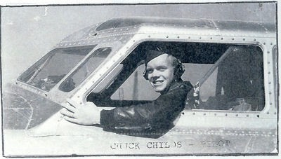
I Flew the Big One
B-17 (Queen of the Skies)

To Vienna – To Blechammer – To Munich [Excerpt]
Chuck Childs (USAAF-USAF retired) Rapid City, SD
November 1, 1944, I was awakened early for briefing for my first combat mission; the target was Vienna, Austria. I had trained for this for years and was looking forward to it, as I had heard all of the battle stories of the German fighters and their merciless flak. The target was Vienna, Austria. It was a group policy that new crews were to fly with a veteran pilot on their first mission. I do not remember the name or rank of the pilot. All of my crew were on this flight except Pewitt, who flew with another crew. We flew in the number two slot of the formation on the right wing of the squadron leader. I got the chance to show my expertise in formation flying and our plane held its position very well. Every fifteen minutes the pilot and I would take turns doing the flying. High altitudes on oxygen wore the pilots out.
Long missions were difficult; by the time you returned from a mission you were ready to hit the sack.

I was intent on watching everything that was going on and what was said while climbing up to our bombing altitude. We reached the IP (Indicated Point) and turned on the bomb run heading. Things became very quiet; flak helmets and flak jackets were put on. In the distance we could see bursts of flak coming up. Soon it was all

around us. It was an amazing sight and I was too excited to be scared This was com bat. We were about to drop our bombs on the South Ordnance Depot in Vienna. Flak was heavy and accurate. It was "Bombs away!" then the formation made a steep climbing turn to the right to get out of the flak being thrown up. A call from the left waist gunner advised us that the right waist gunner had been bit. The pilot asked me to go back and check. This was the position that Pewitt would have been flying.

The boy was pale and bleeding. Keller was working on him and giving him morphine shots. He seemed to be in a shock, so we covered him up to keep him warm. I went back to the copilot seat while the formation headed home. As we arrived at the base, the engineer Simon shot flares
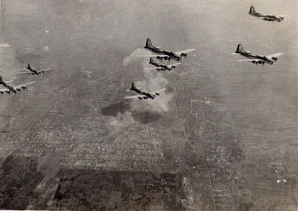
to tell the base that we had wounded. When we landed, the ambulance was there to take the boy away. He survived the mission and was sent home. The crew then went to be debriefed on the mission and go to our tent area to relax. Mission accomplished.
The crew was all talk, but we were also depressed because Pewit's ship was hit and had disappeared. We later found out that five of the crew members bailed out and five did not. The ones who did not bailout ended up landing at Barrie, Italy. On this mission two ships went down, one boy died in his plane, and we had the wounded boy.
This was considered a "milk run" because of the low number of losses.

We went to ground school, tactical flying classes, etc. for the next three days. I was now considered indoctrinated into combat flying. On November 4, 1944, my crew and I flew our first mission together. I was positioned on the left wing of the squadron leader; Mike did a great job flying formations from the right seat.

Every fifteen minutes we would change so the other one would fly.

The target was the Winterfafen Oil Storage at Regensburg, Germany, which was a long and tiring mission. Flak was heavy this day and several planes were hit but there was no loss of planes.

The next three days the crew was sent back to Vienna, then sent to Moosbierbaum. Austria, then to Maribor. Yugoslavia.

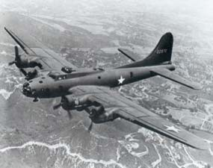
The mission to Vienna was in bad weather with forty-two degrees below zero outside. My oxygen hose became disconnected, and I passed out. Mike took over the controls. I remember being shaken by Don, the Engineer who was asking if I was OK. As soon as my
oxygen hose was hooked up again I was fine. Then the fifteen minute oxygen check got no response from Short in the ball turret. They had to lift him out of the turret and apply oxygen. He was lucky. Sessions, the tail gunner, froze his fingers on this mission. The flack was heavy, and we were hit by our first fighters which were Me-410s. My gunners shot down two planes on this mission.

The mission the next day to Moosbierbaum was with heavy flak and thirteen aircraft were damaged by flak, three severely. After returning from the mission, I was called into the Squadron Commanders office and advised that my flying records were good; he wanted me to lead the squadron the next day to Maribor.

We were briefed to go in at nineteen thousand feet and that they only had a few flak guns. Not so!! This is when I begin to realize just what combat was about. I was leading the squadron into a hellhole! Instead of

seeing smoke from flak, I was seeing flames in the flak bursts. We had to make a second run because the bombardier was knocked off his seat. I could hear the flak ripping through the plane. Keller, the waist gunner, was supposed to take pictures of the bomb drop but flak blew up the camera. I had some other radio operator who got hit. The radio, oxygen, rudder and trim tab controls and the number three engine were shot out
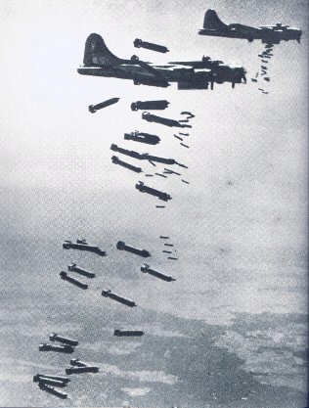
and before we could feather the prop it started to windmill. The plane begin to vibrate so I had the men in the nose come up to the cockpit; when the prop broke off the hub, I pulled the plane in a climbing position, pulled back the throttles and dropped some flaps, and the prop went spinning off somewhere down into Yugoslavia.

The instrument panel was also shot out and when we arrived back to our base,
we counted over two hundred holes in the plane. When the ground crew checked the instrument panel, they found a large piece of flak wedged behind a panel bar that was headed straight for my head! My first lead mission was a tough one.
Photo reconnaissance showed nine hundred cars in the railroad yard. The Germans were using the facilities extensively for the retreat from the Balkans. The bombing effort paid off as many of the cars were blown up and many fires started. The intense and accurate barrage of flak wounded five crewmen and claimed the life of a copilot from the 96th Squadron. No planes were lost, but many were heavily damaged. We were now assigned our own plane, which was a radar plane. Good old number 161. This was mine to fly and she became one of my best friends.

My flying begin to fall into a routine: up early for briefing, the long flight to the mission, the IP (Indicated Point) to start down flak alley, watching for fighters, praying not to get hit, heading home, at ten thousand feet eating my breakfast ration, turning on the radio and hearing Benny Goodman and Lionel Hampton band playing "flying home", landing, briefing, dinner and then playing with the jazz band at one of the enlisted men's clubs which was really a big tent.

A month after I arrived at Amendola, I went to the Officers’ Club, where I heard a group playing jazz. They were made up of both officers and enlisted men. They had someone trying to play drums; I asked to sit in. I was given the job from then on. There was a black Sergeant who showed up with his trumpet one night and asked if he could sit in. Now, at that time, black and white soldiers did not associate with each other. The Sergeant played excellent; he was invited to come any time he could get away from his base. He would always come alone in a jeep and was given the red carpet.

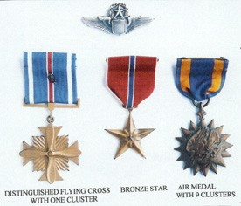
The Squadron Commander promoted me to Captain; that promotion came through November 28, 1944. I had flown nine very tough missions from November 1st through November 22nd SO the Squadron Commander sent me to a rest camp for a few days on the Isle of Capri.
The beautiful Isle of Capri is twenty miles off the coast of Italy and was accessible only by boat from Naples. It has been a resort since the time of the Roman Republic. The Roman Emperor, Tiberius, built his Villa Jovis there. The well preserve ruins of this villa rests high on a mountain top. Tiberius lived and ruled the Empire from the villa from 27 AD until his death in 37
AD.

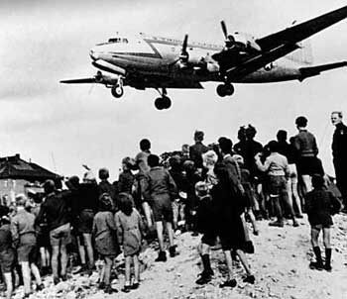
FLYING ON THE BERLIN AIRLIFT

The Salvation of a City
[excerpts]

Chuck Childs, Rapid City, SD

I had the honor and privilege to fly on the Berlin Airlift, also known as Operation Vittles, which was the greatest
humanitarian effort in modern history.

June 26, 2008, was the 60th anniversary of the beginning of the Airlift. While thinking about this humanitarian act, I decided to write this book about the lift and about my involvement in it.

My first assignment after flying combat in Europe was with the Air Transport Command. I was attached to a Ferry Squadron that ferried anything that had wings around the United states. I was put on temporary duty to Charleston Air Force Base for transition in C-54s, which were big four-engine transports. This was the same plane that was called the DC-4, which was used as a civilian commercial passenger plane. Because I had just returned from flying B-17s and was also a B-24 pilot, it did not take me long to check out in the C-54.

My next assignment was with the Military Transport Command, Washington, DC, where I flew "VIPs" (Very Important Persons) in and out of Washington, DC. I was next assigned to Lackland Air Force Base; one day I was called into the Commander's Office and handed orders for

Malstrom Air Force Base to train in C-54s; the training was for the Berlin Airlift. I knew that the Airlift was going on but never dreamed that I would be put on duty flying on the Airlift. I had a 15-day travel leave before I was to report to Malstrom. I drove my wife Grace and our children, Connie, Charles and Cara to Portland, Oregon to be close to relatives.

After my final training phase as a replacement pilot in the C-54 for the Berlin Airlift, I was flown from Malstrom Air Force Base to Rhine-Main Air Force Base in Frankfort, Germany. I was then bussed to the 60th Troop Carrier Group at Y-80, Wiesbaden, Germany, where my Berlin Airlift flying began.

I finished my Combat missions, flying against Hitler in April of 1945 and arrived home to be with my wife Grace and daughter Connie. Three years later I was flying missions again, only this time it was for Germany and against the Russians.

One of the most serious problems that the pilots had to deal with was the constant harassment of the Soviets in the corridors. There were 733 incidents of harassment recorded between August 1948 and August 1949. It was not uncommon for Soviet pilots to fly close, shooting near, but not at, the airlift planes. Balloons were released in the corridors, there was flak, radio interference and searchlights in the pilot's eyes; these were all forms of the Soviet harassment. This did not stop the pilots; the planes kept on flying. One Soviet plane did collide with a commercial plane and 35 people died. Had one of the airlift planes been shot down, that would have started World War III. The Soviets did not want that.

Before I could get out of the cockpit, a crewman would be in the cockpit wanting to buy cigarettes. Since I was

not a smoker, I would bring a carton along on each mission and sell it to the first taker. A game that the crewmen played was to rub up against the pilots to dirty their clean flying suits with coal dust. I never returned to my base without a dirty flying suit.

After debarking from the plane, we were greeted by a weather jeep for weather briefing, by a maintenance jeep for maintenance problems and a mobile snack bar for refreshments. There were manned by beautiful German Frauleins. As soon as our plane was unloaded, we were back in the cockpit, taxiing out for our return trip home.

During the winter we hauled nothing but coal from Wiesbaden as it was badly needed to keep the Berliners warm. The plane would be so full of dust that we would open two back windows to draw out the dust. After the plane had flown 200 hours, it would be flown to Burtonwood, England for major inspection and a thorough cleaning. The soot and grime collected in the planes after around 100 flights to Berlin was so thick that the flying coal trucks seemed beyond revival. The wings were heavily filmed with oil and grease. The interior was black with smudge, and the floor was rough, with black coal dust ground into the wood. I was fortunate to get one of those flights. After staying a night in Burtonwood, we brought back a clean aircraft, which was a great feeling.

To feed a city such as Berlin meant butter from Denmark, coffee from Brazil, sugar from Cuba, wheat from Minneapolis, Minnesota, Coal from Ruhr, etc. In fact, there were few areas in the world that were not represented for the needs of Berlin. Just 3½ years before the lift, I was bombing the Ruhr coalmines in the Ruhr Valley just 60 miles south of Berlin. Now I was hauling their coal to Berlin.

I first flew milk and groceries into Tempelhof; then I would fly a load of displaced persons back to Y-80 in Wiesbaden. These were mostly women and children that were then dispersed to different areas around Europe. In total there were about 161,000 displaced people, mostly Polish and Jewish; those were flown out of Berlin to be transferred to other areas.
When other and I pilot arrived at Y-80, we were immediately taken to our quarters. What an eye-opener. We were placed in an old German enlisted men's dormitory on the third floor. It was wide open, and the bathroom and showers were open. They placed a screen around our iron cots to give us a little space and privacy. We pilots were flying many missions but were treated as second-rate citizens. The permanent administrative personnel lived in nice private quarters, each with a private bath. If I had an after mid-night mission, an orderly would wake me, I would shower, dress in a clean flying suit and walk to the operations building, which was about 5 blocks from the dormitory.

The pilots ate breakfast, lunch and dinner in the Officer's club, which had a German beer room in the basement that was unique; we spent most of our evenings, when we were not flying, in that beer room. I became well acquainted with about 5 other pilots. When we had a day off, we would borrow a car and tour the local area, going into completely bombed-out cities like Mannheim, which was completely destroyed.

Besides food and coal that we flew into Berlin when the weather was good, we would parachute chocolate bars and chewing gum to the children waiting below in the cemetery. This was all started by a 1st Lieutenant Gail

Halvorsen, who was flying out of Rhine-Maine. He had walked over to the fence in Tempelhof and talked to some children gathered there. One boy asked him about the planes and flights. As a good will gesture he handed him
2 sticks of gum, and promised if they did not fight over the gum, the next time he flew over he would drop some more. One child asked him how they would know his plane and he said "I will wiggle my wings." The next day he flew over the cemetery, rocked his wings and the engineer kicked out some chocolate bars attached to handkerchief parachutes to the children waiting below. Every day the children increased and everyday he would drop more.

