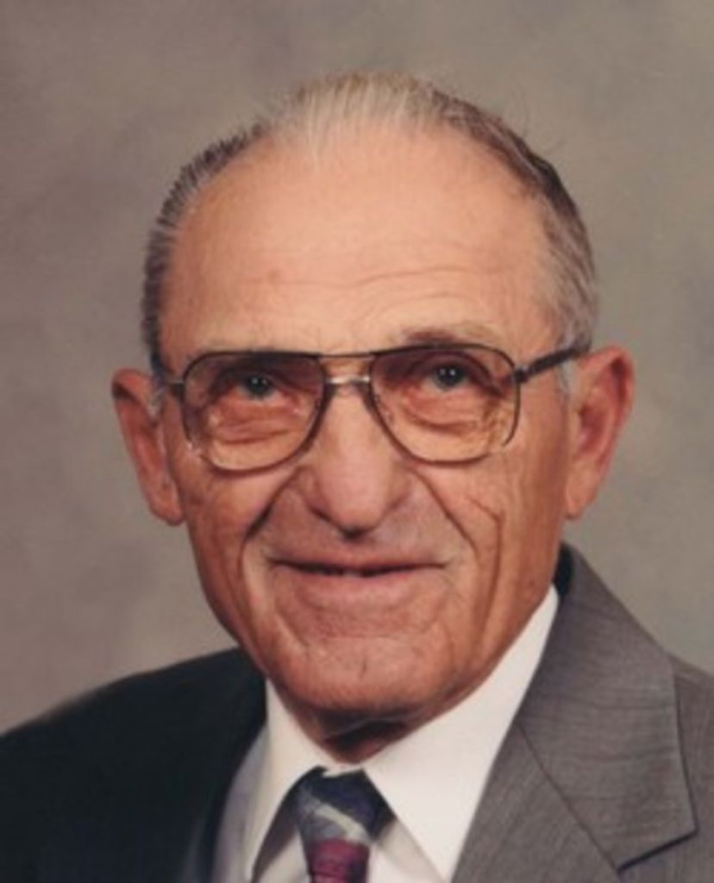
Daniel J. Grosz
July 18, 1921 – March 23, 2011
Dan J. Grosz was born July 18, 1921 at Bon Homme Colony near Yankton, SD to John and Katharina (Wipf) Grosz being the third of seven children. He was raised on the Colony until the age of nineteen when he grew tired of the structured life style, headed south and went to work with a harvesting crew.
He returned to the Colony for a winter, then in June of 1944 seeing there was a job to be done defeating the Axis of powers, joined the Marines to fight in WW II. During the war he saw action at the battle of Iwo Jima and participated in the occupation of Japan. He was honorably discharged from the Marines in August of 1946 at San Diego. He was given 5 cents per mile for the trip back to Mitchell.
Upon returning back to Mitchell he went to work for Cook Livestock Sale Barn. It was during this time he met his future wife Mary Jane Parmenter who was taking nurse's training. They were married on April 1, 1948. The marriage produced four children, Richard, Sandra, Tim and Brian. In the 1960's he worked as a construction foreman for Vittitoe Construction. This work included work on the Missouri River dams. In the early Seventies when Vittitoe Construction ceased, him and a partner, Gary Mogck formed G & M Construction. This new company's main work was moving dirt. They did many improvement projects for area farmers included dams, drainage improvements and building sites. Later he and Gary split up but both continued on in the business with Dan forming Grosz Dirt Moving. He worked at this until retiring in the late 1980's. During retirement with his wife Mary they continued to raise sheep, maintained a large garden and fruit trees and traveled to visit relatives. One of his favorite hobbies was making wine. In the early 1980's he was instrumental in getting Davison Rural Water formed.
He served on the Davison Rural Water Board, South Dakota State Association of Rural Water Boards and was a delegate to the National Association. He worked to ensure safe drinking water for the people of South Dakota. He was a member of First Lutheran Church, a life member of the VFW and American Legion, active in the Davison County Republican Party and Marine Corp League. He was a Marine until the end. Grateful for sharing his life are his wife, children Sandra (Carroll) Twedt of Mitchell, Tim Grosz of Sturgis and Brian (Nadine) Grosz of Mitchell; six grandchildren, Dawn, Jamie, Tom, Christina, Angie and Jesse; six great grandchildren, Isaac, Elijah, Natalie, Natasha, Ashlyn and Andrew; brother Nathaniel Grosz and sister Mary Waldner of Huron Colony. He was preceded in death by his parents; son Richard; sisters Susanna and Katherina; brothers John and Paul.

