Arthur Nebben Obituary
January 24, 1918 — May 29, 2014
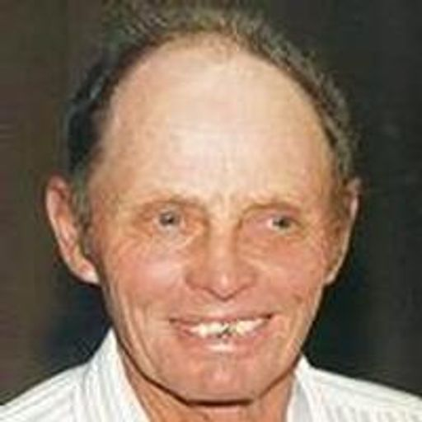
Arthur J. Nebben, 96, of Dell Rapids passed away peacefully Thursday, May 29, 2014.
Funeral services will begin at 11:00 AM Wednesday, June 4, 2014 at the Lutheran Church of Dell Rapids. Burial will be in the Dell Rapids Cemetery.
Visitation will begin at 2:00 PM with the family present from 5:00 to 7:00 PM Tuesday, June 3, 2014 at Minnehaha Funeral Home in Dell Rapids.
Arthur Johan (John) Nebben was born Jan. 24, 1918 to Johannes and Anna (Haugen) Nebben on the Nebben family homestead southeast of Colman, SD. He attended Gale Ridge Country School through the 8th grade. He attended Colman High School until 1933. Due to the death of his father in 1929, he worked the family farm. Art served in WWII from Nov. 21, 1942 – Oct. 11, 1945 in the 163rd Signal Corp, United States 5th Army deployed to the Forward Operating Command in North Africa and Italy. After the war he returned to Colman and worked as a mechanic at Lone Tree Station, hauled cream and carried the US mail on the Star Route. He enjoyed dances and went to many barn dances, area dance halls and the Dells Pavillion, where he met Delores Maseman, marrying her June 19, 1950 at Luverne, MN. They made their home on the Maseman family farm near Dell Rapids where they farmed for 65 years, raising three children.
Art was a lifetime member of the George Fitzgerald Post 65 American Legion and had continuous membership for 68 years and the Dell Rapids VFW #10632. He served as Commander of the Legion, was Historian for over 35 years, was a member of the Firing Squad, Post #129 40&8, Dells Sportsman’s Club and the Lutheran Church of Dell Rapids. Art was elected to the Dell Rapids Bowling Hall of Fame. He raised purebred Hampshire hogs, receiving many awards at the fair. He received the Soil Conservation Farm Award by the Sioux City Chamber of Commerce and Journal. He had a natural artistic talent so could paint or draw anything. He carved many redwood signs around Dell Rapids for the Legion, Sportsman’s Club and Riverview Cemetery. He enjoyed hunting, fishing, trapping and shared in family vacations with his daughters, son-in-law and grandkids. Art could strike up a conversation with anyone and had a great ability for recalling historical events and his knowledge of history and facts were amazing to anyone that knew him. Even at the age of 95, he drove tractor and harvested. He read extensively, did word puzzles, watched “Wheel of Fortune” and always did the daily word “Jumble”. His favorite saying was “we’re making history every day."
In 2009 he went on the WWII Honor Flight to Washington DC, which was a highlight in his life. Many times one would see him wearing his Honor Flight cap around town. Art was instrumental in developing the Veterans Memorial Park in Dell Rapids.
Art passed away Thursday, May 29, 2014 at his daughter’s home in Dell Rapids surrounded by family. He was 96 years old and preceded in death by his parents; infant son, Lynn; brother, Olaf; 3 sisters, Annette Steinborn, Luella Knutson and Dorothy Plummer; daughter-in-law, Sally Nebben; sister-in-law, Darlene Park; nieces, Kim Steinborn and Lori McAthie; uncle, Rudolf Haugen and cousins, Alfred and Arnold Hogan.
Art is survived by his wife, Delores; son, Jay Nebben; daughters, Jan Dybvig and Melanie (Lee) Burggraff, all of Dell Rapids; 5 grandchildren, Cody, Colt and Paige Burggraff and Peter John and Jennifer Nebben; 4 great-grandchildren, Kain Arthur John, Kasch John Joseph, Teagyn and Paislee Burggraff, all of Dell Rapids; brother, Palmer (Swede) Nebben, Colman; sisters, Hilda Johnson and Laura Knutson, Dell Rapids and Rosie Croon, Colman; brother-in-law, Don Knutson along with many nieces and nephews.

Link to original obituary.

