Obituary
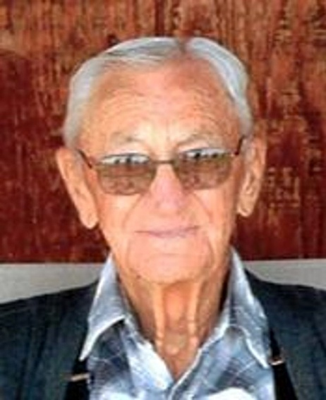
Edward Seiner, 91 of Wagner
January 12, 1922 – April 6, 2013
Mass of Christian Burial will be held 10:30 a.m. Tuesday, April 9, 2013 at St. John Catholic Church in Wagner. Burial will be in the parish cemetery with military honors. Visitation will be at the Crosby-Jaeger Funeral Home in Wagner Monday from 11 a.m. to 5 p.m., followed by a 7:00 p.m. rosary/wake at the church.
Edward L. Seiner, son of Stanley and Marie (Novak) Seiner, was born January 12, 1922 in Tabor. He died Saturday, April 6, 2013 at the Avera Sister James Care Center in Yankton. Ed attained the age of 91 years, two months and 26 days.
After his father's death in 1927, the family moved to Wagner and his mother later married Joseph McCarthy. Ed attended Wagner schools until he joined the Civilian Conservation Corps in Sturgis. He served in the Army Air Corps from October 23, 1942 to October 22, 1945. Ed served in the South Pacific with the 804th Aviation Engineers, 7th Air Force building runways for bomber and fighter planes on the islands of Baker, Makin and Saipan. Upon his return from active duty, he worked on the Fort Randall Dam and then with his brother and step father at McCarthy Bros. John Deere dealership in Wagner until 1950 when he began farming.
Ed married Ardath Alt on August 2, 1949. Four children were blessed to this union: Edward S., Jerry, Patricia and Karen. Together they farmed and raised their children nine miles north of Wagner. They retired from farming in 1981. Ardath died July 31, 1992.
After his retirement, Ed worked at Crossroads until 1994, when he started traveling to Arizona for the winter. He spent 17 years at Coach Stop RV Park in Wellton, AZ, where he made many friends and enjoyed the sunshine every day.
Ed was a life member of St. John the Baptist Catholic Church, Rollie Bucholz VFW Post 7319 and the American Legion Greer Post 11. He also served on the Kennedy Township Board for several years.
Ed will be remembered for his undying love of his children, grandchildren and great grandchildren, especially his nephews who always knew him as Uncle Ladimer. He will also be remembered for his love of farming, anything John Deere, gardening, flowers, plants and his hat collection.
Grateful for having shared his life are his children: Edward S.(deceased); Jerry and wife Sandy of Armour and their family Michael (Sarah), Kimberly (Nick) Buchholz, Scott (Tracy), Jeffrey, and Cody and fiance' Amy Roethke; Pat Griffin-Sides and husband Dave of Custer and her family Jenny (Gene) McNabb, Julie (Jeremy) James and Sam Griffin; and Karen Petrik and Dan of Yankton and their family Jason and fiance' Amanda Dawley and Nick (Brandi) Petrik; 14 great grandchildren: Brady, Dylan and Sophia Seiner; Shante, Makyla and Ella Buchholz; Aubree Seiner; Paige and Morgan McNabb; Jaxon James; Hope Coody; and Mazie Petrik and T.J.; and Addison Petrik.
Ed was preceded in death by his wife Ardath; son Edward S., brother Robert (Bud); sister Eleanor Hoover; son-in-law Walt Griffin; and grandson Kyle Seiner.
To order memorial trees or send flowers to the family in memory of Edward Seiner, please visit our flower store.

