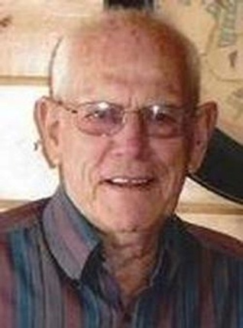
Merrill Dewald
July 4, 1919 – August 9, 2015
Merrill DeWald, 96, of Wagner
Funeral services will be held at 10:30 am, Friday, August 14, 2015, at the United Methodist Church in Wagner, South Dakota. Burial will be at the ZCBJ Cemetery, rural Wagner, with Military Honors. Visitation will be held Thursday at the United Methodist Church from 5:00 - 7:00 pm with family present followed by a prayer service at 7:00 pm. Crosby-Jaeger Funeral Home in Wagner is in charge of arrangements.
Merrill Edward DeWald was born to Merritt and Stella (Malone) DeWald on the family farm near Armour, South Dakota - the grandson of homesteaders in Dakota Territory. He graduated from Armour High School in 1940.
Merrill and Ruth Sparks were engaged on Pearl Harbor Day December 7, 1941, and were married on the Sparks family farm on December 25, 1941. Merrill joined the Army in March 1942, serving with the 90th Infantry Division, landed on Utah Beach during the Normandy Invasion on D-Day. He fought inland to the French Falasie Gap, at the Battle of the Bulge, and earned the Bronze Star. He returned home in the fall of 1945.
Merrill owned and operated DeWald Motor Supply in Wagner and Lake Andes and farmed for thirty five years. He served his community as a Volunteer Fireman, member of the Wagner Hospital Board, Chamber of Commerce, United Methodist Church, Jaycees, Isaac Walton, American Legion, and the VFW.
Merrill enjoyed hunting and fishing, (especially salmon fishing) with friends and family. He knew the value of a good joke and shared his pranks and jokes with everyone. During retirement, Merrill's woodworking hobby became a business for him. He restored antiques and made many new pieces of furniture. He was a master of taking care of things, be it furniture, tools, vehicles, or toys.
Merrill spent many happy times camping, hunting, and fishing with his wife, Ruth, and his family and friends.
Those who treasured Merrill's life are, his daughters Linda (Tom) Soukup, of Wagner, Nila (Roger) Novotny of Fort Pierre. Grandchildren: Becky (Mike) Brunsing of Wagner; David (Amanda) Soukup of Owasso, Oklahoma; Kathy (Stan) Jaeger of Tyndall, SD; Mary (Marshall) Ringling of Platte, SD; Jill (Tom) Hart of Pierre, SD and Steven (Brittany) Novotny of Pierre, SD. Great-grandchildren Jacob and Joe Jaeger; Dylan, Emily, and Abby Brunsing; Heidi, Sam, and Tess Ringling; Bailey and Tori Soukup; Hadley and Ellen Hart, Addison and Gavin Novotny, and his brother Warren DeWald of Mulvane, Kansas.
Merrill was preceded in death by his wife, Ruth, his brother, Elvin, and sisters, Dorothy, Gladys, Bettie, and Bonnie, one grandson, and his parents.

