Charles Childs Obituary
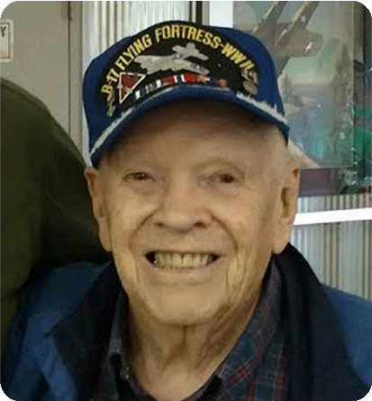
July 17, 1920 - October 27, 2019
U.S. Veteran
Funeral Home Tracy Area Funeral Home

Charles (Chuck) Childs, age 99, of Tracy died Sunday, October 27, 2019, at home. Memorial Service will be 2:00 pm Wednesday, October 30 at Tracy Lutheran Church. Visitation will be one hour prior to the service at the church. Burial is in Black Hills National Cemetery in Rapid City, South Dakota. Memorials may be made to the Tracy Lutheran Church or The Murray County Hospice House for Tracy. Stephens Funeral Service - Tracy Area Funeral Home is assisting the family with arrangements.
Chuck was born to Henry and Adela Bauman Childs on July 17, 1920, in Arnegard, North Dakota. He attended school in Arnegard, graduating from high school in 1938. Chuck attended Mayville State Teachers College from 1938 to February 1941. He had joined the North Dakota National Guard in 1940, while in college, and was federalized into the US Army in February 1941. Chuck entered the Army Air Corps Aviation Cadel program in November 1941 and received his commission as a 2nd Lieutenant and his pilot wings July 3, 1942, in Moultrie, Georgia. On July 4, 1942, he married his college girlfriend, Grace Saueressig, in Moultrie. His first assignment, as a Flying Officer, was teaching British cadets to fly. He flew B-17's on
37 missions in combat in Europe in WWII, flew 196 missions on the Berlin Airlift and flew transport planes in the Korean War. Throughout his military career he visited many countries around the world. He was proud to say that he had been current, as a pilot, in twenty-two military aircraft and seven civilian aircraft. He retired from the US Air Force as a Lieutenant Colonel in February 1961 and made his residence in Rapid City, South Dakota. He was a member of the National Dadalions, an honorary pilot’s association, was inducted in the South Dakota Pilots Association Hall of Fame and was an honorary member of the Experimental Aircraft Association. After retiring from the military service, he became a Professional District Scout Executive for the Boys Scouts of American for several years and then became a volunteer in the scouting program. He retired from the Scout program and worked for the State of South Dakota as a Probation Officer for fourteen years. While working as a Probation Officer he returned to college and received his BA Degree with a major in History and a minor in Psychology. Chuck was a life member in both the Veterans of Foreign
Wars and the American Legion. He was a past President and charger member of the Big Brothers program, a past President of a Masonic National Camping Club and a past President of the National Berlin Airlift Association. He was a life member of the Masons, past Master and longtime secretary of his Masonic Lodge and past Grand Marshal of the Grans Masonic Lodge of South Dakota and he was a life member of the Shriners.
Chuck was a life member of the Eastern Star and as Patron for his Chapter and served as Grand Chaplain for the Eastern Star in South Dakota. On May 11, 2017, Chuck and his wife moved to Tracy, Minnesota to be near their two daughters where they joined the Tracy Lutheran Church and they were accepted and made many friends. He joined the Community Concert Band as a percussionist and presented many speeches on WWII and the Berlin Airlift. He was a lifetime musician and played drums in many musical organizations to include Bid Dance Bands during the Big Band era. For over forty years he played with numerous dance bands in the Black Hills, the Rapid City Concert Band and Symphonic orchestra. He played for thirteen years with the Black Hills Jazz Band until they folded when he was 90 years of age. He also played and was a past president of the 7th Calvary Band. Chuck was inducted into the Dakota Musicians Hall of Fame.
Chuck was the surviving member of his family and was preceded in death by his parents, two brothers, four sisters, a son Charles L. Childs, II and a daughter Cara Dale. He is survived by his wife Grace, two daughters Connie (Norman) Peterson and Candy (Wayne) Taft, both of Storden; four grandchildren; six great-grandchildren; many nephews and nieces; and friends.
Original Obituary for Charles Childs

