'I didn't have sense enough to be scared'
Local man survives kamikaze attack
By Bill Harlan Journal Staff Writer
It's funny, sometimes, what will scare a person.
Hot Springs
On April 16, 1945, a Japanese kamikaze pilot slammed his aircraft into the bridge of the destroyer escort USS Bowers, killing or wounding more than half of the 200 crewmen aboard.
Den Tillotson of Hot Springs, who had turned 19 just eight days before, survived the attack. "I didn't have sense enough to be scared," Tillotson said in a recent interview.
He did have sense enough to slide safety latches into the firing mechanisms of depth charges on deck before they were jettisoned an action that saved the lives of seamen thrown into the water - but Tillotson said he was just doing his job. "That's what I was there for," he said.
An Associated Press story reprinted on a recent Century Page of the Rapid City Journal reminded Tillotson of that day 54 years ago. The Journal is running old newspaper pages every day to commemorate the millennium.
The AP story about the USS Bowers was short, and it was at the bottom of the page.
Still, it was eye-catching. "Tale of Bowers Added to Heroic Sea Legends," the headline read. The story, datelined Philadelphia, began: "With their blood and sweat, crewmen of the destroyer escort Bowers have written another chapter in the never-ending drama of America's heroes of the sea."
A reporter for the Philadelphia Bulletin was even more breathless, calling the tale of the Bowers "The story of a ship that would not die-a story of men who fell screaming into the sea with their clothes afire, of the death or wounding of 105 of her crew of 200, and of an officer who made a comeback the hard way." The prose seems purple until you hear the story yourself.
Tillotson was shocked to see the article reprinted in the Journal after all these years. His mother had sent him the same clipping more than 50 years ago, and he had saved it among his war memorabilis. Tillotson grew up in Hot Springs, the son of the police chief.
He tried to enlist at age 16 but was rejected because of his flat feet. As the war intensified, standards were lowered, and Tillotson qualified for the Navy's fire-control school at Great Lakes Naval Training Station near Chicago. He was trained on gunsights for anti-aircraft guns, but he served as a torpedoman on the brand-new Bowers.
The Bowers reached the South Pacific in time for the Battle of the Leyte Gulf in the Philippines, and the ship would go on to earn four battle stars.
On April 16, 1945, the Bowers was on anti-submarine patrol in the Straits of Okinawa, off the island of Ieshima.
The first of four kamikaze planes attacked about 5 a.m., but American carrier pilots shot it down. Another destroyer escort shot down the sесond attacker, and the Bowers' own gunners knocked out the third.
Then the fourth attacker bore down on the Bowers, spraying the deck with machine-gun fire. Some of the Bowers' gunners were hit. Others fired back. "You could see the bullets hitting the plane," Tillotson remembers.
The kamikaze pilot, flying a "Val" fighter-bomber, flew over the Bowers on his first pass, just a few feet over the bridge.
"He just plain missed us the first time, or else he chickened out at the last minute, we don't know which," Tillotson said.
The pilot circled back, still taking rounds from the Bowers gunners.
Tillotson was standing aft, at the very end of the fantail, where the depth charges were arrayed, as far from the bridge as you could get on the 1,600-ton ship.
Tillotson was wearing a "talker," which saved his life. Talkers were oversized helmets with headphones inside.
The earphones were connected to the ship's communication system by 30 feet of cable. When Tillotson saw the plane was going to hit the ship on the starboard, or right, side, he began running to the port side. "I hit the end of that cable, and it threw me flat onto the deck."
Tillotson hit the deck. Seconds later the plane hit the bridge. A 500 pound antipersonnel bomb on the plane continued through the bridge and out an open door. The bomb exploded 30 feet off the port side of the ship.
"There was shrapnel all over." Tillotson said. "Everybody ran to the port side to get away from it, and that's where the bomb exploded."
Fuel from the plane exploded into flames, setting fires all over the deck. The fuselage of the plane was imbedded in the bridge, and the pilot burned to death.
Forty-five crewmen perished instantly. In Tillotson's torpedo gang of seven, three were wounded and two were killed. He escaped uninjured. The Bowers was still afloat, but the captain had been blown over board, none of the ship's communications worked and the pilot house was disabled.
"You can't imagine the confusion, Tillotson said.
The Bowers had been steaming at full speed. Now the ship was circling out of control at 22 knots, endangering other American ships. A destroyer was preparing to sink the Bowers to stop it, but an engineering officer regained control of the Bowers' rudder below deck.
Miraculously, the remaining crew members were able to extinguish the fires and get enough control of the ship to guide it to port, under its own power, at Okinawa.
Tillotson was among that skeleton crew
"The second day, that was the worst," he said "There were bodies all over."
The final casualty toll: 65 killed and 40 wounded. It was the highest casualty percentage of any US. Navy ship that remained afloat and under its own power.
Tillotson said the crew later searched the pilot and found a white scarf bearing a red Rising Sun. The pilot also had a ceremonial sword, which the crew cut to pieces.
Bowers got the hilt of the sword, which he has kept to this day.
Tillotson and the crew returned the Bowers to California. He and other crewmen who lived in the West went home on leave. The remaining crew sailed through the Panama Canal and on to Philadelphia, where the Bowers was refitted with a new bridge.
Tillotson, who has attended many crew reunions over the years, sent a copy of the Journal's Century Page to the Bowers historian with a note: "Look here guys. Fifty-four years later, we're still making the paper." Undaunted by his first harrowing months at sea, Tillotson would remain in the Navy for 20 years, serving on missile ships and in submarines.
He met his wife, "Irish" McCann, at a roller skating rink on Brand Street in Philadelphia. They have a son, Donald, who lives in Virginia, and a daughter, Nita McClure, who lives in Rapid City.
After Tillotson retired from the Navy, he said, "I couldn't find any used torpedo lots, so he went to work at the Veterans Affairs Medical Center in Hot Springs. He now is retired from the VA.
Tillotson insists he was too young to be terrified in 1945, but he did get a scare later in his Navy career. In October 1960, during the
Cuban missile crisis, Tillotson served aboard the guided missile destroyer USS Sellers. He had just two months left in the Navy. He had a wife, two kids and a different outlook on combat.
"I was 36 years old, and I was scared to death," he admits "Self-preservation hit home real hard."
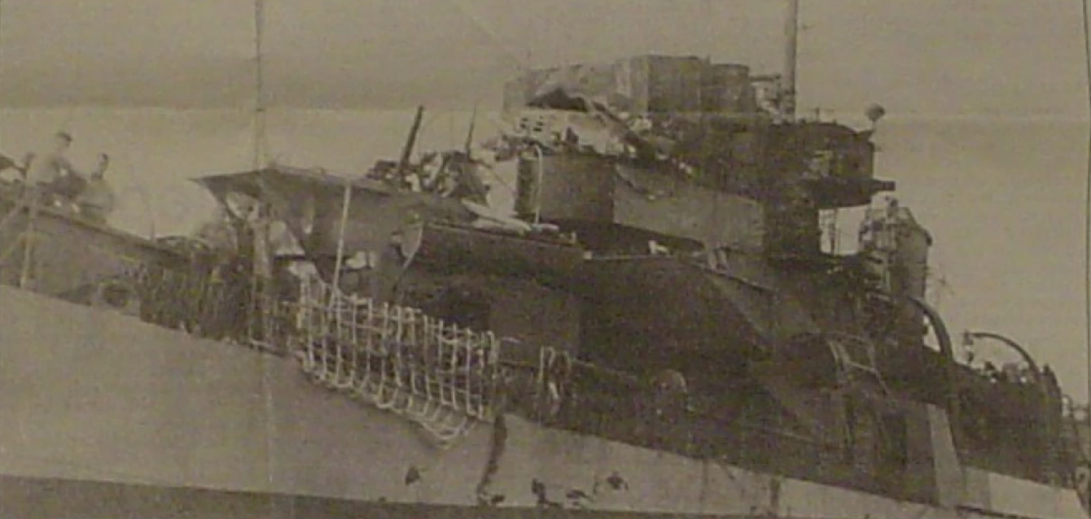
At right (above), a Japanese kamikaze pilot flew his plane into the bridge of the USS Bowers. The plane's fuselage is visible in this photograph. Below, Don Tillotson of Hot Springs, seated in the center with a glass of beer in his hand, enjoys a few hours ashore on a South Pacific island during World War II. Tillotson survived a kamikaze attack on the destroyer escort USS Bowers, but half of the other young men in this photograph did not.
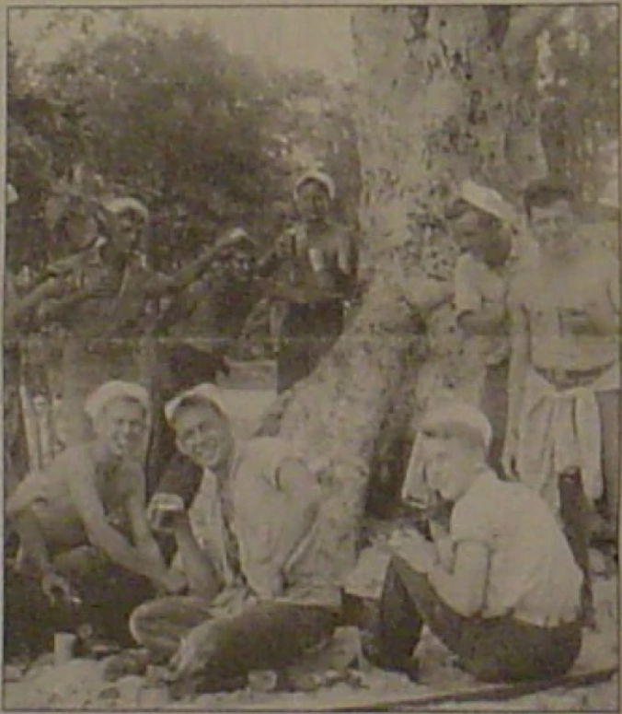
Historic photos courtesy of Don Tillotson
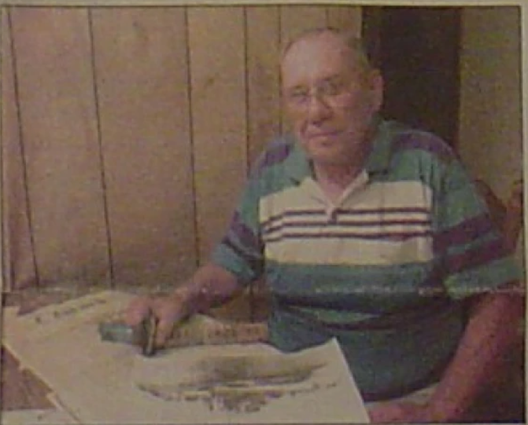
Don Tillotson today, with the hilt of the ceremonial sword taken from a Japanese kamikaze pilot. Journal photo by Bill Harlan

Tale Of Bowers Added To Heroic Sea Legends
Philadelphia. Aug. 30- (AP)
With their blood and sweat, crew-men of the destroyer escort Bowers have written another chapter in the never-ending drama of America's heroes of the sea.
Survivors of a Japanese plane's suicide attack off Okinawa. in which more than half of the ship's 200 men were either killed or wounded, stood stiffly-almost sheepishly-as reporters inspected what remained of the ship's top side, but told their story simply.
"The Jap pilot burned to death," said torpedoman 3-C Jack Elverson, 22, Buffalo, N. Y. "We took off his personal gear and found a white handkerchief stained in the center with what we guessed was his own blood."
"Every man aboard performed feats of superhuman bravery," said Ens. William Word of Amarillo, Texas, the only officer above decks not killed or wounded.
The navy disclosed today that four Japanese suicide dive bombers of a type known as "Val" swooped in for the kill on the, 1.600-ton craft on April 16, 1945. One was shot down by navy carrier planes, a second by a nearby destroyer escort and a third by the Bowers' gunners. The fourth crashed into the bridge on the vessel's superstructure.
A cigar-shaped 500-pound bomb screamed through the bridge and exploded 30 feet in the air, sending steel fragments ripping into the ship and cutting down men on the spot. About 45 were killed instantly and 60 others wounded. Later 20 of the wounded were reported dead.
Fire broke out when the plane's ruptured tanks flooded the pilot house and flames raced unchecked for 40 minutes as the Bowers spun crazily in the water at a speed of 22 knots. A nearby destroyer escort threatened to ram the ship to prevent her from striking other vessels, but enginemen finally brought the Bowers (DE 637) under control.
Some of the men were so badly burned that their teeth were black, said Seaman 1-C Henry Bass, 20, Fort Meade, Fla. Arms were blown off and the deck was strewn with wreckage.
The ship's skipper, Lt. Cmdr. Charles F. Highfield of Duluth. Minn., a 1934 Yale graduate, grabbed a tommy-gun and fired at the onrushing suicide, plane moments before it crashed. The impact flung him overboard into the water, where he lay severely wounded. Two crew-men assisted him into a life raft and helped him back aboard.

