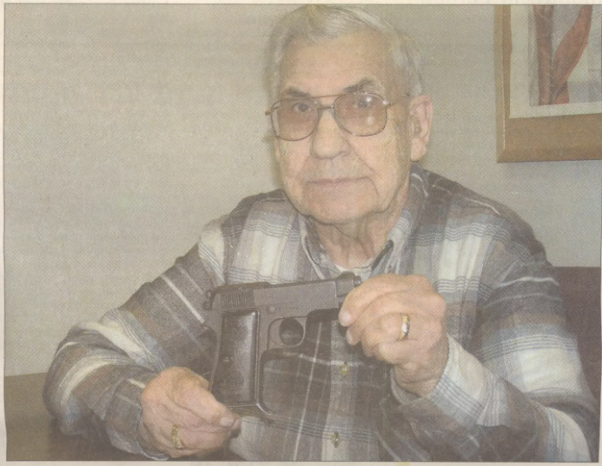
Register photo by John Andrews
Brookings resident and World War II veteran Bob Camp poses with one of his most prized pieces of war memorabilia an Italian 32 automatic Beretta. It was included in six cases of guns Camp confiscated when a man attempting to smuggle them into the mountains passed through his checkpoint in Innsbruck, Austria late in the war.

'Baptism of Fire'
Brookings man served in Europe in World War II
BY JOHN ANDREWS The Brookings Register

The concentration camp was a very gruesome place and it really shook everybody up how they could be so hard, so ruthless."
BOB CAMP
WORLD WAR II VETERAN
TALKING ABOUT LIBERATING DACHAU

Bob Camp clearly remembers what happened on Nov. 16. 1944. That was the day the Brookings man and World War II veteran experienced his Baptism of Fire, or his first day in combat.

It happened in Europe. near the area where France, Switzerland and Germany meet. He recalls getting there at about 8 that morning
"And I got hit that day, Camp remembers Shrapnel from a mortar shell, in my left leg".

He and the other members of the 409th Infantry Regiment of the 103ed Infantry Division had gone up the east coast of France to St. Die, where they encountered a mortar shell barrage.

"We didn't really run into any resistance until late in the afternoon. We'd gone down the side of the mountain, went across a crick and back up into the woods
"We'd already dug our foxholes and had them covered up with pine boughs and that. We were out talking with every body and then they start-ed lobbing these shells inc. Everybody dove for their foxholes "I came in this way, and my buddy came in this way Camp said. gesturing in opposite directions. "And the shrapnel that got me in the leg got my buddy in the head and killed him."

Coming within inches of death was quite an indoctrination to the war for the Midwestern-born son of a minister. And it wasn't the only adventure Camp would have in his 18 months in Europe during the tail end of World War II.

From school to work to war
Camp was born in Nebraska, but because his father was in the ministry, he didn't stay there very long. In his formative years, he called Minnesota, lowa, South Dakota, Washington state and Oregon home at some point.

He was living south of Seattle when the Japanese attacked Pearl Harbor in the Hawaiian Islands on Dec. 7, 1941. Shortly after that happened, the school he was attending was forced to close. Students had the choice of going to Tacoma to work in the shipyards or to Seattle to work for Boeing. Camp chose Boeing, where he ended up working on the then-secret B-29 bomber. He was there until July 1942, when he volunteered to serve in the Army at the age of 18.

He signed up at Fort Lewis, and from there went to San Diego for basic training in anti-aircraft artillery. Then, it was off to Fort Bliss in El Paso, Texas, for more training.

From there, Camp was supposed to go to Kodiak Island Air Base in Alaska, but instead was transferred to the infantry. He was in infantry training for two months, then went to New York City, got on a ship and set sail for Marseilles, France. It was October 1944.

From the hospital to the Bulge
Some of Camp's fellow soldiers helped him out of that foxhole, his leg bleeding. His sergeant asked Camp if he could make it up the hill to tell the captain about the unit's casualties and wounded soldiers. He said he could.

"I limped my way up there and told him," Camp says. "By that time, they started shelling us again."
This time, Camp sought cover under an overhanging rock in a snowdrift, where he stayed for an hour and a half. After that, he walked a mile and a half back down the mountain toward the first aid station.

"I got about 300 feet from the aid station and passed out colder than a cucumber," he recalls. "I'd lost too much blood. It was sloshing in my boot. It was 4 o'clock the next morning before I had surgery on my leg."

He ended up staying in the hospital for six weeks, where he celebrated Thanksgiving, Christmas and New Year's Day.
When he got out, he was the only one left from his squad of 15 and only one of 25 left from his original company of 250.
"They really hit us after I left," he said.
On Jan. 4, 1945, Camp was back on the front line with what was left of his unit, "which wasn't much," he says.
Camp didn't know it at the time, but he was on the east flank of what became known as the Battle of the Bulge, the largest land battle of World War II in which the United States participated. More than 1 mil- the battalion men fought in the battle, which lasted from Dec. 16, 1944, to Jan. 25, 1945. As a sort of last stand, Adolf Hitler launched an attack on the Allied line through the Ardennes Forest. After some initial success, Allied forces regrouped and eventually Hitler retreated.
"We didn't see any combat, as far as the Bulge, Camp remembers. "We were on the east flank of it. Shortly afterward, it got straightened out, and we chased the Germans the rest of the way back to Berlin. They pretty well gave up by that time."
Chasing Germans
Camp's unit was originally supposed to head to Berlin, but was reassigned to Austria. They eventually ended up in Innsbruck, near the Italian-Austrian border. There, they rounded up more Germans and even caught a division of Germans trying to cross the border into Italy.
"We interrogated the older ones, in particular," Camp said. "The 16-year-old kids, we just told them 'Goodbye, go on, get home."
Camp stayed in Innsbruck for two and a half months. It was while he was in Innsbruck that Camp acquired one of his most prized pieces of World War II memorabilia.
He was charged with guarding a radio station when a car came through his checkpoint. As another soldier talked with the driver, Camp surveyed the back seat. Under a pile of coats and blankets, he found six cases of guns and six cases of ammunition that the driver was attempting to smuggle into the mountains. They confiscated it, threw half of it in the river and distributed the other half to the company. The gun Camp got was an Italian 32-caliber automatic Beretta.
"I can't even get ammunition for it anymore," Camp said, with a smile.
Innsbruck is also where Camp received the news every-one had been waiting to hear. "When we came into Innsbruck, the trucks all had their headlights on," he remembers. "We couldn't figure out what was going on. We came to find out the war was over."

Liberating Dachau
In 1986, Camp put together a narrative of his memories from the war. In it, he talks about his "worst memory." That came on April 19, 1945, when his regiment helped break down the gates of the Dachau concentration camp, where thousands of Jews were being held.
"The concentration camp was a very gruesome place and it really shook everybody up how they could be so hard, so ruth-less," Camp said in the narrative.
His regiment released 10,000 Jews that were being held at the camp at that time.
"Some people think it never happened, that it was just somebody's imagination, but it is real, Camp said. "The horror is real.
"When we captured the commandant of Dachau, we put him in the concentration camp prison, and in two days he went completely insane. He couldn't stand being locked up."
From war to school and back home again
Camp stayed in Europe for 18 months altogether. After the war, he took some classes at the agriculture college at the University of Munich, which had been overtaken by the U. S. Army.
In March 1946, Camp was on a Merchant Marine ship that landed in New York Harbor.
"We came up the mouth of the river there and saw the old Statue of Liberty, Camp recalls. "I don't think there was a dry eye on that ship."
He got to Fort Dix, where he remembers the walls were lined with telephones. He called home, and can still remember the conversation he had when his father picked up the telephone.
"Where are you?" his father asked.
"New York City," Camp said. You can't be. "Why?"
"Well, I just got a letter from Germany from you today."
About a week later, he made it back to Tacoma and was discharged on April 1, 1946.
"We were all wondering when we left down toward the gate if it was for real or if it was an April Fool's joke. But they said, You're free to go."
He headed to live with his parents, who were in Washington state at the time. While there, he earned his high school diploma, graduating in a class with one of his sisters.
Life after the war
Camp went on to attend college in Boise, Idaho, and Des Moines, Iowa, where he studied to be a minister. He served churches in the Upper Midwest and in southern California. His wife and three children moved to Brookings in 1965, and never left.
The Camps served as lay preachers here. Camp also drove school bus for the Brookings School District for 10 years and worked for the University Police Department at SDSU for 20 years.
He is a life member of the Disabled American Veterans. He has been the state chaplain. for the organization for 18 years and is currently the commander for the Brookings chapter.

