MEET THE GEFREITER
by Ray & Josephine Cowdery

Some years ago we met Franz “Frank ” Morawa and his wife Elsie quite by accident. At the time we met they lived as we do, along a rural highway in a National Forest. From their accents we knew that Frank was originally from Vienna and his wife was a native of Germany. We liked them and saw them frequently, enjoying Elsie’s homemade zucchini bread and plum jam.

Long after we met, as the Morawas were preparing to move into a new house in a city, Frank mentioned he still had his old military documents andwonderedif we want-ed them. Of course we did.

Born in 1925, Franz Morawa was no different from other young Austrian men growing up in a land that had recently become a part of Germany. Educated as an engineer, he had completed his Reichs-arbeitsdienst obligatory labor service in August of 1942 and registered for con-scription into the armed forces.

His father, Franz Sr., had served in the Artillery in World War I and had been a practicing engineer in civilian life between the wars. When World War II began he was called up in the Luftwaffe and his abilities were put to use con-structing airports. He was sent to Würzburg and then to France. While working in Russia Franz’s father was listed as missing in action on 12 January 1942 in the area of Smolensk.

Because of his background in civil engineering and because he worked for the railway, young Franz was placed in a Railway Engineering Replacement Battalion for training at Korneuburg in August of 1943. Upon completion of basic training his unit went to an advanced mountain engineering school near Innsbruck.

The Austrian army had a tradition of mountaineering for hundreds of years and many military units were trained there as normal military units that would be expect-ed to perform their duties in mountainous terrain. Franz’s unit did exactly that. They trained in every aspect that any other Railway Pioneer unit in the German army would, plus they trained as mountain troops. When you look at the photos that accompany this article you will notice that members of the S t am m k o m p an i e Eisenbahn Pioniere Ersatz Battalion 2 dressed in uniforms that included a Berg-mütze (mountain cap) and Bergschuhe (mountain boots).

Training at the German army special engineering school at Innsbruck was nearly as much fun as it was work. Skiing and climbing were as much a part of the curriculum as transit work, measuring and construction. There was still snow on the ground in the higher elevations when the course work was finished and the unit was ready to move on in mid 1944.

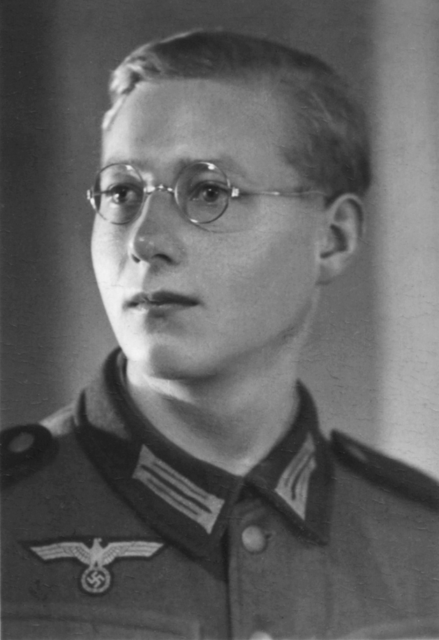

The photo above shows 18 year old Franz Morawa of Vienna in 1943 in training as Landser number 1351 of the 2./Eisenbahn-pioniere Ausbildungsbattalion 2, at Korneuburg, Germany (now Austria). His mother and two sisters lived in Vienna but his father Franz Sr. was an engineer building airports for the Luftwaffe.

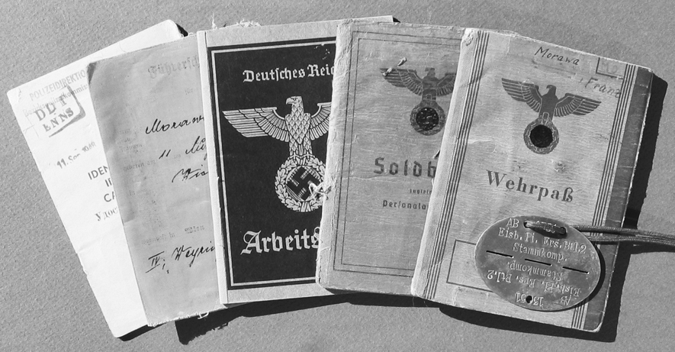
Left, are the five principal documents and the Erkennungsmarke or dogtag Morawa had car-ried with him around the world for over 65 years. They are an 8-page post-war Austrian identity document in German, English, French and Russian; a Führerschein or driver’s license from 1943; a Nazi Arbeitsbuch or Permanent Work Record issued in 1940; German Army Soldbuch (Military Pay Book and Personal Identity Document) number 1253 issued 30 August 1943; German Army Wehrpaß (Permanent Record of Military Service) issued 10 August 1942 and a zinc Erkennungsmarke stamped 1351 AB Ei s b . Pi . Ers . Bt l . 2 St ammk o mp . Contained in the Wehrpaß were many other documents pertaining to Morawa’s service, incarceration and eventual return to civilian life in 1946.

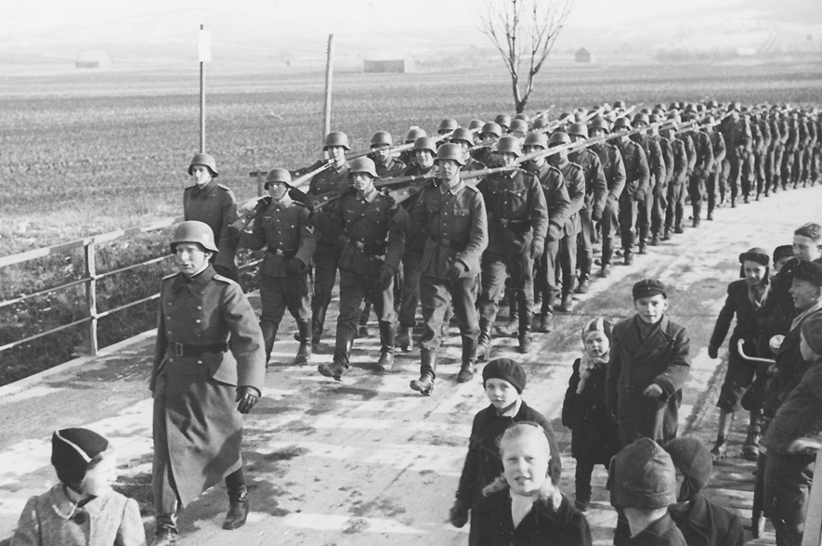

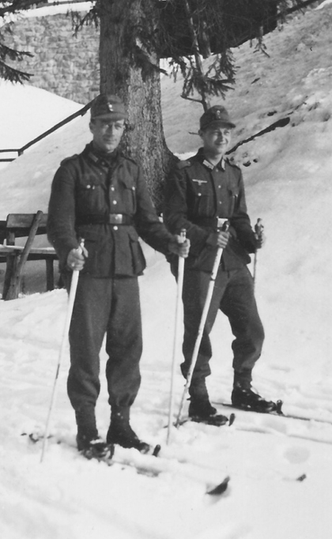

Above, even Railway Pioneers have to learn to march and shoot like every other soldier. Here school children and civilians watch Franz’s unit in basic training at Korneuburg, near Vienna. Left, Franz Morawa and a friend take to their skis during advanced mountain engineer training in the mountains near Innsbruck. Below, training in surveying was emphasized as part of the special mountain engineer training for the Stammkompanie Eisenbahn Pioniere Ersatz Battalion 2 near Innsbruck. The picture in the lower left was taken aboard ship as Gefreiter Franz Morawa’s unit departed Denmark for the voyage to Norway.
Franz came to the United States in 1950 and became US citizen Frank Morawa in 1953. He spent his working life in electrical engineering all over America.

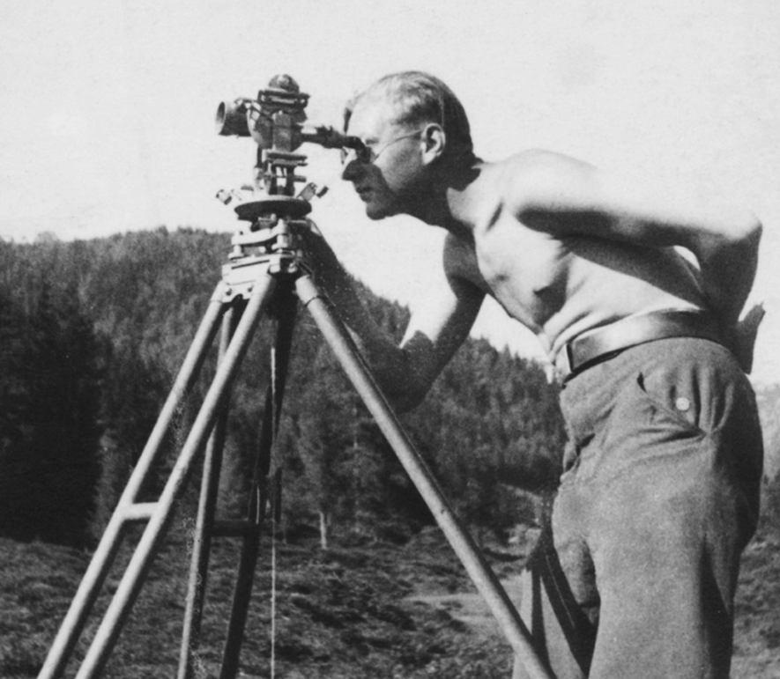
The really special training received at the school near Innsbruck was in constructing and using bridges, lifts and aerial tramways in military sit-uations in mountainous terrain. Franz’s unit was one of only four similar units in the entire Wehrmacht. One of the most mountainous places the Germans were defending against Allied incursions and sabotage in 1944 was Norway.
Franz was ordered to Norway in July 1944. On 20 July 1944s while crossing the border from Germany into Denmark
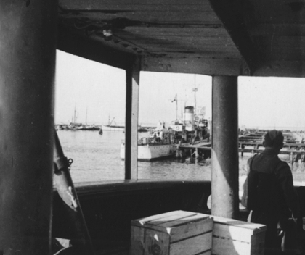

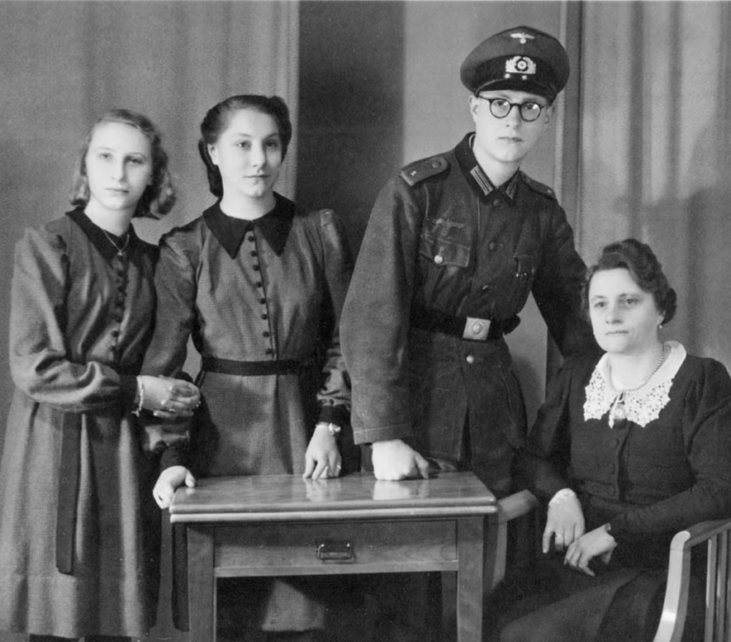
by train, his commanding officer told the troops that they should be prepared to defend themselves against possible attack in Denmark. He revealed that an attempt had been made on the life of Adolf Hitler at the Wolf’s Lair in East Prussia! They had weapons but incredibly had been issued no ammunition.
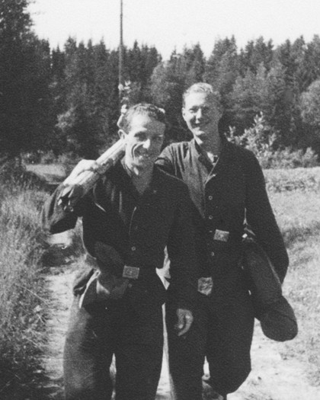

Upon arrival in Norway the first order of business for the Pioneer unit was to construct a new barracks near the picturesque town of Stommen. The camp did not exist so that meant it was necessary to clear the land, engineer the project, make a survey (photo above) and then construct the buildings from prefabricated wooden wall, window and door units.
Two months before the end of the war the 250 men in the company were transferred to a regular engineering outfit on the coast. On 10 May 1945, a British and an American Colonel appeared in Mandel and explained that, “You now work for us”. The troops were not immediately disarmed, but went about their business in uniform much as they had before.
Above, the Morawa family in Vienna: his sisters Ernestine and Gerta, Franz and his mother. Below left, Franz Morawa Sr. is the man at the right in a group of Luftwaffe officers discussing an airport construction project. Franz bought his father the 9 mm pistol he is wearing, on the black market. The picture below was taken at Dombås, Norway in January 1945 where Franz’s engineers were repairing bomb damage to a railway bridge.

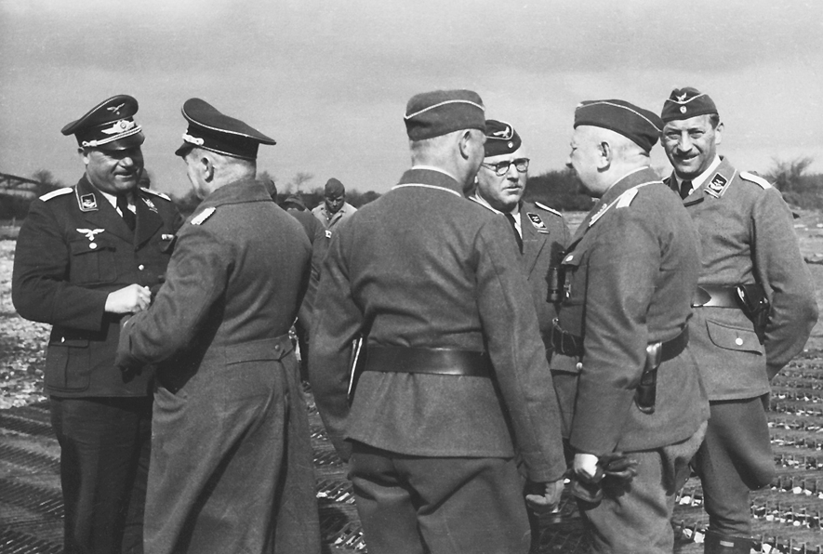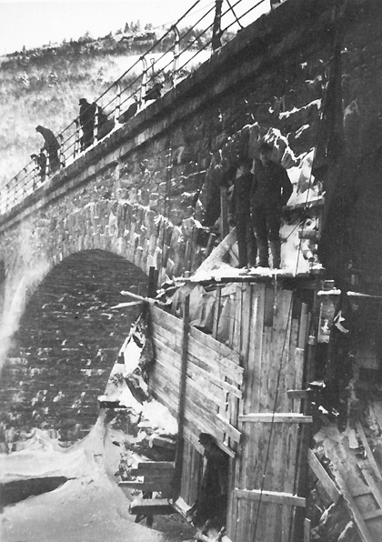
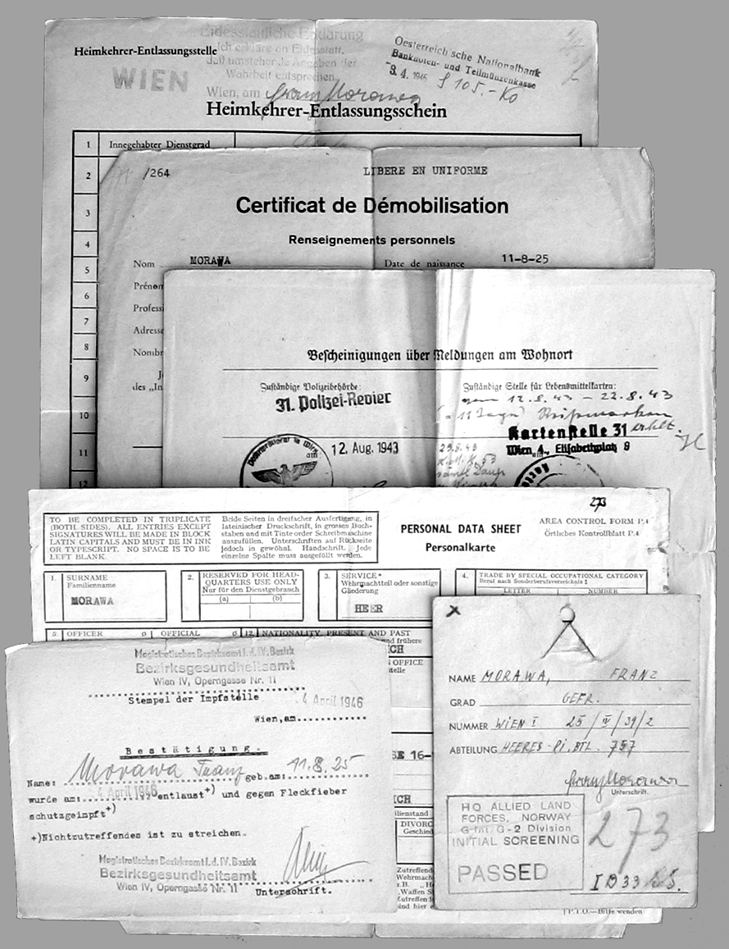
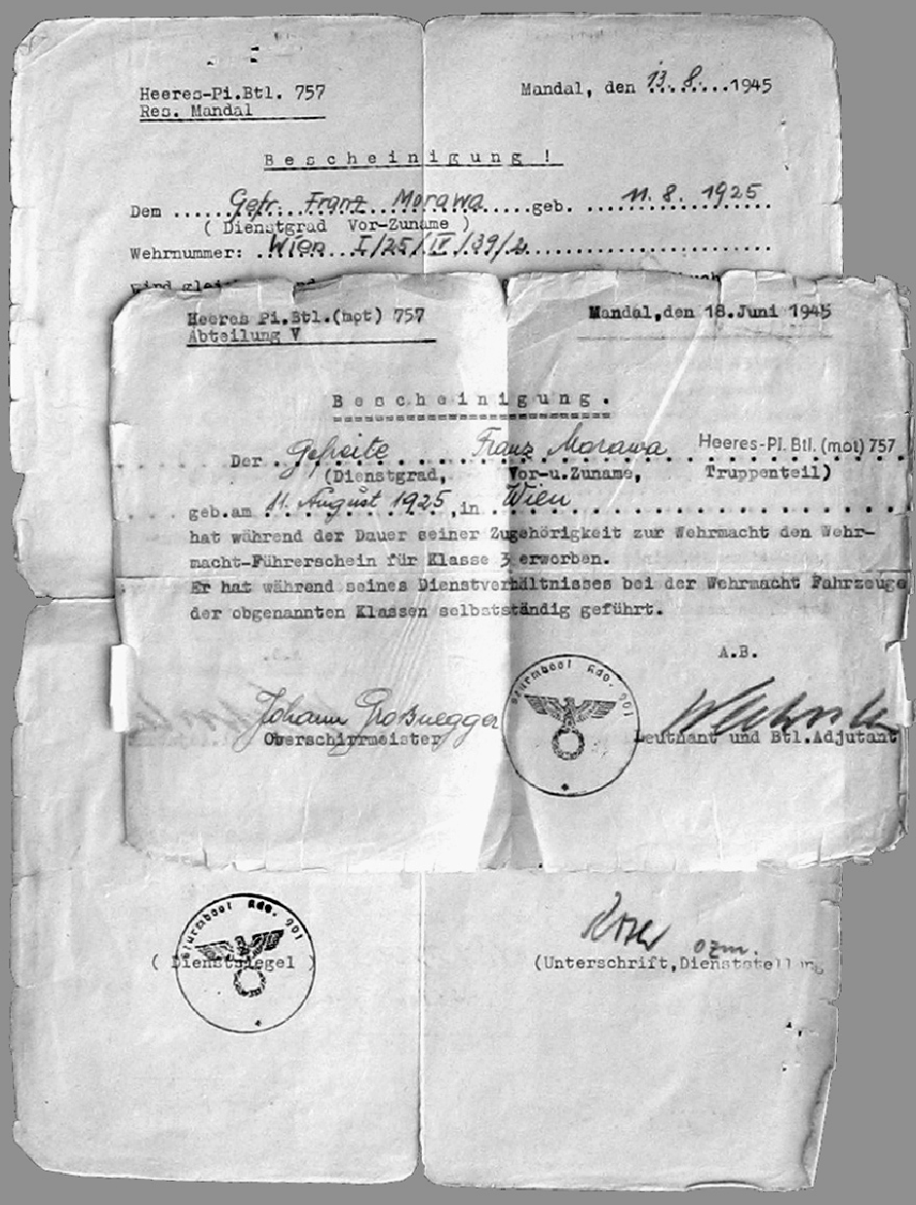
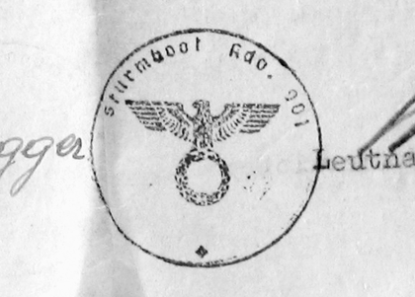
In July 1945 a Hauptmann and Battalion Commander named Rolfs of Sturmboot Kommando 901 brought Gefreiter Franz Morawa’s Soldbuch up to date and paid him. It looked like he was on his way back to Vienna. Back in continental Europe, his train itinerary was to take him via Salzburg in central Austria to Vienna in the east. He was accidentally sent via Strassbourg, a city on the French border 400 kilometers west of Salzburg! Arriving in Strassbourg he and the other German soldiers traveling with him were immediately seized by French soldiers and unceremonially thrown into a Prisoner of War camp. He spent most of a year as a “guest” of the French and still refers to them as “frogs” to this day.

The paperwork shown on this page is part of the assortment found inside the Wehrpaß of Franz Morawa. Most of it deals with his demobilization from the German Army, incarceration by the French, and return to civilian status. The de-Nazified stamp of Sturmboot Kommando 901 was used on paperwork through July 1945!

