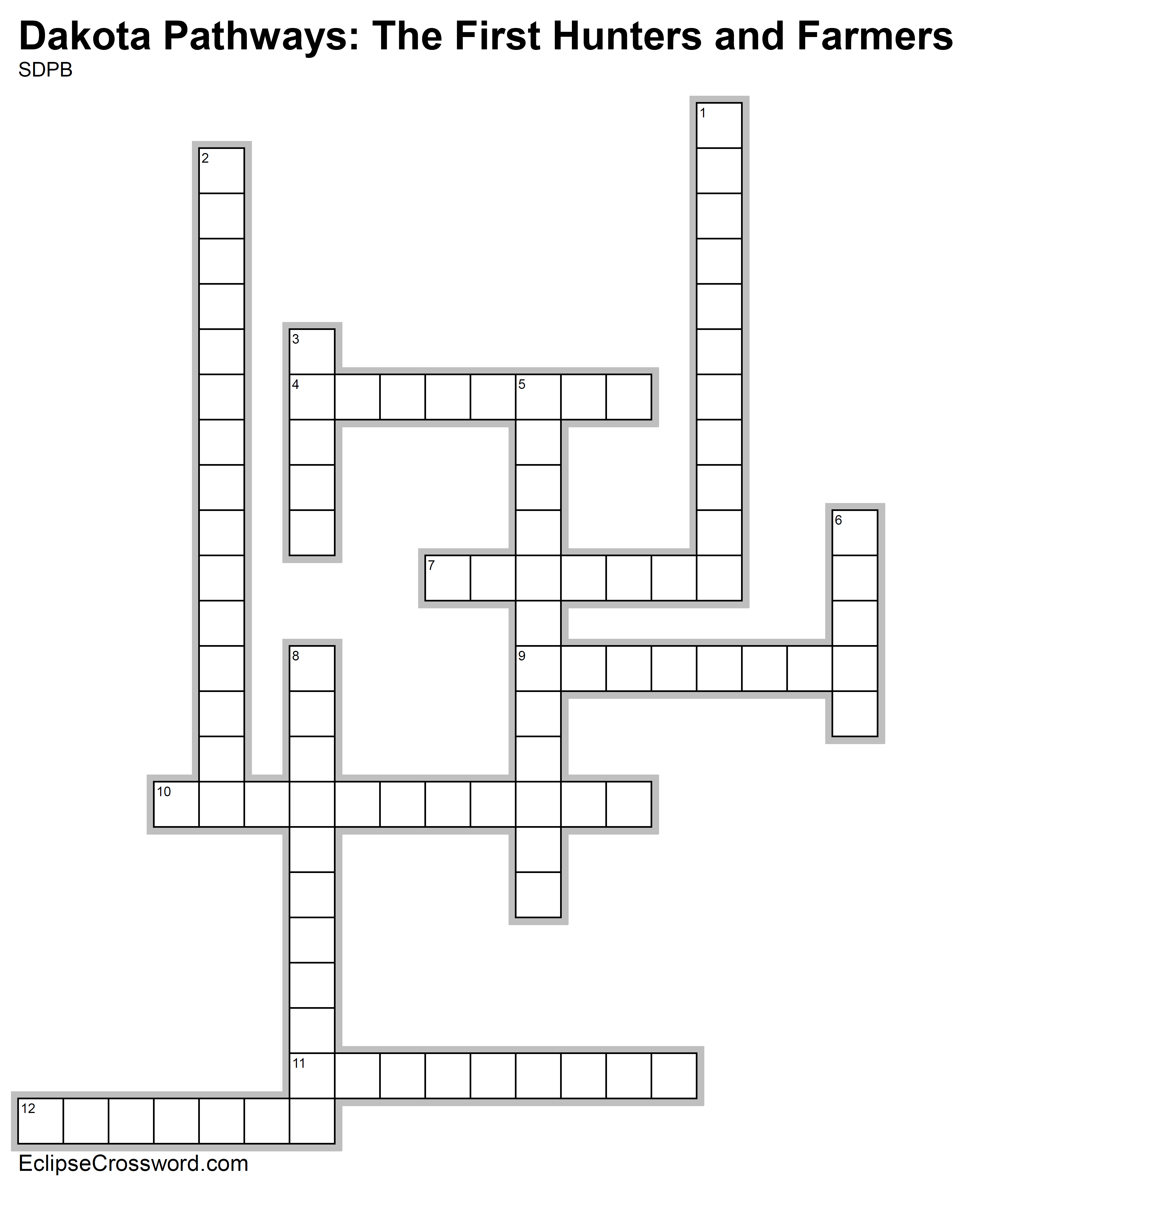

**Word Bank:** ANTHROPOLOGY ARCHAEODOME ARCHAEOLOGY ARTIFACT BURIALS CACHE CULTURE HUNTER-GATHERER MIGRATION PEMMICAN PETROGLYPHS RUINS

**Across**

4. An object produced or shaped by human craft,

especially a tool, weapon, or ornament of archaeological or historical interest

7. Location of graves and the artifacts found in and

around them

9. A Native American recipe that includes buffalo

meat, berries, nuts, and fat that are ground

together, and dried

10. The study of the physical remains of human

settlement

11. Movements of large groups of people

12. The way of life of a group of people. This includes

what they wear, how they govern themselves, their

religious belief, other rituals, etc.

**Down**

1. Ancient pictures that are cut into stone

2. People who hunted animals and collected plants

for food

3. A hiding place used mainly for storing food and

valuables of ancient cultures

5. The study of behavior, artifacts, and beliefs of

different cultures

6. The remains of something destroyed,

disintegrated, or decayed

8. A structure used by archaeologists that allows

them to be protected from the weather so they can

work on a site year-round

