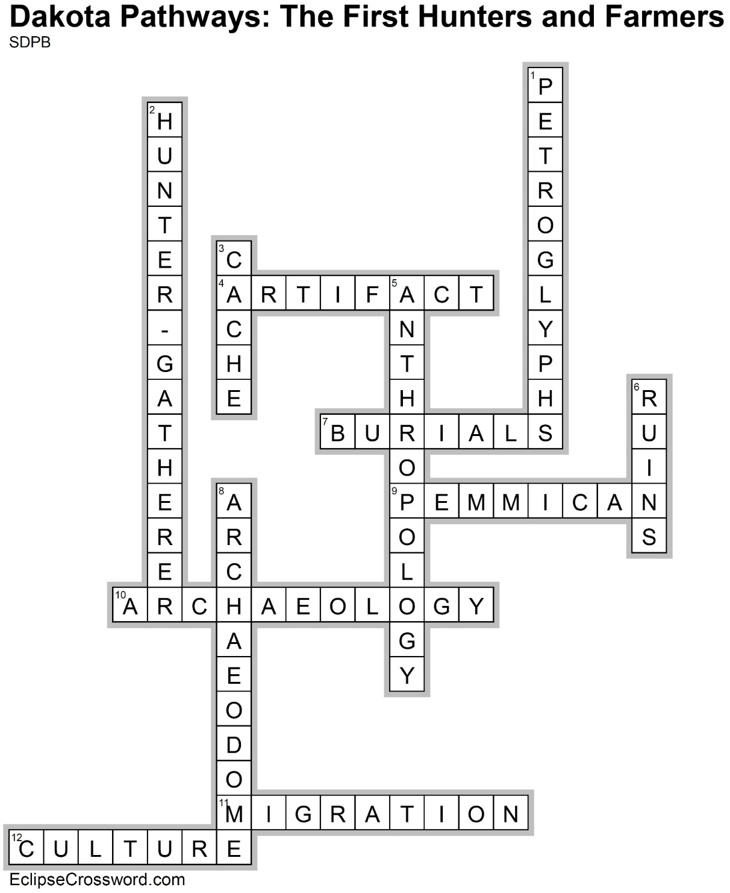

**Across**

4. ARTIFACT — An object produced or shaped by human craft, especially a tool, weapon, or ornament of archaeological or historical interest

7. BURIALS — Location of graves and the artifacts found in and around them

9. PEMMICAN — A Native American recipe that includes buffalo meat, berries, nuts, and fat that are ground together, and dried

10. ARCHAEOLOGY — The study of the physical remains of human settlement

11. MIGRATION — Movements of large groups of people

12. CULTURE — The way of life of a group of people. This includes what they wear, how they govern themselves, their religious belief, other rituals, etc.

**Down**

1. PETROGLYPHS — Ancient pictures that are cut into stone

2. HUNTER-GATHERER — People who hunted animals and collected plants for food

3. CACHE — A hiding place used mainly for storing food and valuables of ancient cultures

5. ANTHROPOLOGY — The study of behavior, artifacts, and beliefs of different cultures

6. RUINS — The remains of something destroyed, disintegrated, or decayed

8. ARCHAEODOME — A structure used by archaeologists that allows them to be protected from the weather so they can work on a site year-round

