Inquiry: Heat Transfer | D.C. Booth
During this activity, your students will design an experiment to investigate heat transfer and the effect of insulation. This is a great science activity for an afterschool group, club or elementary – high school science class.
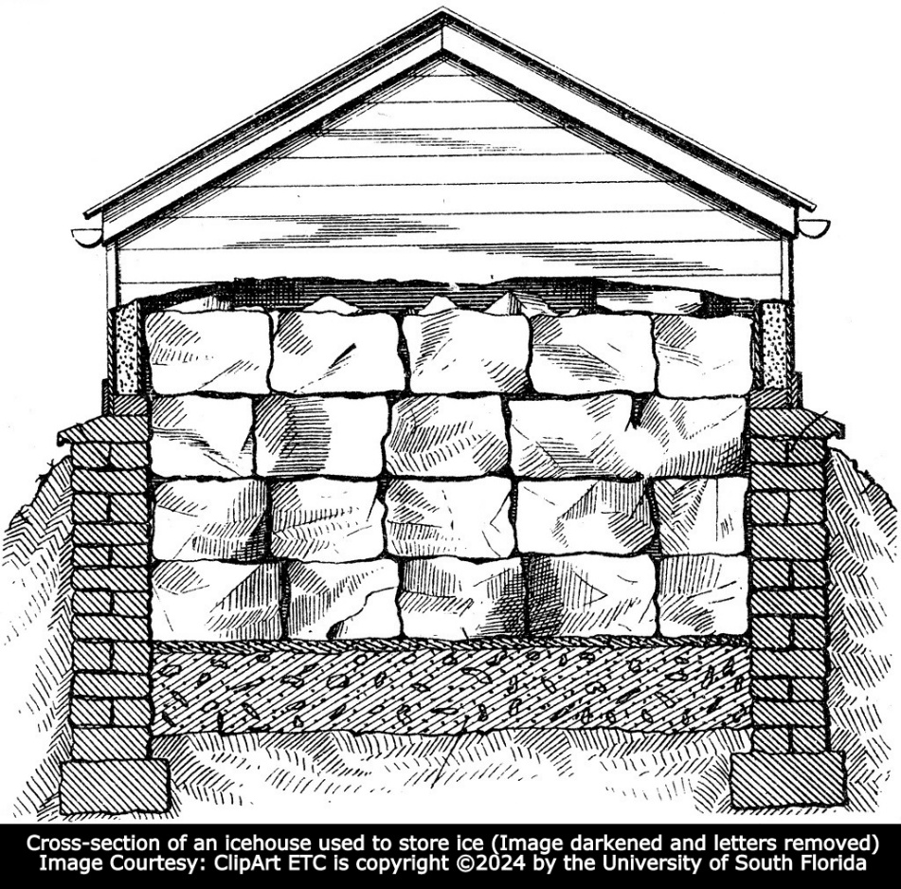

Lesson summary
Heat energy naturally transfers from an area with more heat to less heat. Insulation reduces this transfer by reflecting the thermal energy or reducing the conduction.

Learning objectives
- Students will learn how heat transfer is reduced with the use of insulation.
- Students will learn that ice was used for cooling before refrigeration. The large ice blocks were removed from ponds and lakes and stored for months in icehouses.

Prep for teachers
- Access the video clips and additional information below.
- Help the students gather materials for their experiments.

Introductory activity
The following video clips, information, and investigation should be used with your heat energy curriculum. Discuss how heat energy naturally transfers from an area of more heat to an area of less heat. For example, heat will transfer from the inside of a warm house in the winter to the outside.
View the following video clips about icehouses.
- Keeping Ice Frozen Before Refrigeration - Lean how moving ice long distances was made possible. Also, access the Support Materials section.
- D.C. Booth Fish Hatchery Part One - The video is found on the following website: Images of the Past
  - A section of the historical video (timecode 2:30-3:02) introduces how pond ice, sawdust, and icehouses kept food cold before modern refrigeration.
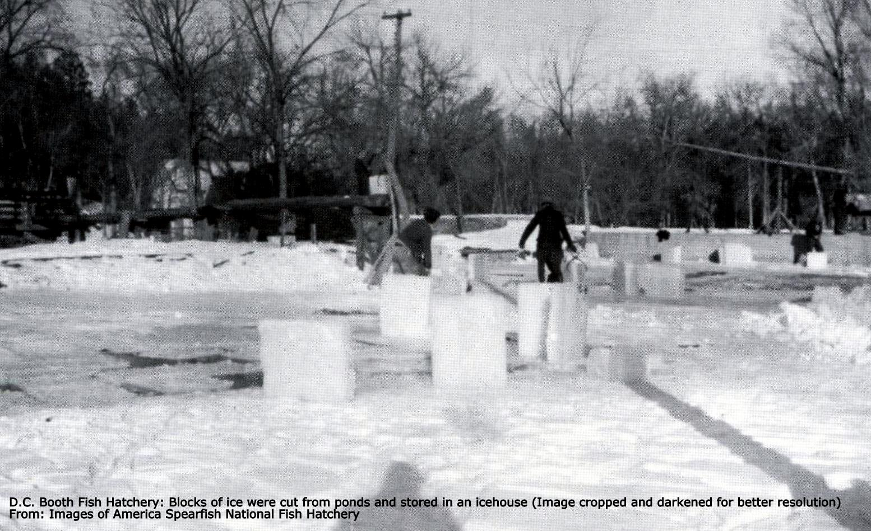
The students should research and discuss how ice (cut from lakes and ponds in the winter), sawdust and/or straw (insulation), and icehouses were used to keep food cold before refrigeration throughout the spring, summer, and fall months.
- Interesting Related Resource - Archival: Food Storage Methods: Read the 1966 US Department of Agriculture food storage and usage guide, including pits.
Learning activities
- The students should design an experiment to investigate how insulation reduces heat transfer. Below is an example of an experiment that could be used for this investigation or as an example to get the conversation started.
  - Possible Experiment: The effectiveness of coffee cups in reducing heat transfer.

    - Selection of cups:
      - Test disposable coffee cups from local eateries, coffee houses, and/or convenience stores.
      - Test different name-brand/generic disposable coffee cups.
      - Test insulated and non-insulated coffee cups.

        - Option #1 - Place an equal amount of hot water in each coffee cup - and record each temperature. Then, record the water temperature in each cup every ten minutes for 60 minutes.
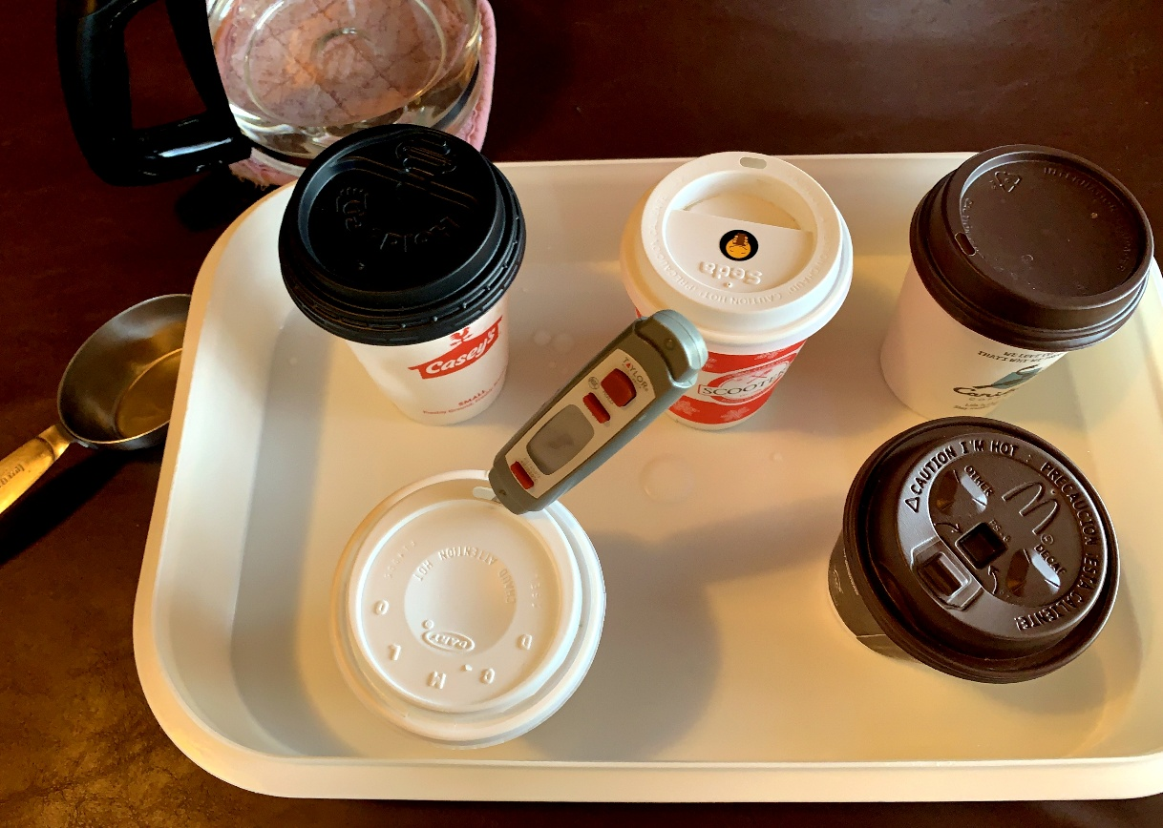
        - Option #2: If a thermometer is unavailable, the following could be used. Freeze the same amount of water in each cup. Place the cups in a warm bath (protect the outside of each cup with saran wrap if needed). Heat should transfer from the warm bath into the cup, increasing the rate of the phase change from a solid to a liquid. Pour out the liquid water from each cup throughout the experiment (at set intervals). Record the amount of liquid water and the time.
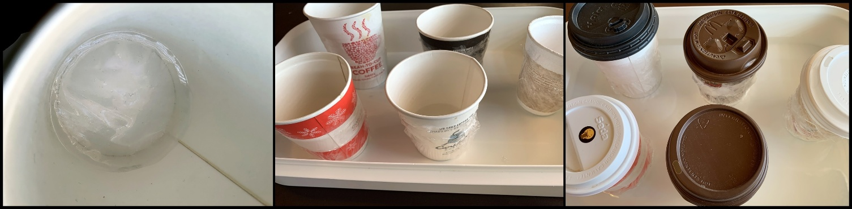
- The students should design an experiment to test how insulation reduces heat transfer.

  - Divide the class into groups of 2-4; provide time to discuss the challenge, design an experiment, and list needed supplies to bring from home.
  - Provide additional requirements/restrictions to meet the needs of your group.
  - Conduct the experiment.
  - The students should share their results with the group and discuss design features of the experiment that worked well/did not work well.



