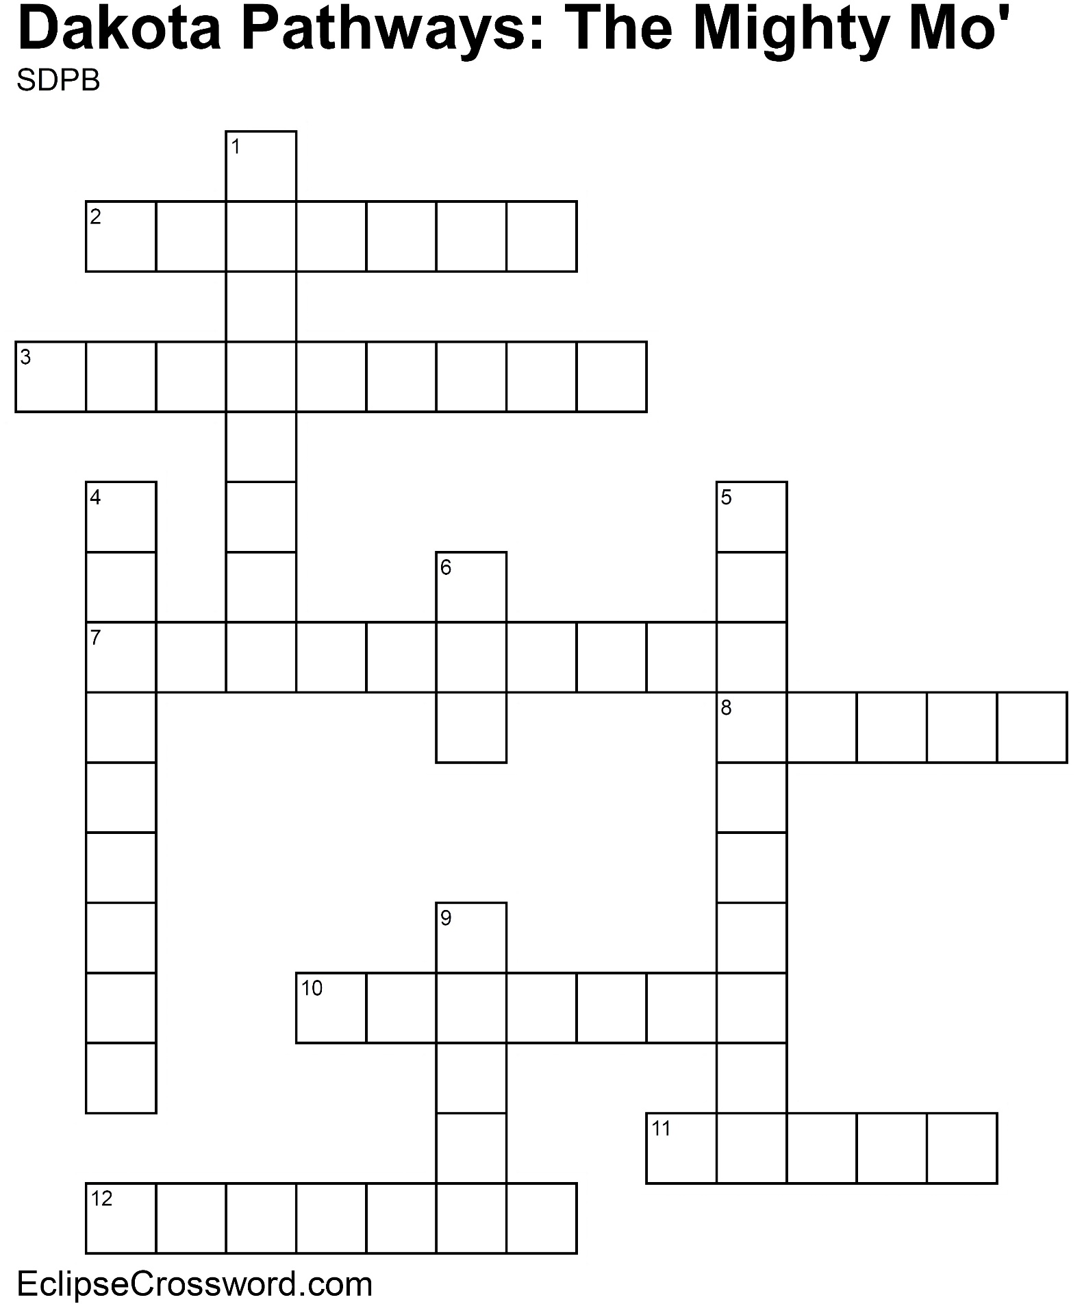

**Word bank:** CHANNEL CONFLUENCE DAM DELTA DROUGHT EROSION FLOOD HEADWATER IRRIGATION MOUTH SAND BAR TRIBUTARY

**Across**

2. Deeper part of a river; usually more navigable

3. Where a river begins

7. Water used for farmland

8. When water flows across land that is normally dry

10. Process of wearing away

11. Fan-shaped area of sediment at mouth of a river

12. Long period with little or no rainfall

**Down**

1. Submerged ridge of sand or gravel

4. Stream or river that feeds into a larger waterway

5. Place where two rivers come together

6. Structure designed to hold back river water,

creating a reservoir

9. End of a river