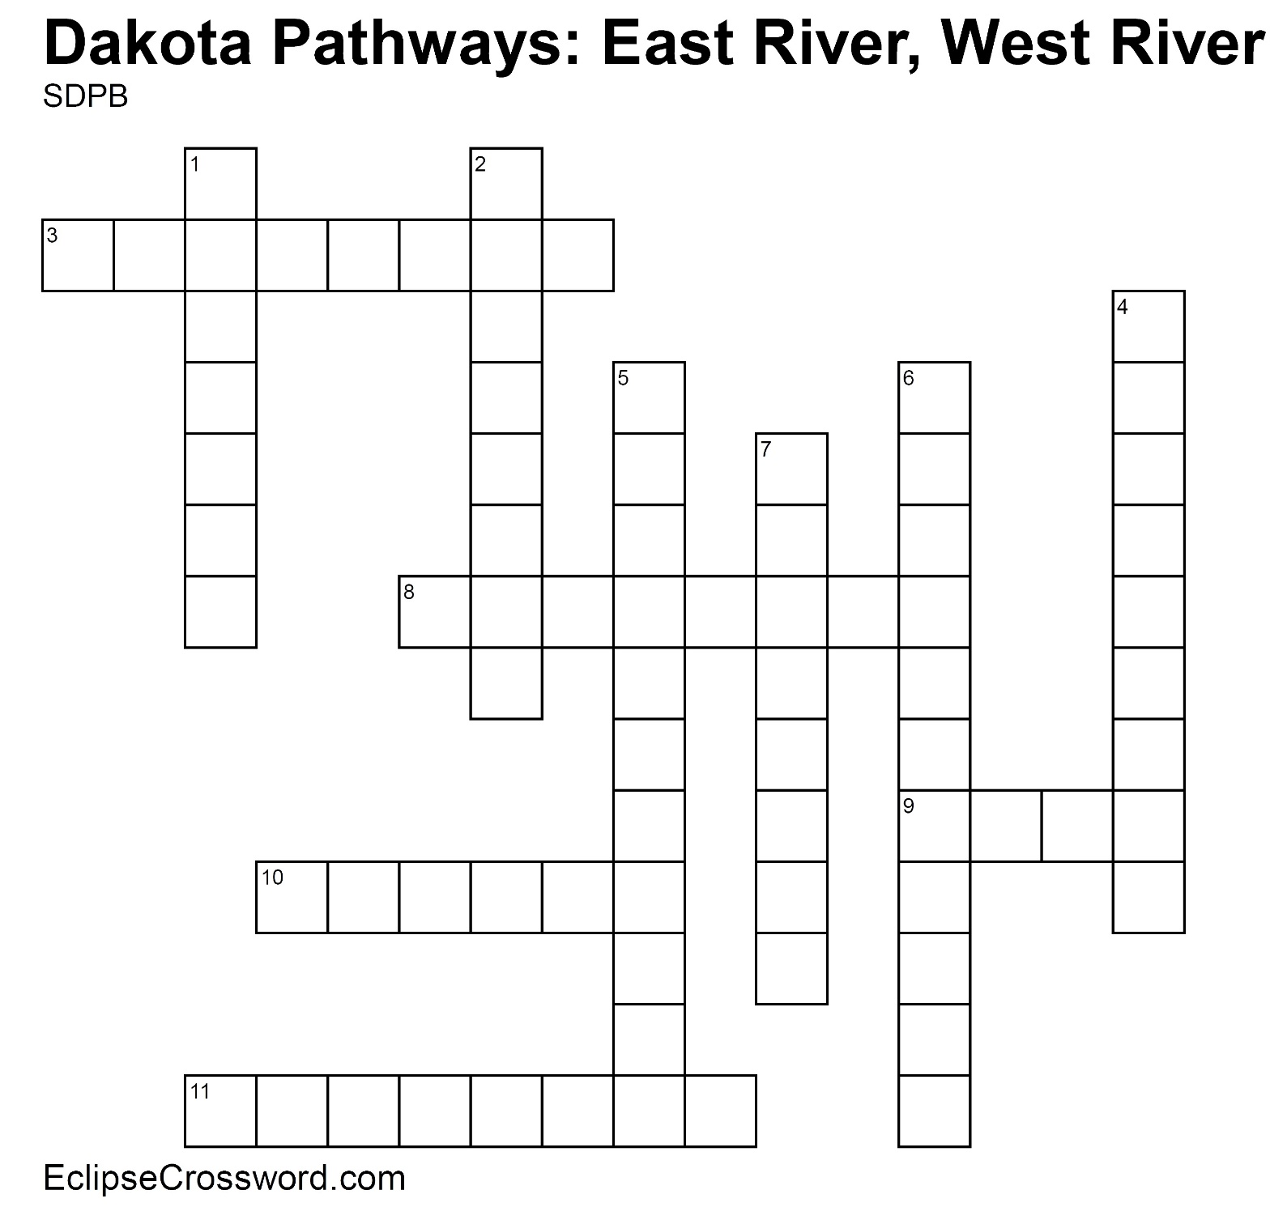

**Word Bank:** AGRICULTURE ARID BOUNDARY DESERT DROUGHT FRONTIER INFESTATION LATITUDE LONGITUDE MERIDIAN PARALLEL

**Across**

3. Another name for lines of latitude, which run east

and west on the map

8. Parallel lines starting at the equator measuring

distance north and south

9. Lacking moisture; not enough rain

10. Dry, barren, and often sandy region

11. The extreme limit of settled land beyond which lies

wilderness, especially referring to the western US

before Pacific settlement

**Down**

1. Prolonged period without precipitation

2. Another name for lines of longitude, which run

north and south on the map

4. Meridian lines starting at the Prime Meridian

measuring distance east and west

5. Science, art, and business of producing crops and

raising livestock

6. Spread of something harmful

7. Something that indicates a border or limit

SDPB Learn logo. 