**“ROSIE’ DELPHINE KLAPUT**

Glenn L. Martin Aircraft Company – Clerk – 1943-1944 Baltimore, MD (or Essex, MD if you want to be exact)

Delphine Virginia Tedeski Klaput was born November 23, 1924 in the small coal mining town of Cadogan, Pennsylvania to Angelo and Genevieve Dantella-Tedeski. Delphine’s father served during WWI. During his service, he was exposed to mustard gas to save his regiment and suffered from the exposure until his death. Therefore, Delphine spent a lot of her childhood with her grandparents.

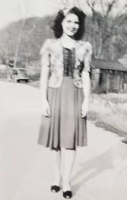

Delphine met her future husband George Benedick Klaput during her high school years. George and his twin brother Joseph, joined the Army Air Corps in 1942. While George was Flying missions as a ball-turret gunner on a B-17 over Europe, Delphine’s Uncle secured her a position to work as a clerk at the Glen L. Martin Aircraft Company in Baltimore, Maryland. So, she left school and went to live in Baltimore with her uncle and started work. Her daily duties consisted of keeping track of parts and plans for the aircrafts and distributing them to the assembly line.

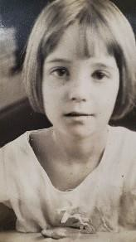

When George returned from Europe in 1944 after completing all his missions over Europe including missions over France during D-Day, he and Delphine were married. George was then assigned to Lowery Air Force Base for further training. George left for Denver and Delphine returned to Glen L. Martin until George sent for her. Once she arrived in Denver, Delphine secured a job working at Western Union. When George’s training was complete, they were sent to Greenville, Mississippi to await new orders. While in Greenville WWII war ended. They moved back to Cadogan and began raising a family. Their first three children, Sandra Jerry and Diana were born in Cadogan, Pa.

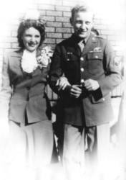

In 1952, George and Delphine moved to Royal Oak, Michigan as George was offered a job as a

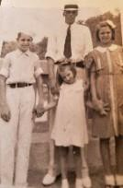

mill wright at Martini Tool & Die Manufacturing. They had two more children, Cheryl Ann and Mary Jane. Delphine was a stay-at-home mom while her children were growing up. Delphine loved to sew crochet in her spare time. Once her children left home, she worked at a nearby clothes cleaners doing alterations. She also spent time volunteering at the nearby Senior Center. In her mid-70s Delphine went to work at Costco doing demonstrations for 16 years.

George and Delphine were married 72 years at the time of his death in 2016. After his passing Delphine’s son-in-law Jerry Kelley was attending an Optimist meeting where a “Rosie” enactor and

historian talked about “Rosie the Riveter” history and the history of Willow Run B-24 Bomber Plant in Ypsilanti,

Michigan. After the meeting, Jerry talked to the presenter, about Delphine working at Glenn L. Martin Aircraft company and she confirmed that Delphine was indeed a “Real” Rosie the Riveter. Delphine was surprised and very excited to receive this news.

Delphine always regretted that she had not completed high school because of her leaving to go to work during WW II. One day she mentioned this to her daughter Diana and Grandson Bryon Kelley. Later that day, Diana asked her husband if anything could be done to get her a diploma. So, Jerry contacted the Armstrong County Schools in Pennsylvania, who confirmed she was eligible and issued Delphine a diploma.

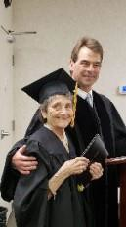

In May of 2018, with the help of Bryon’s secretary/receptionist a surprise diploma presentation was arranged at the Yankee Air Museum Willow Run. With family, Rosies and Rosebuds present, Judge David Parrot presented Delphine with her a diploma. She said that it was one of the best days of her life.

In the Fall of 2021 Delphine moved to Ypsilanti, Mi to live with her daughter Diana and son-in-law Jerry.



Delphine is extremely proud to be a Rosie and is active with several Rosie organizations, including the Michigan Rosies.