Wesley Joseph Zacharias
September 10, 1924 – September 7, 2012
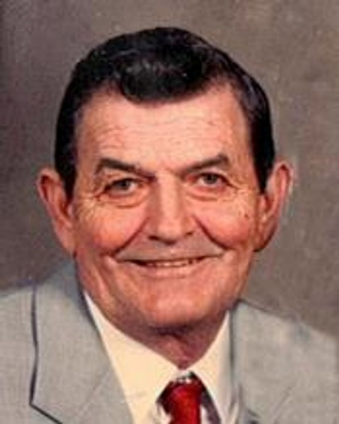

Wesley J. Zacharias, 87 of Wagner
Mass will be held 10:30 a.m. Monday, September 10, 2012 at the Assumption Catholic Church in Dante. Burial will be in St. John Catholic Cemetery, rural Wagner, with military honors. Visitation will be 1 p.m. to 5 p.m. Sunday, September 9th at the Crosby-Jaeger Funeral Home in Wagner, followed by a 7 p.m. rosary/wake at the church.
Wesley Joseph Zacharias, son of Frank and Agnes (Novak) Zacharias, was born September 10, 1924 on the family farm south of Wagner. He died Friday, September 7, 2012 at St. Benedict Health Center in Parkston. Wes attained the age of 87 years, 11 months and 29 days.
Wes attended Ree County School #62 through the eighth grade. He served in the U.S. Army from April 13, 1945 to October 11, 1946.
Wes married Lila Weber on February 13, 1945 at the Assumption Catholic Church in Dante. They farmed south of Wagner from 1945 to 1995. Upon their retirement, they moved into Wagner. Wes and Lila became residents of the Golden Living Center in Armour on August 22, 2011.
Wes was a member of the Assumption Catholic Church in Dante; Rollie Buchulz VFW Post #7319; Dante Lake Club, and Farmers Union. Besides farming, Wes also was a Cargill Seed dealer for nearly 30 years.
Wes will be remembered for his enjoyment of fishing and hunting.
Thankful for having shared his life are his wife, Lila of Armour; children: James of Wagner; Larry and wife Danielle of Astor, FL; Jane Blaha and husband, John of Dante; Nancy Hermanson and husband Steven of Yankton; Mary Lou Snyder and husband Larry of Lake Andes; Angela Blaha and husband Roger of Wagner; and David and wife Deborah of Long Pine, NE; 24 grandchildren; two step grandchildren; 52 great grandchildren; three step grandchildren; one great-great grandchild; sister, Angeline Minnehan of Aurora, CO; his in-laws: John and wife Elaine of Parkston; Elaine Anderson of Mitchell; Dale and wife Shirley of Salem; Dean and wife Karen of Wagner; and Pearl Weber of Wagner; and many nieces and nephews.
Wes was preceded in death by an infant daughter Anne Marie; his parents; daughter-in-law, Mary; and four brothers-in-law: Robert Minnehan, Lester and Eddie Weber and Bill Anderson.

Link to original obituary.

