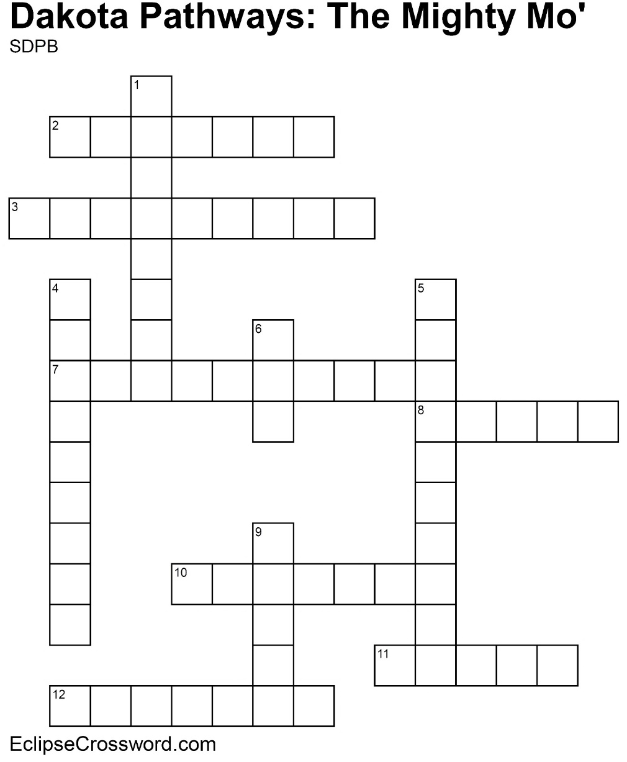

**Word bank:** CHANNEL CONFLUENCE DAM DELTA DROUGHT FLOOD EROSION HEADWATER IRRIGATION MOUTH SAND BAR TRIBUTARY

|  |  |
| --- | --- |
| **Across**  2. Deeper part of a river; usually more navigable  3. Where a river begins  7. Water used for farmland  8. When water flows across land that is normally dry  10. Process of wearing away  11. Fan-shaped area of sediment at mouth of a river  12. Long period with little or no rainfall | **Down**  1. Submerged ridge of sand or gravel  4. Stream or river that feeds into a larger waterway  5. Place where two rivers come together  6. Structure designed to hold back river water,  creating a reservoir  9. End of a river |