1st Law of Motion and the Realities of Stagecoach Travel
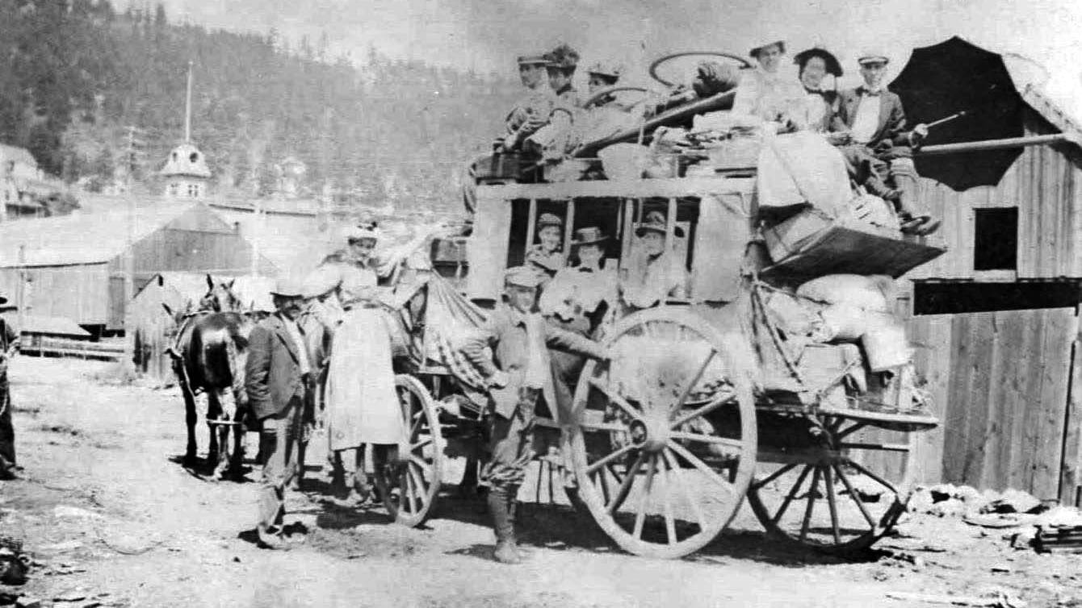
Image Courtesy: Deadwood History Inc.

During this activity, your students will learn about the often unglamorous and harsh realities of stagecoach travel. They will also participate in a hands-on activity in which they will use coaster wagons to investigate Newton’s 1st Law of Motion.
Process
- Introduce the activity by viewing photos and reading about a four-day stagecoach journey beginning on August 13th, 1878. The article introduces many challenges encountered by the passengers of the stagecoach as told through the diary of passenger Anna Gerard.
- During this hands-on activity, your students will learn about Newton’s 1st Law of Motion. You could try the following demonstration to introduce the concept.
Newton’s 1st Law of Motion states that an object at rest (velocity = 0) or an object moving at a constant velocity will remain at that velocity unless an outside unbalanced net force acts on it. Simply stated… an object that is at rest wants to stay at rest, and an object that is moving at a constant velocity wants to continue moving at that velocity.
- Complete a demonstration of Newton's 1st Law
- Watch an explanation of Newton’s 1st Law
- Discuss the 1st Law of Motion in relation to riding in a vehicle.
- Describe how they feel when the driver quickly accelerates. Does it feel like the seat is pushing them forward? What happens to a cup of coffee in the vehicle?
- How do they feel when the brakes are suddenly applied? What happens to cargo in the vehicle? What is the function of a seatbelt?
- How do they feel when the driver makes a sudden turn? Does the door push against them?
- Describe how items in a vehicle (like a cup of coffee, cargo, or a passenger) want to stay at rest, and an object that is moving at a constant velocity wants to continue moving at that velocity.
- The students will now participate in a hands-on activity in which they will use coaster wagons to investigate Newton’s 1st Law of Motion. Teams of 2-4 students will be given cargo which they must safely navigate through an obstacle course while testing their knowledge of Newton’s 1st Law of Motion.
Materials
- Obstacle Course – The area selected for the obstacle course should be a safe environment, free of trip hazards, low-hanging objects, and other safety issues. The obstacle course should provide many opportunities for acceleration, deceleration, and change in direction. Additional items could be added to the course, like a tire that would require the students to go around it. All selected items should be safe for the students. Wood, blocks, and other potentially dangerous items should be avoided.

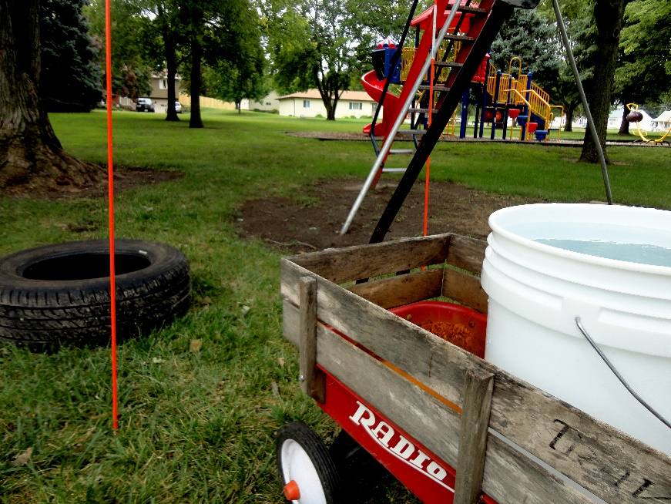
- Wagon – One for each group
- Cargo:
- Bucket of water (shown)
- Stack of toilet paper in the shape of a pyramid
- 2-4 eggs in the wagon with cans of vegetables and fruit
- Cans of vegetables and fruit stacked in the wagon
- Etc.
NOTE: There must be a way to quantify how well one group does in comparison to other groups. For example, comparing the amount of water that remains in each bucket, how many eggs are broken/cracked, etc.
- Stopwatch
- Notebook to record the time for each group
Procedure
- Divide the class into groups of 2-4 students: 4–8 groups.
- The game should be played in an open area, possibly a park or playground (free of trip hazards and low-hanging objects). The area may get wet; try to prevent slipping onto a hard surface. Load the wagons with cargo that can be quantified.
- One student from each team will navigate the course first. Then the student will return to the starting area, and another teammate will traverse the course. All members should participate.
- Scoring: Each team has the opportunity to score in two categories. Points will be given for safely moving the cargo and for time. The team with the least damaged cargo will be given the most points for cargo, and the team with the least time will be given the most points for time. See examples below.
Example Score Sheet for 6 Teams
Time (Note: Least time is 1st)
Time (place) | Points
1 | 6
2 | 5
3 | 4
4 | 3
5 | 2
6 | 1
Volume (Note: Most volume is 1st)
Volume (place) | Points
1 | 6
2 | 5
3 | 4
4 | 3
5 | 2
6 | 1
Total of 6 Teams for these Examples
- Team A was the first to finish but had the most damaged cargo.
- Score Team A: Time = 6, Safe Cargo = 1. Average score = 3.5
- Team B was third to finish and had the second safest cargo.
- Score Team B: Time = 4, Safe Cargo = 5. Average score = 4.5
Taking it to the Next Level
Incorporate the Spill-Not device into the discussion of acceleration, forces, etc.

Contact EdServices@sdpb.org for more information about SDPB’s educational resources.

Note: This document was made accessible with the help of the Gemini Enterprise.

