Albert Bernard Breck was an employee of the Homestake Gold Mine in Lead, South Dakota, when the Japanese attacked Pearl Harbor. In early 1942 he left his job at Homestake to join the war effort. He was 34 years old, married to Myrle Breck. They had three children, Evelyn, 5, Abbie, 4, and Betty, 3, which placed him in Selective Service Class 3.
With his extensive experience in mining, he was chosen for the then Top Secret Red Hill Underground Fuel Storage Facility being built near Honolulu, Hawaii. To construct the complex, the Navy used advanced mining techniques and employed over three thousand expert miners and laborers to carve out space several hundred feet deep in volcanic rock for 20 gargantuan fuel tanks, each big enough to hold an entire twenty story building!

The Red Hill facility is still in use today, storing more than 250 million gallons of fuel for the US Navy, Air Force and Marine Corps sea and air fleets stationed in the Pacific.

The project remained top secret until 1995, at which time the American Society of Civil Engineers designated the Red Hill facility a civil engineering accomplishment on a par with the Brooklyn Bridge, the Washington Monument, the Hoover Dam and other feats of American civil engineering. It has been called the "Eighth Wonder of the Modern World".

It was designated a National Historic Civil Engineering Landmark in 1995, and dedicated to the "Red Hillers", the miners and laborers who constructed it.
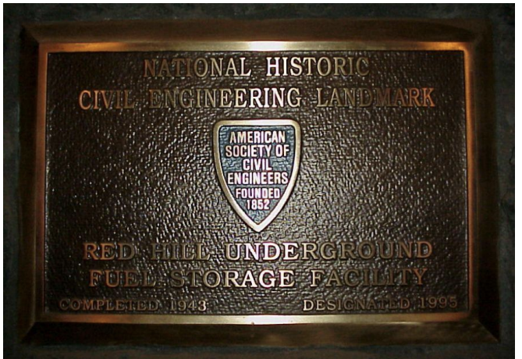
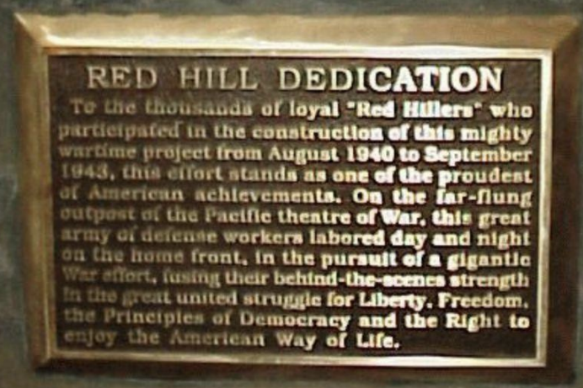
The dedication plaque reads:
"To the thousands of loyal "Red Hillers" who participated in the construction of this mighty wartime project from August 1940 to September 1943, this effort stands as one of the proudest of American achievements. On the far-flung outpost of the Pacific theatre of War, this great army of defense workers labored day and night on the home front, in the pursuit of a gigantic War effort, fusing their behind-the-scenes strength in the great united struggle for Liberty, Freedom, the Principles of Democracy and the Right to enjoy the American Way of Life."

The Red Hill project was finished nine months ahead of schedule, so Al returned home briefly before boarding a train to Minneapolis, where he joined the Merchant Marines.
Here he is aboard the train departing from home, saying "Farewell for now" to his wife and daughters.
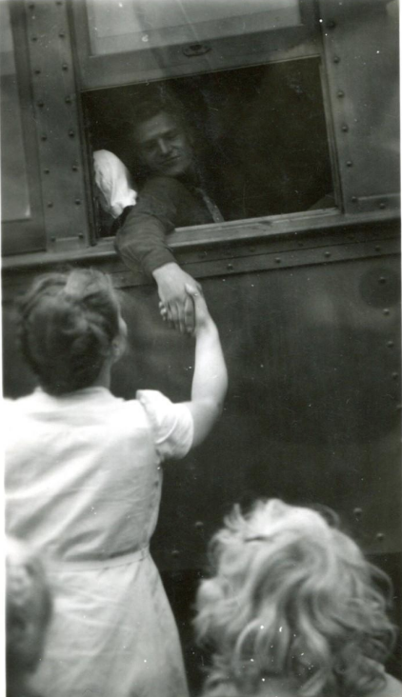

After training at the US Maritime Graduate Station in Brooklyn, NY, while awaiting assignment to a sailing ship, Al was sent out into the streets of Brooklyn on bond detail. In a letter home he wrote that he sold a lot of bonds, and "was nearly a wreck; my feet are in bad shape from the walking involved." His efforts were acknowledged by the War Finance Committee for New York.
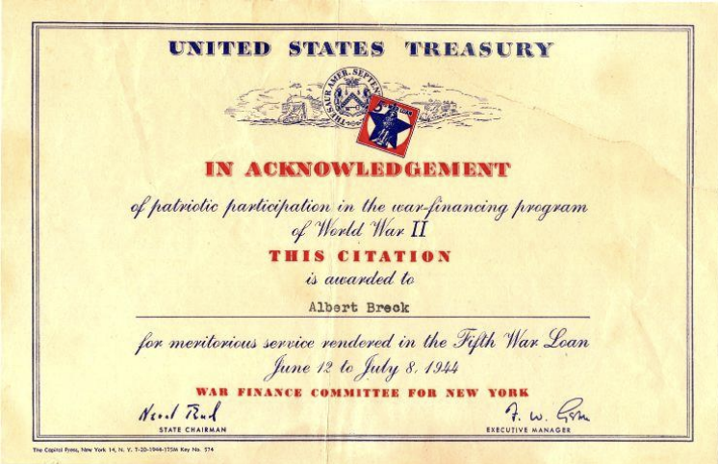
In his Merchant Marine service, Al was assigned first to the SS Watertown, then the SS Wahoo Swamp.
The Merchant Marines played a key role in transporting the troops and war materials that enabled United States and Allied Forces to turn the tide of victory against the Axis powers.

As a 2nd Class Seaman whose specialty was Messman, Al helped prepare a traditional Thanksgiving feast for the homesick sailors on board the Wahoo Swamp in 1944. The menu included all the usual Thanksgiving trimmings and more.
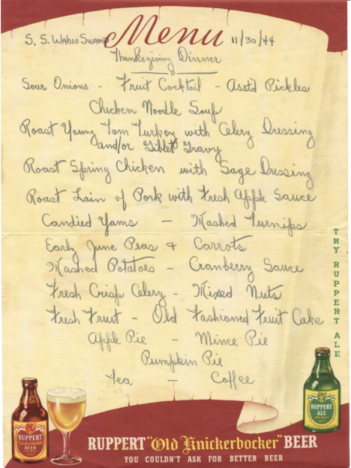

It was during this time that Al penned a poem on a brown paper bag, entitled it "Alone", and dedicated it to his faraway family
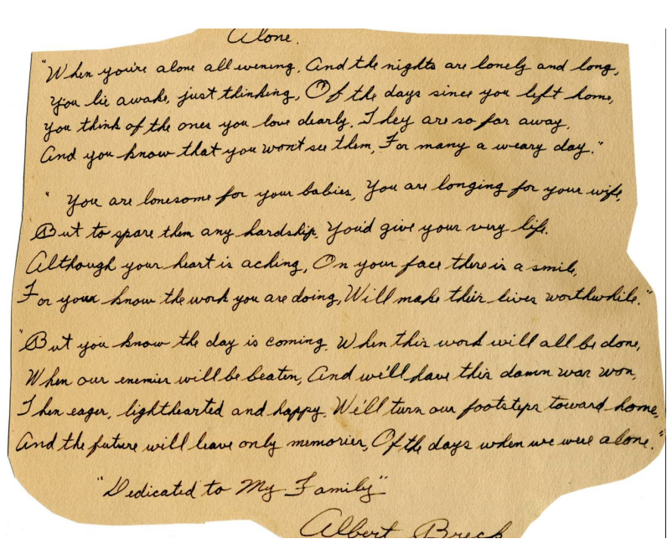
"Alone"
When you're alone all evening, and the nights are lonely and long,
You lie awake just thinking, of the days since you left home.
You think of the ones you love dearly. They are so far away.
And you know that you won't see them, for many a weary day.
You are lonesome for your babies, you are longing for your wife,
But to spare them any hardship, you'd give your very life.
Although your heart is aching, on your face there is a smile,
For you know the work you are doing, will make their lives worthwhile.
But you know the day is coming, when this work will all be done,
When our enemies will be beaten, and we'll have this damn war won.
Then eager, lighthearted and happy, we'll turn our footsteps toward home,
And the future will leave only memories, of the days when we were alone.
"Dedicated to My Family"
Albert Breck

Al's letters home mentioned ports of call in exotic places such as Aruba, Cuba and the Panama Canal Zone, as well as San Francisco, New York City and Baltimore. His young daughters responded to those letters with letters of their own, written with excitement and enthusiasm.
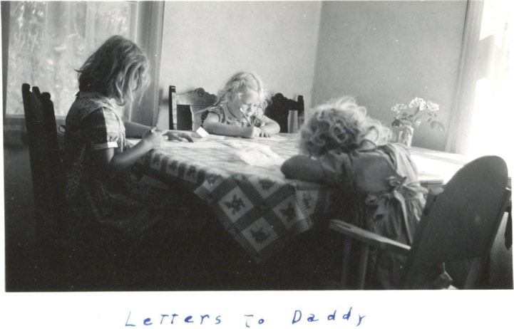
Al received his discharge from the Merchant Marines at the end of the war in 1945.
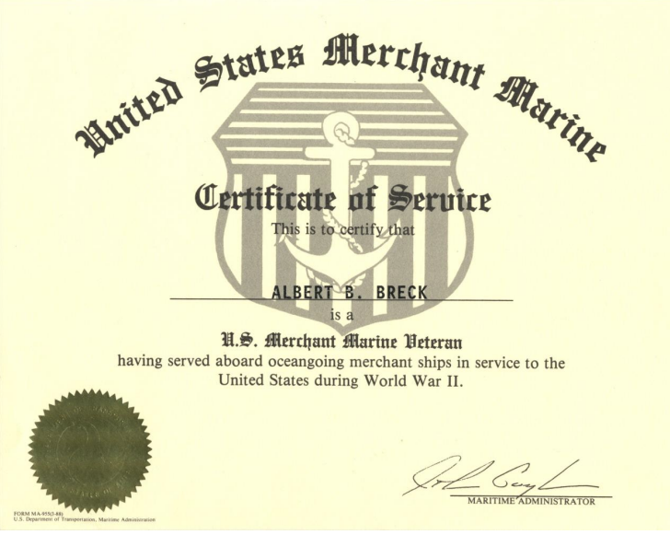
When the Merchant Marines were retroactively made a part of the US Coast Guard in 1988, Al received his Honorable Discharge from the US Coast Guard.
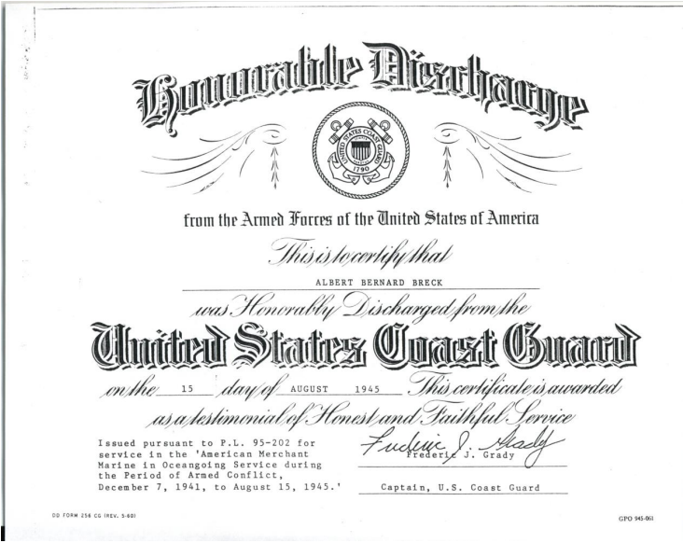
Al's family is proud of his contribution to the war effort as a miner, Merchant Marine, bond salesman, and cook. It was the combined efforts of everyone that resulted in victory and the preservation of our freedom. His family feels he did indeed help "make their lives worthwhile", as he expressed in his poem "Alone".

