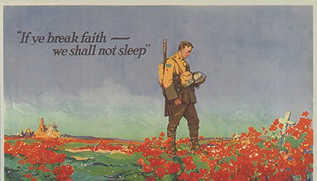

Taps Delayed
by Harry E. Nollsch

Last January I stood on a gentle slope in a cemetery in Knoxville, Tennessee. Looking downward at a grave marker, my thoughts flew back fifty years. I seemed to see a handsome young sergeant who piloted a small observation plane. We had been in North Africa a short time and hadn't seen enemy action as yet. I was his crew chief, and he often took me with him when flying. We became close friends. He often talked of his wife and baby girl. One afternoon several of us climbed into a half-track vehicle and went swimming in a river some miles from our bivouac area.

When we returned we were met by several of the soldiers in our outfit. "Did you hear the news?" they asked. "Sgt. Still was killed in a plane accident this afternoon." He and I shared the same pup-tent. That night as the full moon rose, I looked across at the empty space beside me. Sobs shook my body. I had memorized his parents home address and intended to write to them, but never did. Now as we drove through Knoxville I knew I must try to locate some member of his family. We found his brother, William, on the third call. "Can I meet you somewhere, so we can visit?" he asked. We met at Shoney's Restaurant and lunched together as we were getting acquainted. Later we followed him as he drove to the cemetery. As we stood by the grave of his brother, I felt that some loose ends had been tied. A fifty year debt had been paid at last!

