A Wall Story
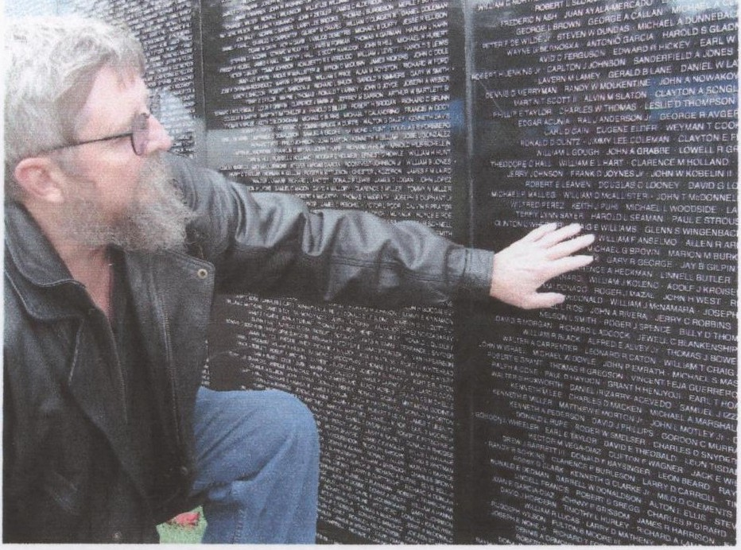

A Visit to the Vietnam Memorial Moving Wall
By: Dan F. Horner

It was a clear, cold, windy day. I was feeling an odd mix of youth, and every one of my 62 years. My wife and daughter were with me as I walked down the hill into the natural grassy bowl. A long black wall stood before us. Feeling uncomfortable at first, I busied myself finding names of people from my home town, and people that I had promised to find for friends and acquaintances. I took pictures and some rubbings of the names as I found them.
Having put off feeling for as long as possible, I went back to the panel bearing the names Noel Rios and William Anselmo. I remembered their faces and realized how young they were. They seemed so much older back then. I thought of C-130s' and 123's. I thought ofDanang, Khe Sanh, and so many other things from so long ago.
I reached out and touched Bill's name etched into the wall. It must have come from somewhere deep within me, but I cannot say for sure. As my fingers touched Bill's name, an almost warm, almost electric pulse traveled from my fingers, and up my arm. It must have made it to my heart, because I cried. I think it was the first time I had cried for them. I don't know if I spoke to them in that instant or they talked to me, but for that short time we were together again.

