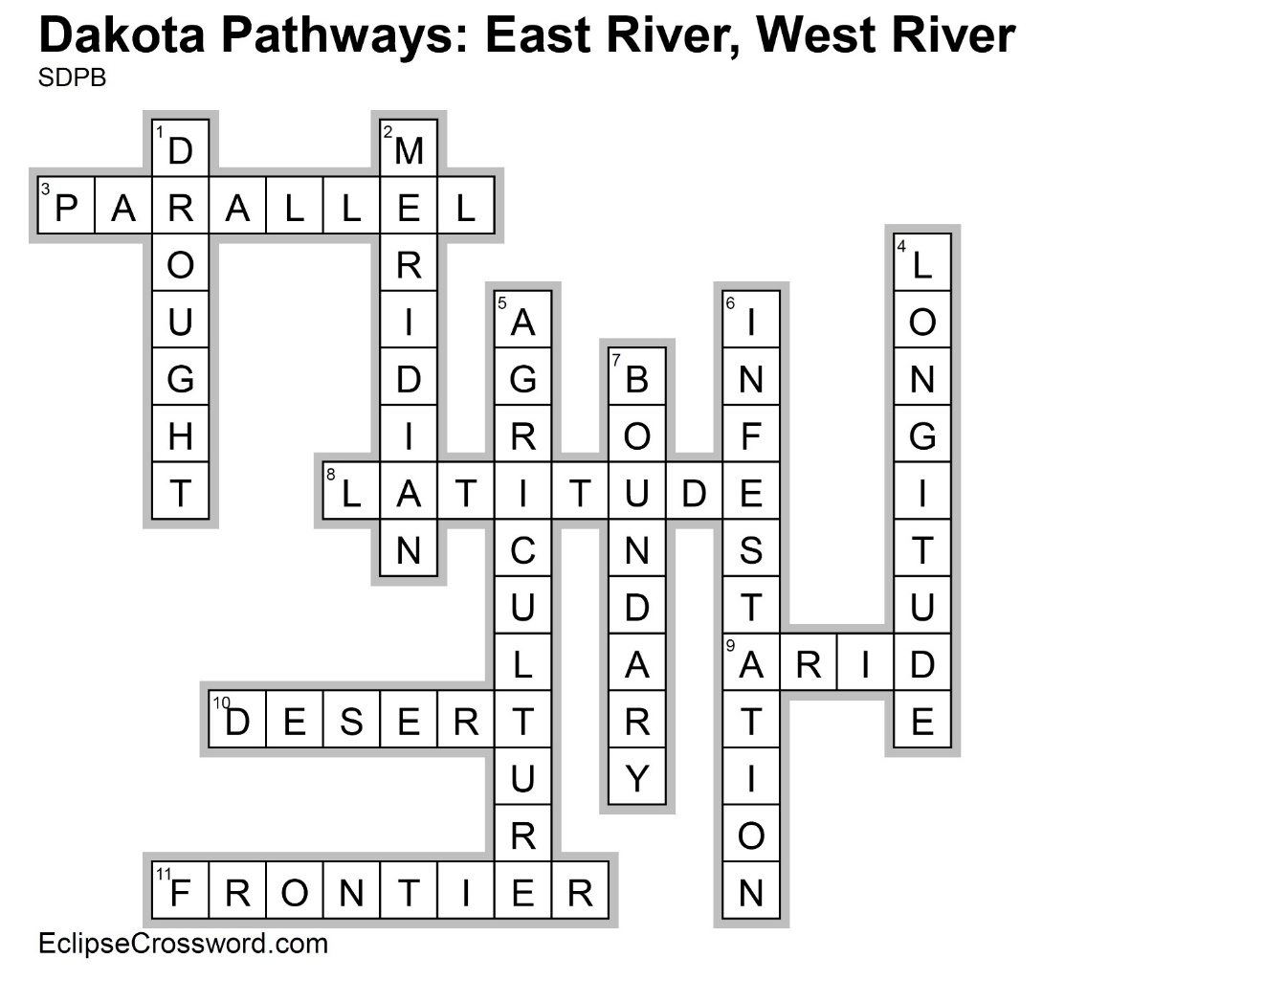

|  |  |
| --- | --- |
| **Across**  3. PARALLEL — Another name for lines of latitude, which run east and west on the map  8. LATITUDE — Parallel lines starting at the equator measuring distance north and south  9. ARID — Lacking moisture; not enough rain  10. DESERT — Dry, barren, and often sandy region  11. FRONTIER — The extreme limit of settled land beyond which lies wilderness, especially referring  to the western US before Pacific settlement | **Down**  1. DROUGHT — Prolonged period without precipitation  2. MERIDIAN — Another name for lines of longitude, which run north and south on the map  4. LONGITUDE — Meridian lines starting at the  Prime Meridian measuring distance east and west  5. AGRICULTURE — Science, art, and business of producing crops and raising livestock  6. INFESTATION — Spread of something harmful  7. BOUNDARY — Something that indicates a border or limit |