Great Depression Photo

Still Sparks Debate

Edited Photos: Say What You Want to Say
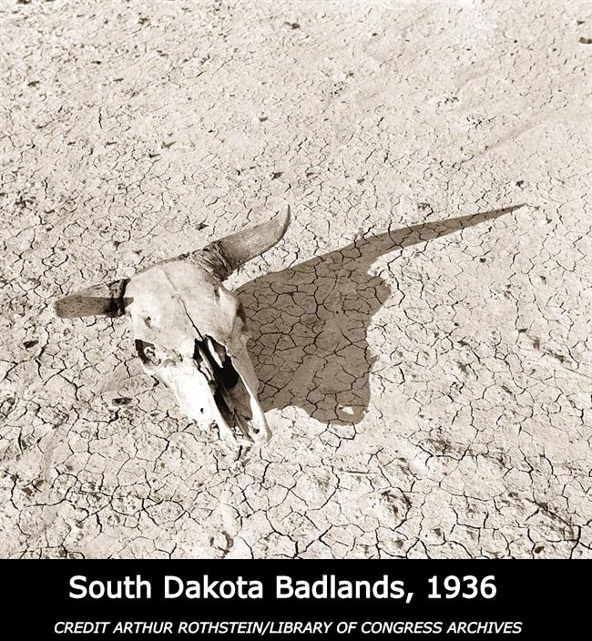

During this activity, your students will learn about Farm Security Administration photographer Arthur Rothstein’s famous 1936 bleached steer
skull and other staged or edited images. They will also use a photo editing program or other techniques to manipulate a photo to convey a given feeling or expression.
“Digital technology makes it easy for photojournalists to alter and change photographs. In a 2006 image distributed by Reuters, a photographer copied and darkened smoke to exaggerate bombing damage in Beirut. During the early days of the Iraq invasion, the Los Angeles Times published a photo that combined two photographs taken seconds apart to improve composition.

Faking and staging photos is nothing new. In 1936, Farm Security Administration photographer Arthur Rothstein moved and photographed a bleached steer skull at several locations in the Badlands to convey devastation during severe drought. Opponents of President Roosevelt’s New Deal criticized the image as government propaganda. Rothstein’s photo of what critics called the perambulating skull is included in an exhibit at the Bronx Documentary Center, Altered Images: 150 Years of Posed and Manipulated Documentary Photography.”

[NOTE: The Bronx Documentary Center, Altered Images: 150 Years of Posed and Manipulated Documentary Photography exhibit has expired. However, it does not affect the SDPB Radio interview or the activity on the following pages.]

- Introduce the activity by listening to an interview about how Arthur Rothstein moved and photographed a bleached steer skull.

- Next, using a projector, display the images below and watch the videos - What happens when Photoshop goes too far? and 'Full Measure': 'Altered Images.'

  - 2006 image distributed by Reuters, a photographer copied and darkened smoke to exaggerate bombing damage in Beirut (Images).
  - In 1936, Farm Security Administration photographer Arthur Rothstein moved and photographed a bleached steer skull at several locations in the Badlands to convey devastation during severe drought (Image).
  - What happens when Photoshop goes too far? (PBS video with photos)
  - 'Full Measure': 'Altered Images' (CBS video and photos)

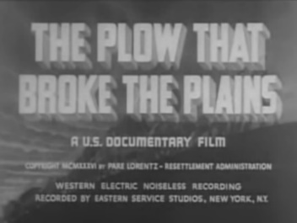
Still from Film

- If time allows, view THE PLOW THAT BROKE THE PLAINS, A U.S. Documentary Film

- Learn about Dorthea Lange’s iconic image, Migrant Mother, described in the radio interview. (More information at “Whose Migrant Mother Was This?”

- Activity - Your students will manipulate/alter images by using physical methods or by using photo editing software to convey a specific feeling, topic, issue, or expression. Images can be persuasive if used correctly - helping sell products, proving a point, or influencing others. (Note: The activity is designed for MS/HS-aged students. The topic could be introduced and discussed with younger students to build awareness of how photos can be used to convey a message.)

  - With your students, formulate 5-10 feelings, topics, issues, or expressions. It might be helpful to view a newsfeed for topics.

    - Examples
- Sadness - Taller
- Population Decline - Older
- Cold - Heat Wave
- Inspirational - Reduction in Size
- Conflict - Smaller Crowd
- Anger - Large Precipitation
- Safety Concerns - Increase Population
- Larger Crowd - Savory (Food Ads)
- Ballot: Tax Increase (Park Improvements)
- Equipment/Harvest (Safety Concerns)
- Smaller or Larger
  - Each student will select one of the items from the list. Images should be taken by the students to avoid copyright issues.
  - Both the original photo and the altered photo should be displayed together, with an explanation of the changes – like the Bronx Documentary Center display.

Taking it Further

- The students could display their photos without the explanation, allowing the other students to guess which feelings, topics, issues, or expressions are represented. Then each student could identify the change and explain how they tried to convey it.
- Below are a few examples.

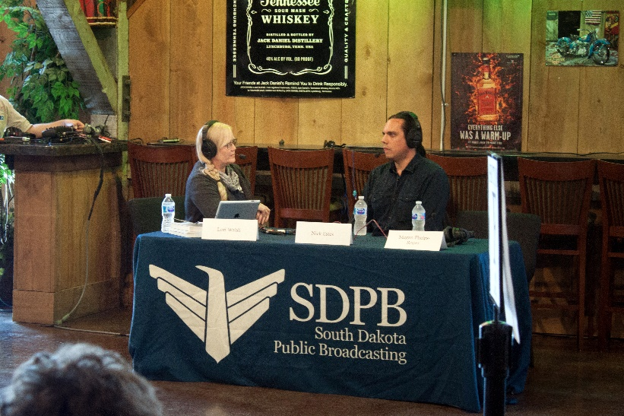

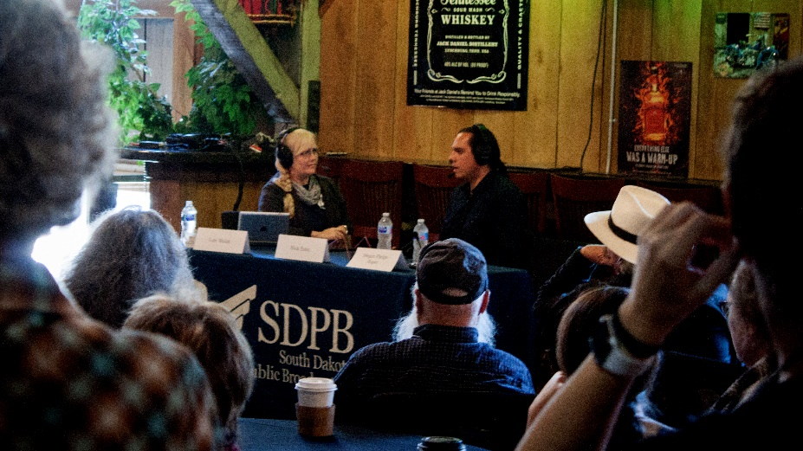

Large Crowd - The camera angle was lowered and taken from further back to suggest the crowd was very large and blocked the view. The photo was also darkened slightly to soften the mood for a sense of closeness. The photo was cropped to 16X9 to suggest a tighter space.
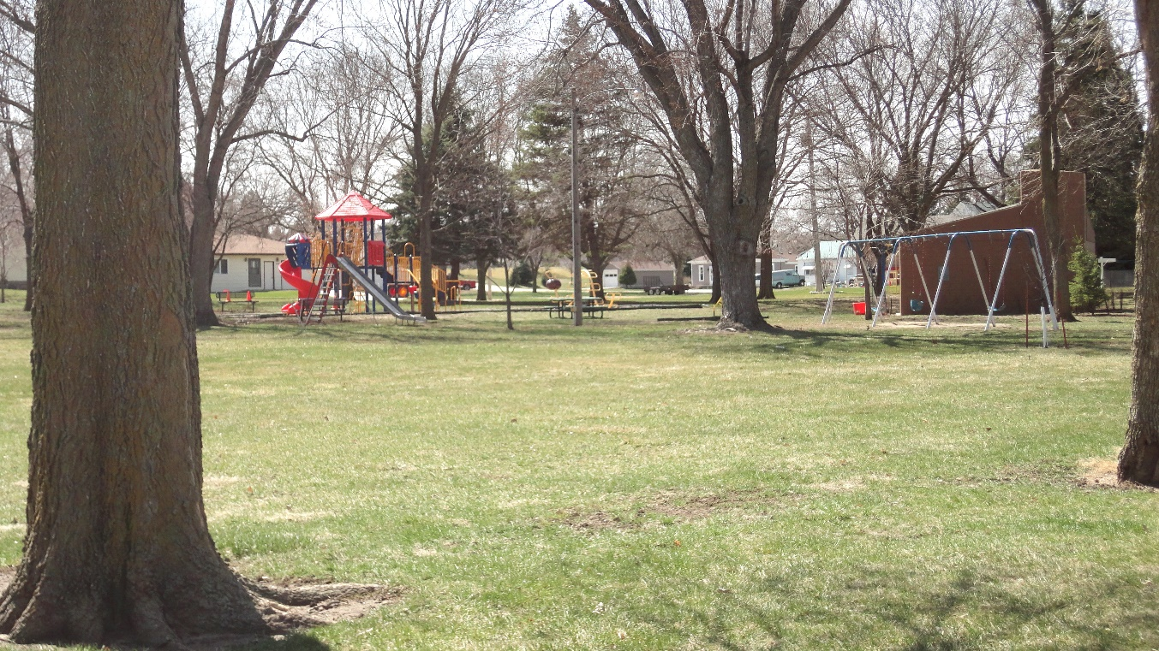

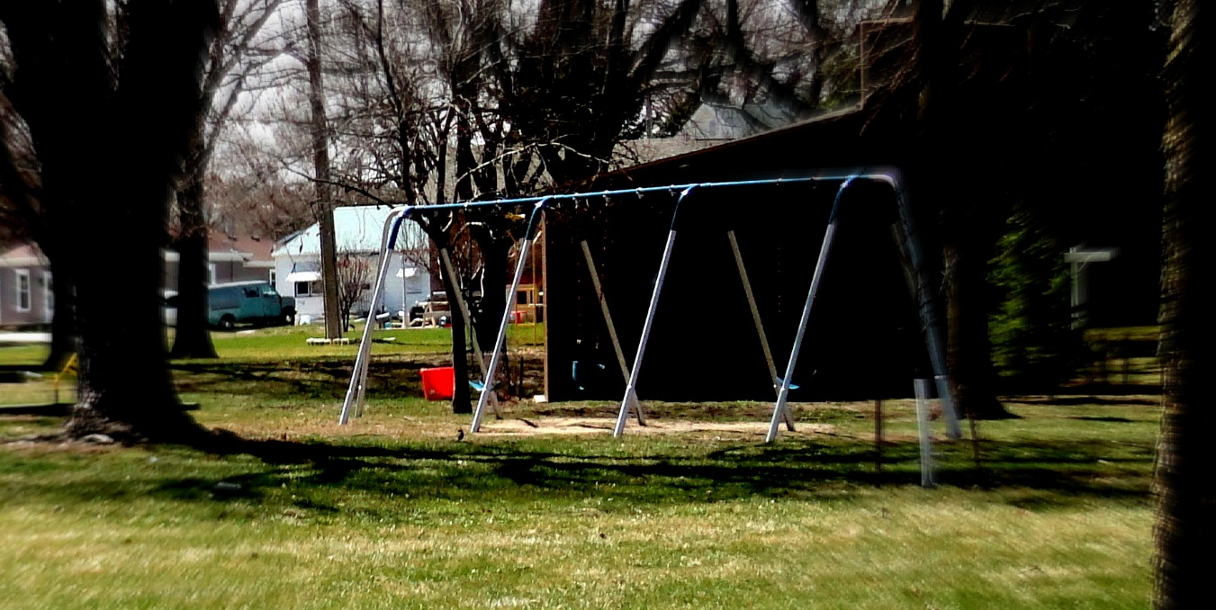

Tax Increase on Ballot - Park Improvements Needed: The photo was cropped to highlight an older swing set with a missing swing. Newer equipment is not shown. The photo was darkened to make it look later in the day or colder, making it less inviting. The edges were also blurred. An older model van is shown in the background.

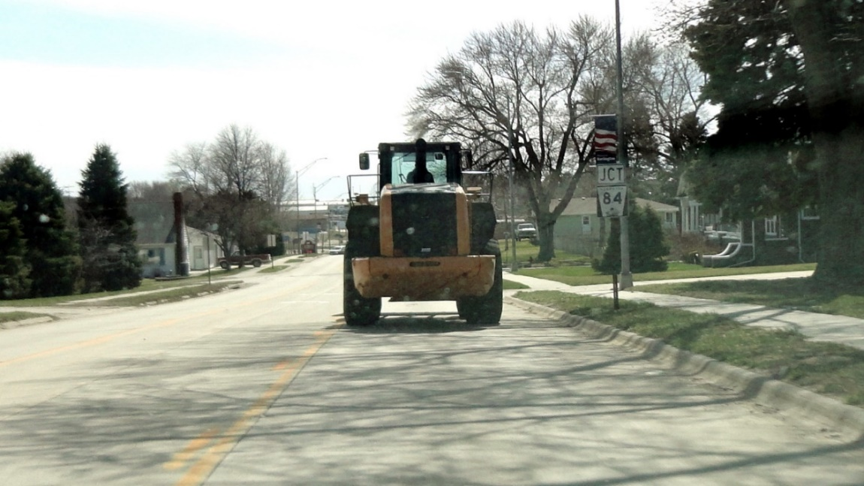

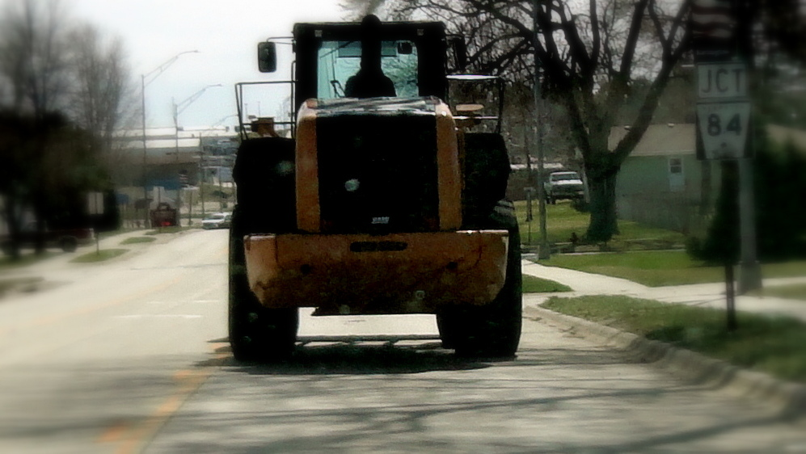

Heavy Equipment or Harvest - Safety Concerns: The photo was cropped to suggest the equipment is very large, obstructing the view. The edges were also slightly blurred to focus on the equipment and to suggest an obstructed view. The photo was darkened to suggest a decrease in the ability to see clearly.



