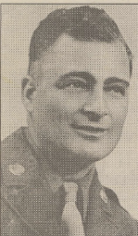
The American Legion Auxiliary Greer Post #11 is honoring Laverne Mazourek as July Veteran of the Month.
Mazourek entered the service in March 1941 and served until October 1945, 22 months of which was spent in Europe. He received basic training at Fort Meade, where he trained with the horses. They then took 300 head of horses and trained in the swamps of Louisiana.
He then trained with tanks on the Mojave Desert in California.
He went by ship to England where the soldiers water-proofed the vehicles, being one of the first mechanized units to land on Utah Beach. He was in the Fort Cavalry Reconnaissance Unit. He went by tank into Germany being in the unit which took Aachen, the first major city in Germany to be taken by the allies. He saw action at the Siegfried line but of course could not get through. Mazourek remembers once, while on a road block, during a quiet time, he decided to clean his weapon when a shot rang out and his bedroll, which had been tied to the turret, fell off. Needless to say he finished the cleaning quite rapidly. He also remembers being bombed by our own Air Corps. He remembers being on the front line and given a half hour to move back three miles, as it would be bombed, as soon as the bombers went through they would again take off and move forward again. The enemy also moved the three miles with the bombing being done behind them so that when the allies moved again they encountered them.
Mazourek feels the war was an exciting experience but not one he would like to experience again.
Mazourek was in the combat zone for 337 days and advanced a total of 1,200 miles. His commendations include five battle stars, one for each campaign, one of which was for the distinguished unit award.
After he returned from the service he worked on building construction, in the Ford garage and he farmed for many years. He is retired and now enjoys woodworking, fishing and working in his yard. He is a life member of Greer Post #11 and a charter member of the VFW. Mazourek and his late wife Delores have four children and 10 grandchildren. Thank you, Laverne, for being the July Veteran of the Month.
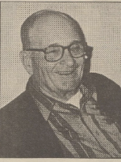
THE WAGNER POST
WEDNESDAY, JULY 15, 1998 PAGE 5

