Class Activity – Tall Tale
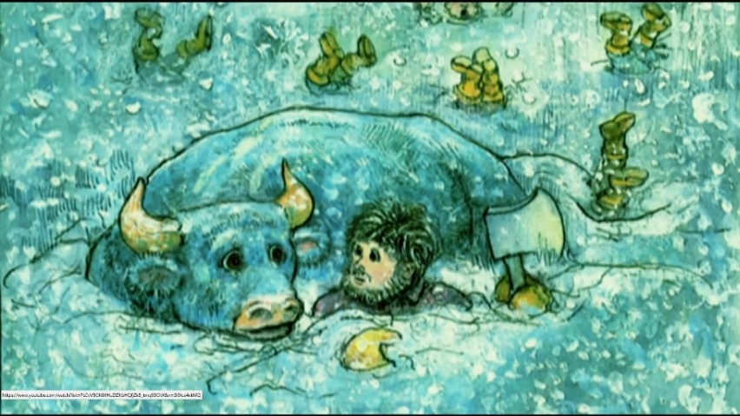
There are many ways that history is passed on from generation to generation. In today’s world, people learn about history by reading books, watching television, reading material from the Internet, or checking their phone. But these weren’t always the ways that people learned history.
A major way that history was passed down from generation to generation was through stories. Young children would learn about the history of their cultures by listening to stories.
A lot of times the information changed from story to story. And a lot of times, the stories became larger than life. Sometimes people or things in these stories were able to do extraordinary things that were sometimes hard for people to believe. These stories are called myths and legends.
Have you ever heard a myth that you had a hard time believing was true? If so, you aren’t the only one. Myths have confused, and entertained, people for thousands of years.
You will write and illustrate your very own “tall tale” set in South Dakota. Have some fun and be creative.

