Three Sioux Falls Schools - 1928

Point of View: First & Third Person
A promotional film shot in 1928 for the city of Sioux Falls lauds three of the city's schools: Columbus College, a private Catholic school that closed in 1929, Washington High School, and Augustana College.

The buildings and grounds of Columbus College were purchased by the Federal Government in 1948. The site is now the home of the Royal C. Johnson Veterans Memorial Hospital. Washington High School, shown in the video, is now the Washington Pavilion of Arts and Sciences. Training students to become teachers was one of the primary missions of Augustana College in 1928, and that mission continues today at Augustana University.

During this activity, your students will practice writing using the first and third person points of view. They will learn how pronouns like I, me, my, mine, myself, we, us, and ours are used to write the first person point of view. They will also learn how pronouns like them, they, he, she, his, her, and theirs are used to write the third person point of view.

Process:

- Introduce the activity by showing the “Three Sioux Falls Schools - 1928” video.

- There are two groups of students shown in the video footage. At first glance, the massive groups seem to flow together into an ordinary assemblage. Although under close observation, individual students (characters) emerge from the video. Each student in the video has a unique life (history) that shapes their actions and viewpoints about the video footage recorded that day. The following three examples show students acting in unique ways.
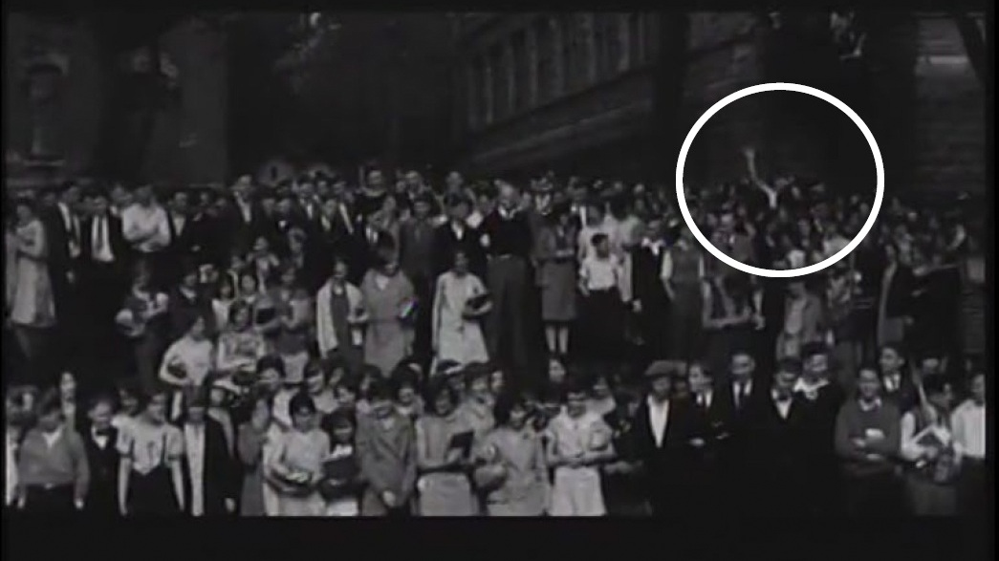
At 01:38, only one student was waving.

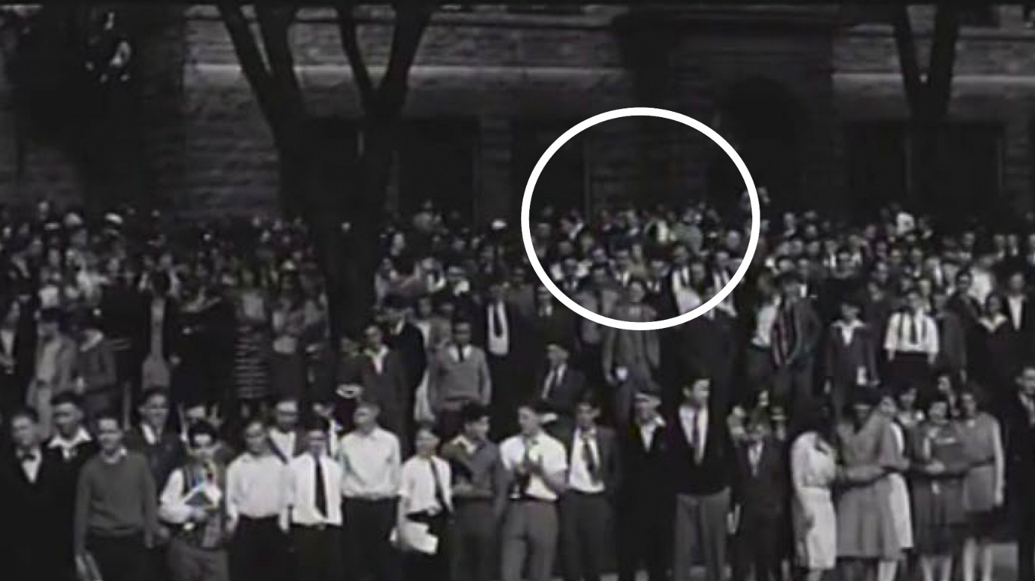
At 01:49, a group of about 8 students were running around for no apparent reason.

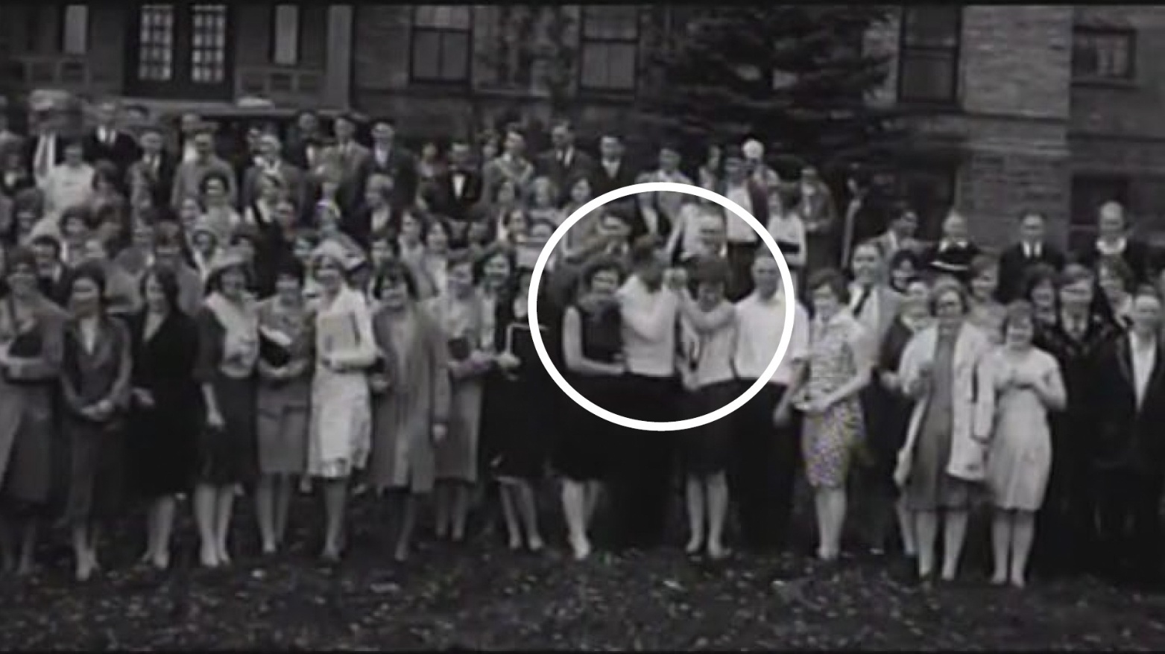

At 02:44, two students seemed to be messing around.

- Your students should view the video and select a student from the video that they will hypothetically become. Use the video as a story starter. Assume the student works for the student paper, and they are required to write about the day.

- Two blog posts should be written about the day, including feelings about the gathering and about being captured on video (which, unlike today, is unusual for the time), the weather, etc. The first blog entry should be written in first person; the second entry should be written in third person. Encourage creativity.

Contact EdServices@sdpb.org for
more information about SDPB’s educational resources



