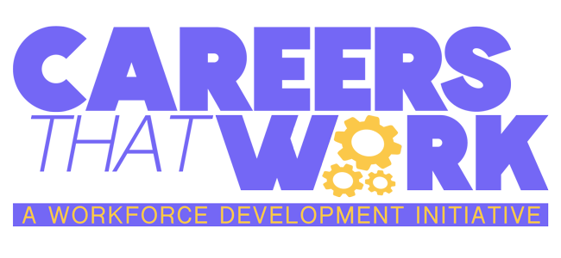


Lesson #2 - Careers that Work: Licensed Professional Counselor
Subject: Application of Career Specific Skills - Active Listening
Grade Levels: 7th grade - 12th grade

Standards
CC.1.5.8.A - Engage effectively in a range of collaborative discussions, on grade-level topics,
texts, and issues, building on others’ ideas and expressing their own clearly.
CC.1.5.9–10-12.A - Initiate and participate effectively in a range of collaborative discussions on
grade-level topics, texts, and issues, building on others’ ideas and expressing their views on
these topics.
CC.1.5.7-12.E - Adapt speech to a variety of contexts and tasks.
CC.1.5.7-12.G - Demonstrate command of the conventions of standard English when speaking
based on grade level and content.
13.1.8.A-B - Relate careers to individual interests, abilities, and aptitudes.
13.1.8.D - Explain the relationship of career training programs to employment opportunities.
13.1.8.E - Analyze the economic factors that impact employment opportunities, such as, but not
limited to
• Compensation
• Geographic Location
• Global Influences
• Job Growth
• Job Openings
• Labor Supply
• Potential Advancement
• Potential Earnings
• Salaries/Benefits
• Unemployment
13.1.8.F - Analyze the relationship of school subjects, extracurricular activities, and community
experiences to career preparation.
13.3.8.D – Analyze budgets and pay statements, such as, but not limited to:
• Charitable Contributions
• Expenses
• Gross Pay
• Net Pay
• Other Income
• Savings
• Taxes
13.3.8.E – Identify and apply time management strategies as they relate to both personal and
work situations.
13.3.8.G – Identify formal and informal lifelong learning opportunities that support career
retention and advancement.

Objectives
Describe “active listening.”
List one non-verbal cue that shows someone is genuinely listening
Duration
1 class period, approximately 40 minutes.

Activities
Divide students into groups of 3. Each group will appoint a speaker, a listener, and an observer.
Ask the speaker to spend one minute describing a time they felt challenged.
During this time, the listener should only listen. They should not react, reply, or suggest anything to the speaker. If the speaker asks a question, the listener may respond non-verbally (e.g., nodding).
The observer should not interact with either the listener or the speaker but should observe the non-verbal cues given by the listener.
Give each student a chance to play each of the roles.
At the end of the exercise, hold a class discussion. Ask the following questions:
How did it feel to be the listener? The speaker? The observer?
How much did you use non-verbal cues? Did they come naturally to you?
As the speaker, what non-verbal cues were most effective? Were there any non-verbal cues that distracted you?

