Controlling Density: Ballast Tank
During this activity, your students will learn how submarines use ballast tanks to change their density resulting in ascending and descending in water.
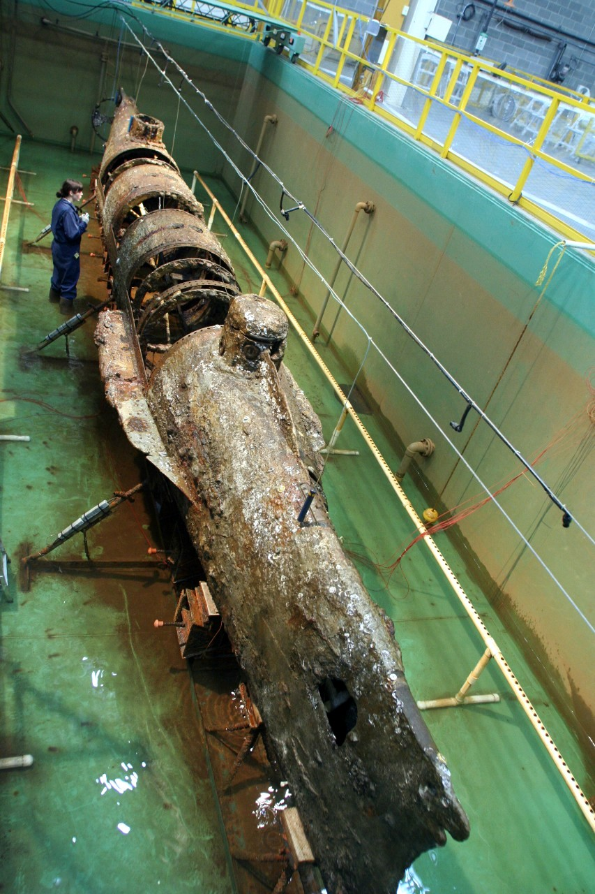
H. L. Hunley in Conservation Tank (Photo from Naval History and Heritage Command)

Lesson summary
They will also learn about the sinking of the American naval ship, the USS Maine, on February 15, 1898, and how Congress declared war on Spain on April 25, 1898. Finally, they will learn about the South Dakota soldiers at Camp Dewey of Sioux Falls and their involvement in the Spanish-American War.

Time allotment
Class Demonstration: 10 Minutes
Class Activity: 50 minutes

Learning objectives
- Students will learn about ballast tanks and how submarines use them to change their density resulting in ascending and descending in water.
- Students will learn about the Spanish-American War.
- Students will learn about the submarine, H.L. Hunley.

Prep for teachers
- Gather materials for the activity in the Supplies section below.
- Access the video clips and additional information below.

Supplies
- Video clips and background information
  - Camp Dewey, Sioux Falls, 1898 (About the USS Maine)
  - The idea for this activity originated from a Teaching Guide presented by Scientific American Frontiers called Beneath the Sea: Blowing Ballast.
    - Related video – Episode #5 (Mysteries of the Deep - The H.L. Hunley)
    - Related video – Episode #7 (Alvin the submersible)
  - Below is a list of materials for a submarine model (it will vary depending if you use this as a demonstration or a lab activity).
    - Items used to make the model: (Example Video)
      - Plastic tub with locking lid (easy storage)
      - Fish aquarium tubing
      - 20 oz. pop bottle
      - Fishing weights (lead-free)
      - Packing tape/plastic baggy (secure weights)
      - Aquarium valve (optional)
      - Small pump
      - Balloons
      - Duct tape
      - Zip ties
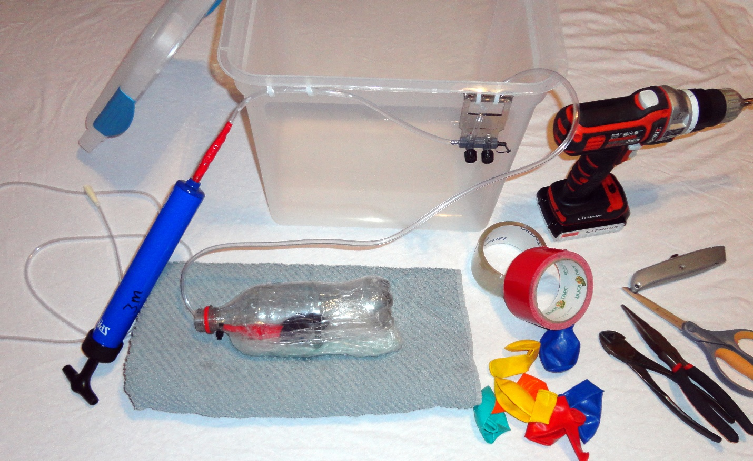

Introductory activity
Introduce the activity by reading about Camp Dewey. The USS Maine entered Havana Harbor on a goodwill visit to the Spanish Colony of Cuba on January 25, 1898. Three weeks later, on February 15, 1898, a massive explosion destroyed the battleship at anchor. An American court of inquiry concluded that Maine was sunk by a mine explosion under the forward magazine. Congress declared war on Spain on April 25, 1898, and America embarked upon what Secretary of State John Hay termed “the splendid little war!” President William McKinley asked for 125,000 volunteers for service in the war. South Dakota’s quota was to supply 1,000 men.
- Camp Dewey, Sioux Falls (About the USS Maine)
- Discuss density in relationship to buoyancy (boat – sink/float). A ship will sink if the air in the hull is replaced by water.

Learning activities
Try the demonstrations below in your class.
- Liquid Flax Demo
- Sink/Float Test - Place a diet can of pop and a regular can of pop in a water container. The regular soda pop (with sugar) will sink because it has a higher density than water. The diet pop will float because it has a lower density than water.
- Try the following demonstration – Do bowling balls sink or float? Both - in general, a bowling ball that is less than 12 lbs. will float, a ball that is more than 12 lbs. will sink, and a ball that is 12 lbs. will hover almost perfectly because it is very close to the density of water. Note: The density of a watermelon is very close to the density of a 12 lb. bowling ball.

Culminating activity
The following activity could be assigned individually, as a group, or completed as a demonstration for the entire class.
- Complete the following activity individually or as a group.
  - The idea for this activity originated from a Teaching Guide presented by Scientific American Frontiers - Beneath the Sea Blowing Ballast
    - Related video – Episode #5 (The Hunley submarine)
    - Related video – Episode #7 (Alvin the Submersible)
- Complete the following activity as a demonstration for the class.
  - Below are a series of photos showing an example of a submarine made from items on the list below.
    - Items used to make the model: (Example Video)
      - Plastic tub with locking lid (easy storage)
      - Fish aquarium tubing
      - 20 oz. pop bottle
      - Fishing weights (lead-free)
      - Packing tape/plastic baggy (secure weights)
      - Aquarium valve (optional)
      - Small pump
      - Balloons
      - Duct tape
      - Zip ties
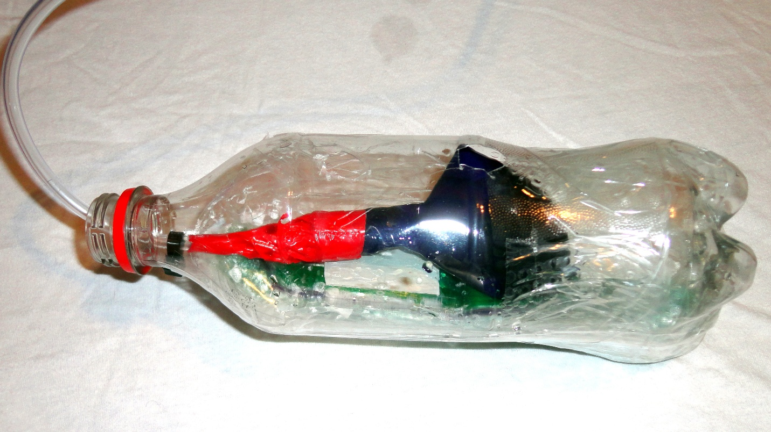
The photo above shows a 20 oz bottle with aquarium tubing and a balloon (ballast tank).
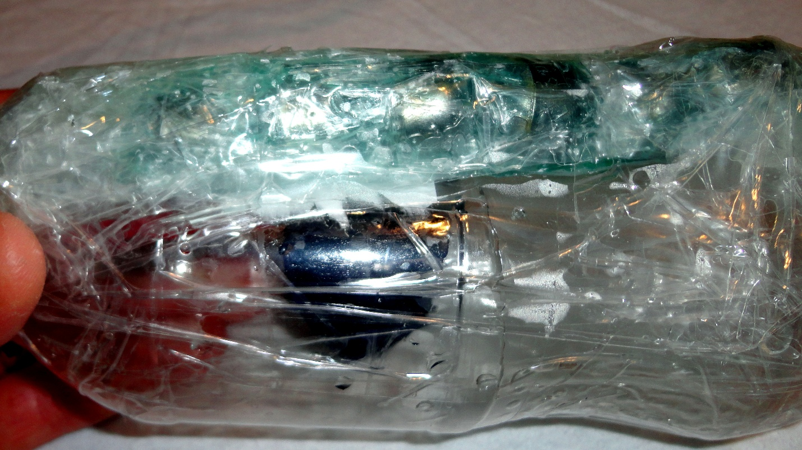
Fishing weights are attached to the bottom of the submarine (pop bottle) using packing tape, which will increase the density of the submarine.
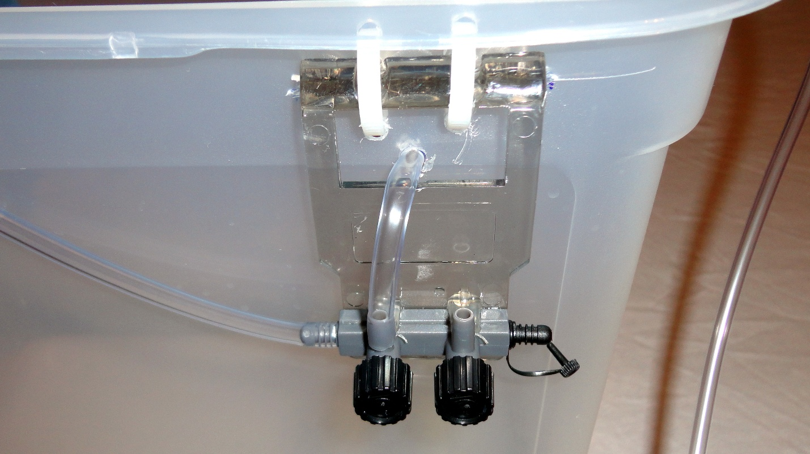
The aquarium valve and tubing to control airflow are shown above.
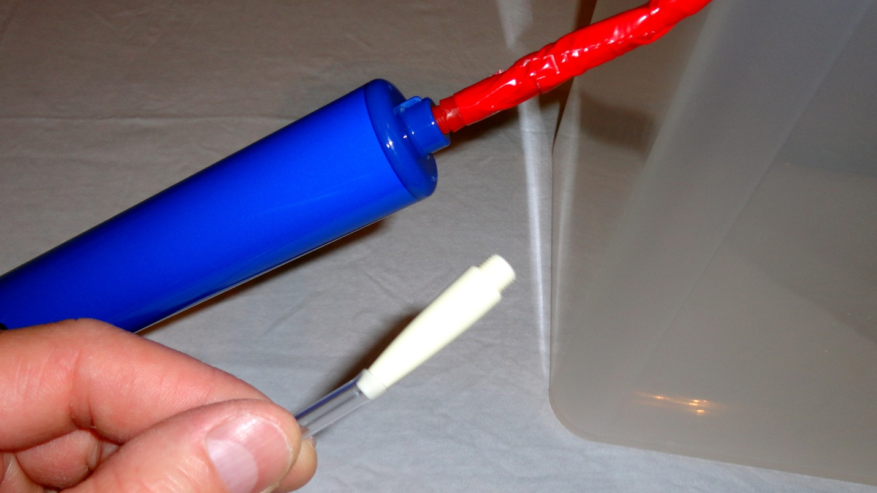
The air pump and adaptor are shown above.
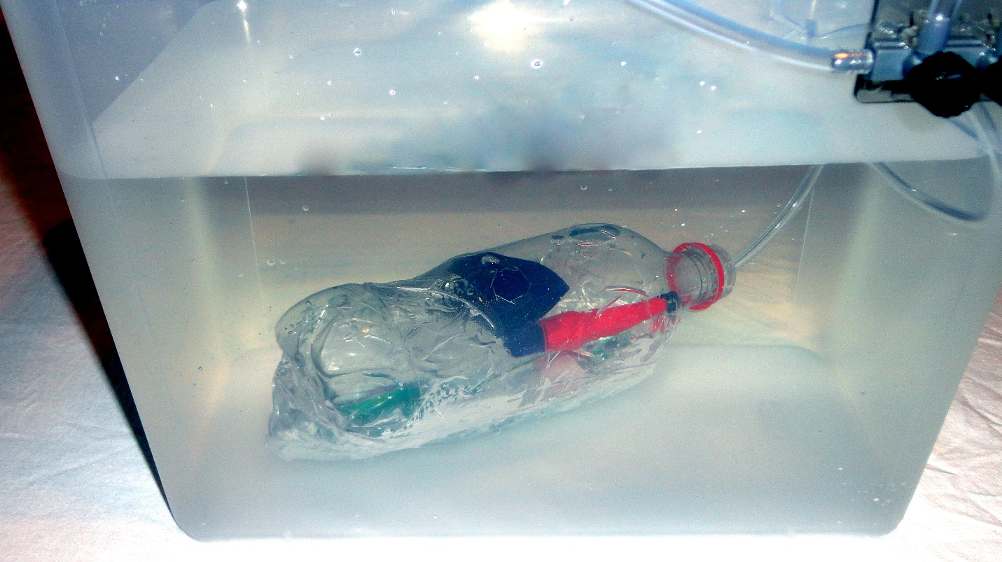
Above, the submarine's density is greater than the density of water (the bottle sinks).
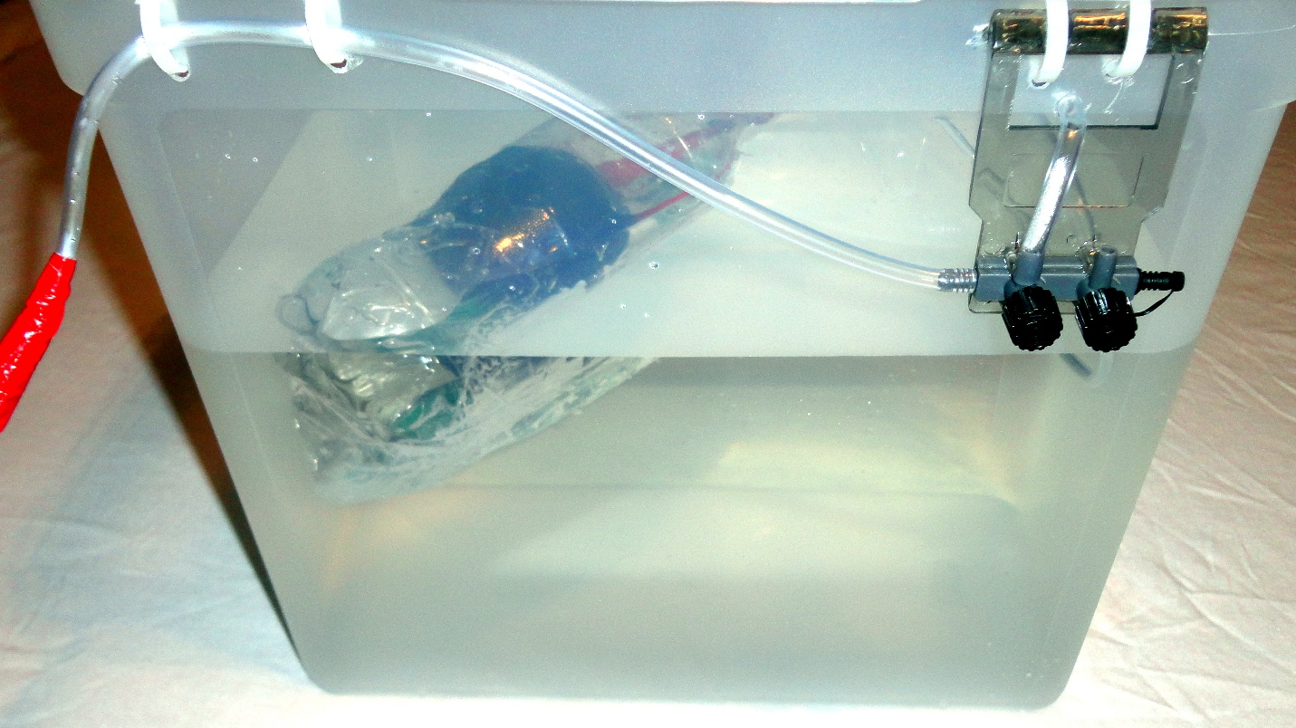
The size of the balloon is increased, and water is displaced, which decreases the density of the submarine (the bottle floats).



