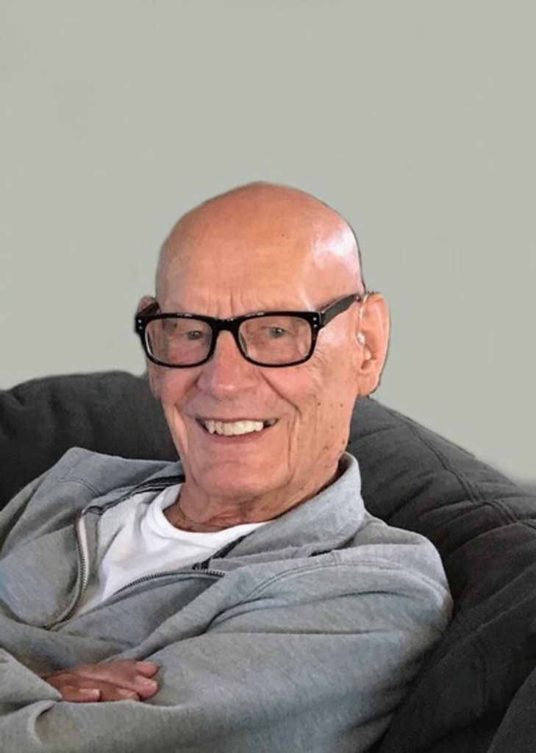
James Memory Martin
March 5, 1926 – September 24, 2023
James Memory Martin, Jr. (Jim) was born March 5th, 1926, in Deadwood, SD to parents James M. Martin and Alice Josephine (Hagen) Martin. He and his younger brother, George, attended school in Rapid City, SD, where he graduated with his high school diploma in June of 1944. Following his graduation from high school, Jim proudly joined the United States Marine Corps. He became a member of the machine gun platoon B Company, 1st Battalion, 27th Marines in the 5th Marine Division on December 25th, 1944 and served in the Pacific Area of Operations from November 23rd, 1944 to April 29th, 1945. On February, 19th, at the tender age of 18, he was in the first wave of Marines to storm the beaches of Iwo Jima; on March 5th, he celebrated his 19th birthday in a black-sand foxhole and was wounded in action six days later. Jim was honorably discharged from the Marine Corps on June 4th, 1946, and awarded the well-deserved Purple Heart for his service to his country. Throughout his life, when greeting other Marines, with great pride he would offer a firm hand shake and a hearty "Semper Fi, Oorah!".

Following his discharge from the military, Jim attended Black Hills State College (now University) in Spearfish, SD where he worked hard to acquire both a Bachelor of Science degree in Education and the love and devotion of his future bride Shirley (Dale) Martin. Jim graduated with his Education BS in August 1949. Jim was passionate about learning and was not content to offer students education in half measures; to further his own knowledge, Jim continued to attend school, later achieving a master's degree in chemistry from the University of South Dakota where he also attained a minor in Biology in August of 1956. After his tour on Iwo Jima, Jim was thrown into a different sort of "fire" and quickly transitioned from "Private First Class Martin, B Company" to "Mr. Martin, School Teacher". He often told of his first years in Belle Fourche, SD teaching a unique group of 5th grade students Science and Math; having been a marine and survived the assault on Iwo Jima, he was thought the only man capable of the job. He reported that at one time he had 16-year-old students in his science class that would leave for smoke breaks in the afternoon; you can imagine why they hoped Mr. Martin could keep a robust class like that in line. Jim taught in Belle Fourche, SD from 1949 to 1969 where he also was an assistant coach in football, basketball, and track. From Belle Fourche, Jim went on to teach High School Chemistry in Brookings, SD for the remainder of his career (1969-1988) where he also helped to coach the freshman football team. Throughout his career, he engaged in various education courses and research opportunities through Syracuse University, Kent State, South Dakota State University, Minot State College, and the South Dakota School of Mines and Technology in Rapid City, SD. Jim received the Certificate of Meritorious Achievement from the South Dakota School of Mines & Technology in recognition of outstanding service to the State of South Dakota in education in 1965. From 1966 to 1969, in addition to his teaching, Jim was appointed as a Radiological Defense Officer Instructor for Butte County, SD testing the environment for radiation during the Cold War; he could often be found with his Geiger counter, checking the radiation levels of snow and dirt. In the summer of 1986, Jim partnered with the SDSU Chemistry Department to help high school teachers with limited hours in Chemistry become more qualified. Jim finally retired in May of 1988 with over 39 years of teaching in the state of South Dakota.

Jim, and the love of his life Shirley Leone Dale were married in Rapid City, SD, on his birthday, March 5th, 1949, (so he would never forget an anniversary). Jim and Shirley were blessed to share forty-nine and a half years together. Built on a firm foundation, their love carried them through schooling, moves, child rearing, and eventually Shirley's battle with cancer. Following her death, Jim often lovingly shared stories from their life together, usually concluding with a laugh and the phrase "I don't know how she put up with me". Together, they were blessed with five children: Kathleen (Tim) Pavek, Carol (Paul) Shubeck, Georgene (Scott) Sommer, Patti (Bill) Konechne and Major James M. Ret. (Rebecca) Martin. They often say that from blessings come more blessings, and Jim's blessings proved that to be true. In his lifetime, Jim was further blessed with 15 Grandchildren, 32 great-grandchildren, and one (unknown to him) happily on the way.

Jim completed his earthly journey and began his heavenly walk with Jesus, Sunday, September 24th, 2023 in Rapid City, SD. He was preceded in death by his parents, his brother George, his beloved wife, Shirley, and two rambunctious son in-laws Paul and Bill.

Funeral Services will be held at Trinity Lutheran Church, Rapid City, SD, 10:00 a.m. Tuesday, October 3rd, 2023, with full military honors burial to follow at the Black Hills National Cemetery 1:00 PM.

