Paul Priest, US Army WWII, Rapid City, South Dakota
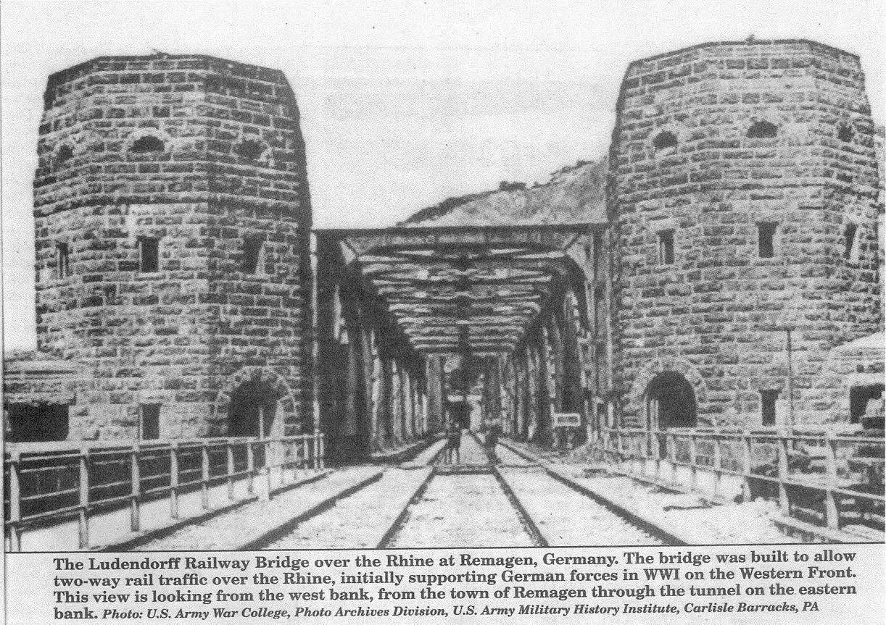

Crossing the Rhine River

The Ludendorff Railway Bridge at Remagen

Lt. Col. George A. Larson, USAF (Ret), Rapid City, SD

A personal remembrance by Paul Priest, a former member of the 9th Armored Division in WWII.

As Allied troops advanced along a broad front toward Germany, U.S. Army units were looking to capture a bridge over the Rhine River intact, allowing troops and heavy equipment into Germany. The Rhine River was the last major obstacle to Allied forces on their continued offensive that began on D-Day, 6 June 1944, at Normandy, France. U.S. aerial reconnaissance identified two bridges intact over the Rhine. One was at Oberkassel and the U.S. Army's 83rd Division moved toward the bridge. As U.S. troops approached, German engineers blew up the bridge. The second was at Uerdingen and units assigned to the U.S. Army's 2nd Armored and 95th Infantry Divisions pushed toward that bridge. U.S. troops reached and crossed the bridge, but a German counterattack drove these soldiers back across the bridge. German engineers then blew up that bridge. This near loss caused great concern in Berlin and Adolf Hitler ordered all remaining bridges over the Rhine blown up, even if German forces fighting east of the river were cut off from escape.
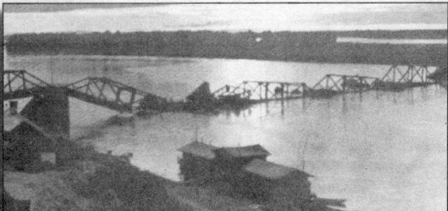
The Germans destroyed this bridge over the Erif River prior to the Division's arrival at the Rhine. Photo: Paul Priest

German troops followed Adolf Hitler's orders to blow up the remaining bridges over the Rhine - all but the Ludendorff Railway Bridge at Remagen, Germany, located between Bonn and Koblenz. The Rhine River was considered the last physical barrier to Allied troops conquering Germany and ending the war in Europe. On the afternoon of 7 March 1945, a reconnaissance unit assigned to the U.S. Army's 9th Armored Division reached the town of Remagen and reported the Ludendorff Railway Bridge was intact and being used by the Germans.

This railway bridge was built by German engineers during WWI to move supplies and troops to the Western front. After WWI, France occupied the area and took control of the bridge. French engineers filled in the built-in demolition chambers with cement, making it very difficult to be destroyed. This played an important factor when German engineers in WWII attempted to destroy the bridge before U.S. troops forced their way across the river to the east bank.

9th Armored Division history

The 9th Armored Division came out of the 2nd Cavalry Division, a mechanized force activated on 15 July 1942 at Fort Riley, Kansas. It remained at Fort Riley for training for a year before transferring to the Mojave Desert near Needles, CA, for light armored warfare maneuvers. It was transferred to Camp Polk, LA, for final war maneuvers. In August 1944 the Division took a train to New York, boarded the British passenger liner Queen Elizabeth and made an unescorted voyage through German U-boats to England. After drawing its complement of equipment in England, the Division crossed the English Channel, landing at Marseilles, France, on 24 December 1944.

Paul Priest

During WWII Paul Priest was assigned to the 9th Armored Division. His account of events follows:
"I was born on 25 December 1925, in Flint, Michigan. On the morning of 7 Dec 41, I was at home, hearing the news of the Japanese attack on Pearl Harbor. On Monday, 8 Dec, when President Franklin Roosevelt declared war against the Japanese Empire, I was in class, a senior in high school. Quickly we were at war with Germany and Italy. In the spring of 1942, I graduated from high school and was drafted into the U.S. Army on 28 June 1944, at Fort Sheridan, IL. I completed basic training at Blanden, FL, and was assigned to the 9th Armored Division.

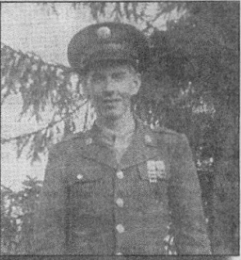
PFC Paul Priest, after the end of the war in Europe.

"After landing in France, on 25 Dec 44, the 9th Armored Division moved to the front. I was an infantryman. I almost did not make it to the Rhine River, being involuntarily assigned as a replacement crewman on a Sherman tank. I did not like it and after one day asked the captain of the unit to let me out, which he did. I was assigned to the Division's headquarters' company, performing reconnaissance patrols for the Division. On patrol we normally used a halftrack as the primary method of transportation. On patrol I had an M-1 rifle and sometimes a carbine. Most of the time on patrol I carried three pistols: a long barrel .38 caliber German Luger, a .38 caliber Italian Beretta and a .25 caliber pistol. I retrieved all three from dead German soldiers. In close combat I preferred to use the pistols. "I was in the reconnaissance force, which operated in front of the Division. We were rotated into and out of
reconnaissance on a regular basis.
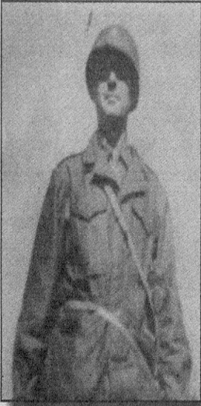
Lt. Col. Leonard E. Engeman.
When in reconnaissance, we were always on the move. Lt. Col. Leonard E. Engeman would let us sleep in buildings in occupied towns. We only slept outside five or six times after leaving Belgium. The homes and buildings usually had been bombed or shelled and were with out roofs. When assigned to a road guard position, I slept on top of the engine hood of the halftrack, the warmest spot I could find. It was cold at night and we did our best to keep warm.

"On 5 March 1945, two days before we reached the Rhine River, I was detached from the lead division's reconnaissance group and dropped off at a road check point to direct the division's vehicles to which one of three roads to take. I took up my guard post at 1430 hours and was told the division should reach my position by 1600 to 1630 hours. The vehicles did not reach me by that time and it kept getting later. I went out and picked and up all the guns I could locate created a large pile near the gas station that I decided to use as cover for the evening. I found the weapons all over the ground, recovering them from dead German soldiers. I feared that someone might pick one up and turn it on me.

"I was in the building until 2130 hours when I heard the sound of tank tracks coming toward my location. It was the lead column of the 9th Armored Division. I showed the lead tank which road to follow and then climbed in, rejoining my reconnaissance unit in time to make the historic dash across the Ludendorff Railway Bridge over the Rhine River. On the morning of 7 March 1945, we were on the west bank of the Rhine, above the town of Remagen, seeing the railway bridge still intact. Lt. Col. Engeman was excited about finding a bridge intact over the Rhine."

Seize the bridge

At 12 noon, U.S. Army Brigadier General William M. Hodge, Commander Combat Group B, 9th Armored Division, III Corps, First Army, received verification from the leading reconnaissance unit that the bridge was intact and had not been destroyed by the Germans. Against standing orders not to deviate from his planned objective, he ordered the bridge to be seized and force a bridgehead across the Rhine River. The bridge had been the target of repeated air attacks after the Battle of the Bulge in an effort to slow the movement of supplies and troops toward Belgium. U.S. air attacks had damaged the bridge but German engineers repaired the damage. The bridge was to be attacked again on the morning of 7 March, but the attack was canceled due to bad weather, which turned out to be a fortunate turn of events for the American troops looking down onto the bridge from Remagen. It was apparent the U.S. reconnaissance unit arrived at the bridge earlier than expected, otherwise the Germans would have allowed more time for vehicles and troops west of the Rhine to cross safely. Planking had been laid over the tracks to allow the movement of vehicular traffic across the bridge.
Even if the German defenders of the bridge had waited too long, there was no assurance American troops could make it across the bridge before demolition charges were set off. Lt. Col. Engeman reasoned the Germans would probably wait until his tanks roared onto the bridge, then set off the demolition charges.
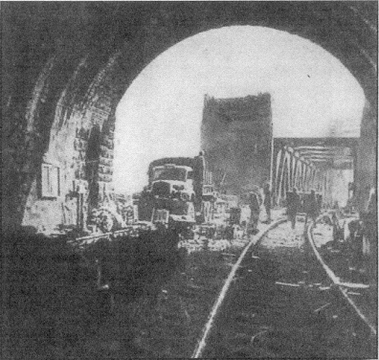
Inside the railway tunnel on the west bank of the Rhine River, looking west toward the still intact Ludendorff Railway Bridge. Photo: Paul Priest
Lt. Col. Engeman ordered Company A, 27th Armored Infantry Battalion, with a platoon of Pershing tanks from the 14th Tank Battalion, each equipped with 90mm main gun, to go into town.
His orders were "Get through it as quickly as possible and reach the bridge. The infantry will follow on foot. Their halftracks will bring up the rear. Let's make it snappy."

The Pershing tanks clattered down the winding road into Remagen; the infantrymen followed. Tanks and supporting infantrymen moved rapidly against spotty resistance from scattered German snipers.

German prisoners were taken from houses on the outskirts of Remagen and were asked about defenses in the town and on the bridge. One German soldier told the Americans the Ludendorff Bridge was to be blown up at 1600 hours. Similar intelligence information was obtained from troops assigned to the 52nd Armored Infantry Battalion at Sinzig, several miles away.

These reports were relayed to General Hodge who then ordered Lt. Col. Engeman at 1515 hours "You've got 45 minutes to take the bridge.

Plan of attack

Lt. Col. Engeman radioed the leading Pershing tank commander, Lt. John Grimball, telling him to get to the bridge as quickly as possible. Lt. Grimball radioed back, telling him that he was already there. The Pershing tanks turned to a firing position near the west end of the bridge and one of the first targets they found was a long string of freight cars along the east bank. The Pershing tanks quickly destroyed the train.

Paul Priest recounts, "On that morning, I was in the group heading toward the bridge. Not in the lead soldiers, farther back in the reconnaissance column. Our tanks quickly knocked out the German train on the eastern bank. There were many secondary explosions. The tanks first knocked out the engine, bringing the train to a stop in a large cloud of steam released from the destroyed engine."

Infantrymen, led by Lt. Karl Timmerman, moved through the town of Remagen toward the bridge. Lt. Grimball's Pershing tanks took up firing positions at the bridge's west end. When the 27th Infantry Armored Battalion's Company A reached the west end of the bridge, at 1550 hours, the Germans set off a demolition charge creating a large crater to the bridge's approach, preventing the tanks from crossing the bridge. The second detonation went off when Company A was approximately two-thirds of the way across the bridge. The resulting explosion knocked out the main steel diagonal supports located on the upstream side of the bridge and destroyed a section of the wooden planking and flooring, resulting in a six-inch sag to the bridge, but did not destroy the bridge.

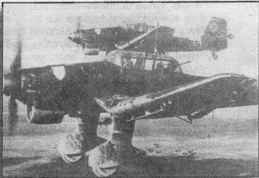
Stuka dive-bombers attacked the Ludendorff Bridge. Photo taken from a German solider captured by Paul Priest.

Paul again recounts, "I was in the group of infantry attacking across the bridge when the tanks had to stop because of the large crater at the west end of the bridge. The demolition charge was set off
in front of me and we were taking machinegun fire from the two bridge towers at the east end of the bridge. I was not thinking about anything other than making it safely to the other side of the river."
The Pershing tanks provided covering fire for the advancing Company A, 1st Platoon, followed by 2nd and 3rd Platoons (mixed together, in which Paul Priest was assigned). At about the same time, three 9th Armored Division engineers were on the bridge, cutting wires to four-pound demolition charges placed in a series, not yet set off. The engineers were lead by Lt. Hugh Mott, supported by SSgt. John Reynolds and Sgt. Eugene Dorland. They located the main demolition cable, but it was too thick to be cut with pliers. Lt. Mott used his carbine to fire three shots to cut and destroy the demolition cable.
TSgt. Joseph Delisio knocked out the machinegun in one of the east bridge towers and TSgt. Mike Chinchar knocked out the other. The first U.S. infantryman to make it to the east bank of the Rhine was Sgt. Alexander Drabik.

Paul Priest recalls, "One of our Pershing tanks, fitted with a bull-dozer blade, filled in the crater at the west end of the bridge to allow tanks to move across. Engineers also were on the bridge to repair the hole in the flooring about two-thirds of the way across the bridge. Once the east bridge tower machineguns were silenced, we cleaned out the tunnel of scattered German troops, young kids and older men. I helped make a sign on a piece of wooden planking, nailing it up on the east bank of the bridge: 'Cross the Rhine with dry feet, courtesy of 9th Armored Division.'

"We moved through the railway tunnel, into the cliffs beyond, attacking remaining German 88mm and four 20mm flak guns there. Our Pershing tanks destroyed some of the 88mm guns and the others were abandoned by the German troops, while we destroyed the flak guns. We did not encounter any real organized German resistance; it took about a day for the Germans to bring in more troops."

Command failure

The exploitation of the bridgehead almost did not take place because of a U.S. Army command failure. The overall operations plan for U.S. offensive troop operations east of the Rhine was under control of Supreme Headquarters Allied Expeditionary Forces, G-3. General Pinky Ball did not want the broad front plan of advancement to be discontinued. General Omar Bradley telephoned General Dwight Eisenhower that the 9th Armored Division had captured the Ludendorff Bridge across the Rhine intact and had established a bridgehead on the east bank of the river. General Eisenhower told General Bradley, "Brad, that's wonderful. Sure, get right across with everything you've got. It's the best break we've had... to hell with the planners."

In the final look at the Allied operations against Germany, General Eisenhower continued to follow the broad front general offensive against German forces, not pouring everything across the Ludendorff Bridge.

When the Germans failed to destroy the Ludendorff Railway Bridge, 8,000 U.S. troops and large numbers of tanks, self-propelled artillery and trucks crossed the Rhine River within 24 hours. However, everything did not go smoothly. Tanks assigned to Company A, 14th Tank Battalion, made it across the bridge, but a tank destroyer assigned to the 656th Tank Destroyer Battalion broke through the wood planking, stopping traffic. Many U.S. troops in halftracks got out and walked across the bridge. It took some time to clear the stuck vehicle and resume the movement of heavy equipment across the bridge. After the first 24 hours, the German 9th and 11th Panzer divisions were repositioned around the bridgehead the American forces had set up, attempting to isolate the U.S. 9th Armored Division.

On 9 March, 10 German Air Force aircraft, eight of which were Stuka dive-bombers, attacked the bridge, scoring two hits. On 15 March, a larger force of 20 turbojet aircraft attacked the bridge, a mixture of twin turbojet engine Messerschmitt (ME) 262 fighters and twin turbojet engine Arado (AR) 234 B-1 bombers. They scored no hits.

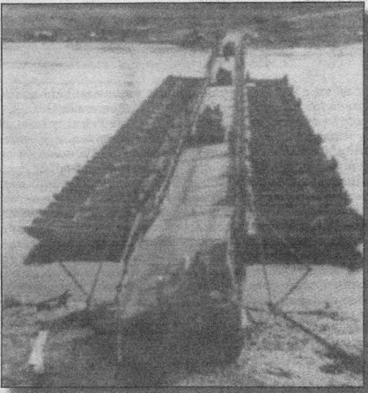
As the Germans destroyed bridges the U.S. Army engineers built tempo-rary ones to continue the offensive. Photo: Paul Priest

Destroy the bridge

After General Eisenhower ordered the bridgehead to be exploded, miliotary policy on the west bank of the Rhine had to deal with a traffic jam of military vehicles and thousands of infantry. All roads leading to the bridge were crowded with traffic, slowing the movement across the Rhine. To protect the bridge from German aircraft, flak vehicles were lined up side-by-side on the west bank, supported by artillery firing across the river at German troops attempting to isolate the 1½-mile deep and 14-mile wide American bridgehead. German artillery, begin-ning on 9 March, shelled the bridge and engineers assigned to the 51st and 291st U.S. Army Engineer Bat-talions. The engineers constructed a
pontoon and treadway bridge across the Rhine to increase vehicular traffic and tonnage moving into Germany.

German artillery shelled U.S. Army engineers building the pontoon bridges but the engineers continued to work in spite of the heavy German shelling. German civilians were moved out of Remagen to reduce or eliminate the possibility of German troops receiving clandestine reports on what was happening on the west bank and the effects of their artillery shelling. U.S. Army engineer teams worked 24 hours a day to keep the railway bridge operational. As soon as they could be positioned around the American bridge-head on the east bank, German troops began making determined efforts to destroy the Ludendorff Bridge. German soldiers floated a barge containing explosives down-stream to blow up the bridge. This was done at night and it was not a very hidden attempt. U.S. troops intercepted the barge, preventing it from getting close enough to the bridge to be ignited. Mines were floated downstream to blow up the bridge, but U.S. Army sharpshoot-ers fired at the mines, blowing them up before they reached the bridge. Finally, volunteer German troops put on rubber suits and entered the water upstream, towing explosives behind them. They were detected by U.S. troops on the river's east bank and killed.

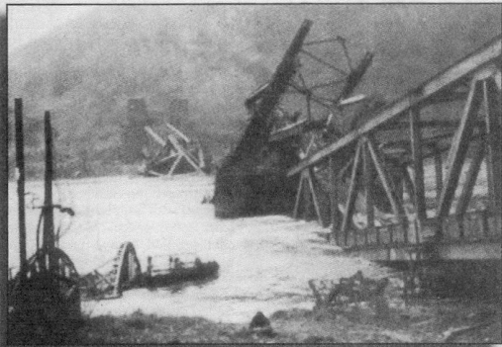
On 17 March 1945, after the conclusion of the V-2 barrage, the Ludendorff Railway Bridge collapsed. Photo: U.S. Army War College, Photo Archives Division, U.S. Army Military History Institute, Carlisle Barracks, PA

Germany's plans

The Germans tried to make do with the troops and weapons they had at their immediate disposition. The capture of the Ludendorff Bridge cut off 300,000 German troops and their equipment west of
the Rhine. Adolf Hitler was furious, ordering the arrest and execution of eight officers who failed in the defense of the bridge.

The secret German high-tech weapon, the V-2 rocket, was used against the Ludendorff Bridge. On 16 March, Adolf Hitler ordered General Bayerlien to attack the bridge with V-2 rockets. German troops opposite the U.S. east bridgehead pulled back approximately nine miles because of the accuracy of the V-2.

General Kammler received the missile attack order to fire V-2 missiles at the bridge, the first use of the missile in a tactical role. The unit assigned to fire the V-2s against bridge was located at Hellendorn, Netherlands, 130 miles north of Remagen, positioned at that location on 8 March. Because of Allied air attacks on its supply lines, the rocket unit suffered fuel problems and a V-2 supply problem. Adolf Hitler wanted to fire 50 to 100 V-2s against the bridge to destroy it over a two-day time span, stopping the Americans from using it to bring troops and supplies across the river. German rocket troops only fired 11 V-2s against the bridge on 17 March. The rockets struck around the bridge, with the farthest, at a distance of 40 kilometers, near Cologne, Germany. Even though none of the rockets hit the bridge, the shockwaves, along with the first attempt at demolition and constant use of the bridge resulted in its collapse. At 1500 hours, the bridge fell into the Rhine River.

Tribute

Paul Priest recounts, "When the bridge collapsed, 28 U.S. Army engineers working on the bridge were killed. I was not in the area when the bridge collapsed, as we had moved up into the hills through a gully. It was there that I was shot with a wooden bullet; the impact took my helmet off. I was kept in the line since it was considered only a flesh wound. By the time the bridge collapsed, the pontoon bridges had taken the burden of moving men and equipment across the Rhine.

The bridge was a mass of twisted metal, visible near both the west and east banks of the Rhine.
"As we moved away from the river, more and more German troops sur-rendered. They threw their weapons down onto the ground, raised their hands in the air and surrendered. I did not take part in any large actions after crossing the Rhine; it seemed the German troops gave up, surrendering to U.S. or Brit-ish troops rather than to the Soviet Army troops farther to the east.

"It was at this time that I found out my parents had received a tele-gram reporting my death; it was another Paul Priest. Things like that happen in war. It was a great relief to my parents when they heard I was still alive and they got a letter from me. We were again the spearhead for the American attack into Germany: the 9th Armored Division was assigned to move into Czechoslovakia to be certain the Germans would not attempt any real effort to regroup and continue resistance. Germany surrendered at Rheims, France, on 8 May 1945; two months to the day after the 9th Armored Division captured the Ludendorff Railway Bridge.

"Eventually, I was shipped back to the United States. I returned to Flint, MI, where I married by pre-war sweetheart, Joan, on 22 August 1945. I still remember the bridge over the Rhine and the role the 9th Armored Division played in capturing it and ending the war. After 60 years, many of those who served with me are gone and I wanted to tell their story."

