Class Activity – Skiing: Safety First

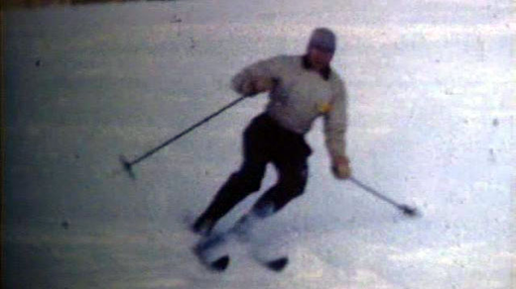
A skier on Terry Peak in 1949 (still frame from the film)

Introduction:
During this activity your students will construct, test and modify a shuttle that will safely transport passengers (3 eggs) down a slope. This is a perfect engineering activity for an afterschool group, club or elementary-high school class.

Process:
- Introduce the activity by showing a portion of the “Skiing at Terry Peak” video (Watch PBS) and the website. Also, the Canton Ski Hill website.
- Discuss slope/incline and the forces involved in the movement of an object up and down an incline
- Reference the video and discuss the forces applied to a body when it is moving and suddenly stops, whether it is a person falling on a ski slope, a vehicle or bicycle accident, etc.
- Discuss safety considerations/designs in reference to skiing (ex. reinforced boots), vehicles (ex. seatbelts), bicycling (ex. helmet), etc.
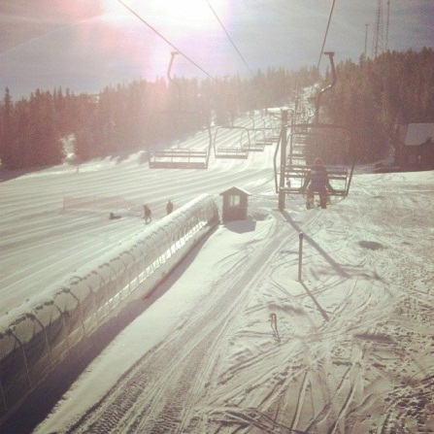

- Introduce the challenge – using household items, design a shuttle to safely transport 3 eggs down an inclined plane (the eggs should be visible)
- Divide the class into groups of 2-4; provide time to discuss the design and to make a list of needed supplies to bring from home
- Formulate additional requirements/restrictions to meet the needs of your group
- Construct and test shuttles
- Increase slope until one shuttle remains
- Discuss design features that worked well/did not work well



