**Maps and Borders**

**Class Activity –Reading a Map**

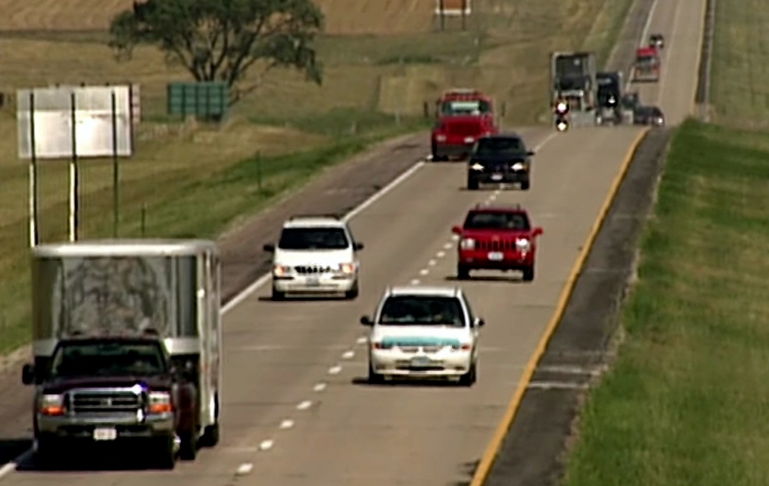

Reading a map has become a lost art when traveling because devices like cell phones are more accurate and convenient. However, there is something about the basic understanding of direction and sense of place you experience from reading a map. The following activity introduces the students in your class to the traditional state map, which some may have never seen. Feel free to add additional questions to personalize the activity for your area of the state.

**Materials:**

* Ruler
* Calculator
* Pencil
* State map – (one for every two students) Maps can be obtained from the state. I would use the same maps for a few years to reduce the total number of new maps required for your class on a yearly basis. The Information may be a little outdated, but the skills used by the students would be the same whether the map is 2 years old or 2 months old. Maps can be requested from the Office of Tourism at (605) 773-3301. South Dakota maps can be viewed online at the [SD DOT](https://dot.sd.gov/inside-sddot/forms-publications/maps) website (Example maps from the website: [high resolution](https://dot.sd.gov/media/fdf81efe/SDmap2023-high.pdf)/ [lower resolution](https://dot.sd.gov/media/fe353f35/SDmap2023-med.pdf)).

**Process:**

* Divide the class into groups of two.
* Distribute one South Dakota map and two SDPB Map Reading worksheets to each group.
  + [Map Reading - Teacher](https://npr.brightspotcdn.com/1f/f5/0700d1e34fdf9006beae927e4403/mapactivityteacher-2025.docx)
  + [Map Reading - Student](https://npr.brightspotcdn.com/1e/74/50ef56d6414b9d01fb1e90a578ee/mapactivitystudent-2025.docx)
* The students should work together to complete the worksheet.

Additional map questions could be included, depending on the amount of time you have planned for this activity. Extra room for additional questions is included on the worksheets.

 