Density: Team Boat

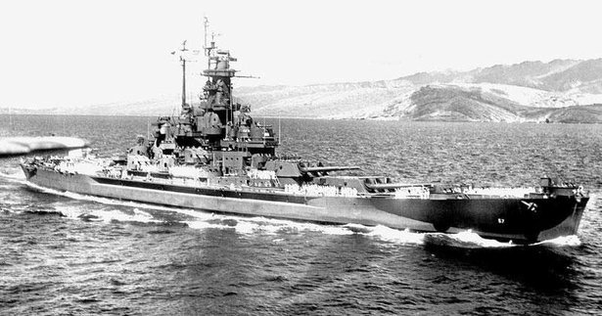
USS South Dakota
South Dakota State Archives
During this activity, your students will learn about the launching of the 35,000-ton Battleship South Dakota in 1941. Then they will complete an activity in which they will learn about density and how buoyant force can float a very massive ship.

Process:

Introduce the activity by reading the information, viewing the photos, and listening to audio recordings.
- Take a look around the USS South Dakota
- Double Christening of the Battleship South Dakota blog.
  - Audio clip of the Christening
- Images of the Past: USS South Dakota
  - Veterans of the WWII Battleship South Dakota
  - Veterans of the WWII Battleship South Dakota - Part Two
- New USS South Dakota Honors the Past
- USS South Dakota Battleship Reunion

Challenge:

Your students will complete the classic density challenge by designing and constructing a boat out of aluminum foil that holds the most cargo (pennies). Although there is a twist, the students will work together as a large group to design a boat that will set the class record. The maximum number of pennies for the class will be recorded on a poster or plastic boat and displayed in the classroom. Each year, the new students in your class will compete against prior classes for the record. The activity encourages critical thinking, experimentation, cooperation, and competition.

Aluminum is a metal that does not float. Take a piece of aluminum foil and compress it into a tiny ball, removing all the trapped air. The ball of foil will sink when placed in water, because the weight of the water displaced is less than the weight of the foil. Then show how the foil can be made into a shape, like a bowl, that will increase its volume. Increasing the volume will increase the volume of water displaced. If the foil floats, then the weight of the water displaced is more than the weight of the foil. An object will sink if the downward force of its weight is greater than the upward force (buoyant force) of the water, the object will hover if they are equal, and float if the buoyant force is greater than the weight of the object. In other words, if the density of the foil + density of the pennies + the density of the air in the foil boat is less than the density of water, the aluminum boat will float. Naval architects must design ships that displace enough water to support the weight of the vessel, its cargo, and its crew without floating too high, which would upset the ship's center of gravity and cause it to capsize. Ballast tanks adjust the weight in large vessels.

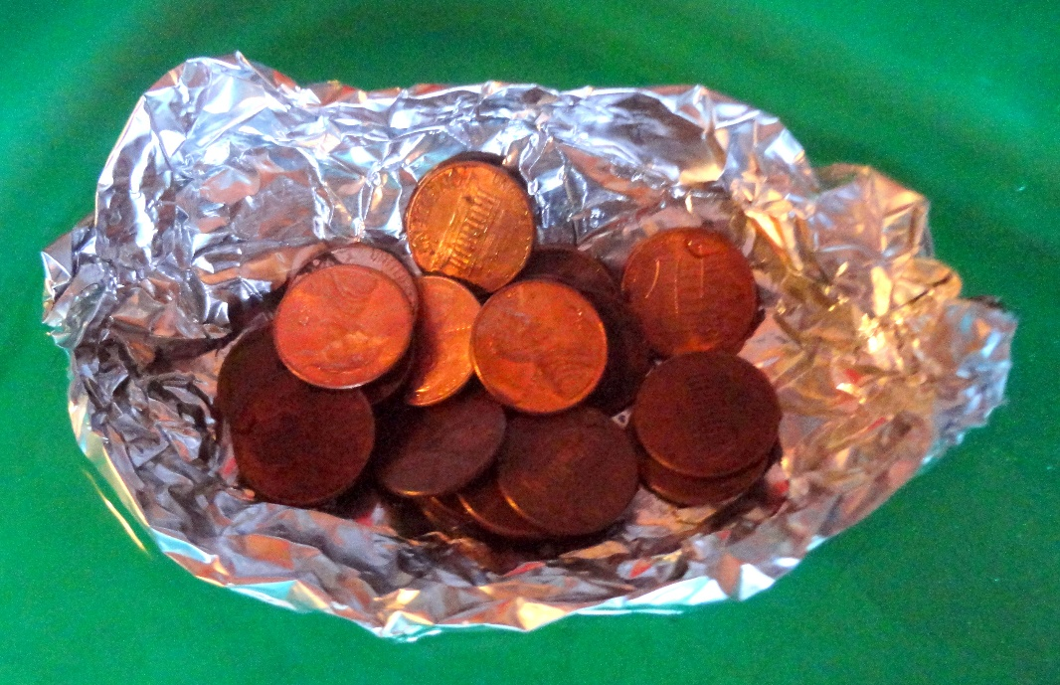

Materials:
- 6” x 6” Aluminum foil - (3 pieces for each pair of students)
- Pennies – Enough to test designs (100-150)
- Clear tub of water – Placed on a table in the center of the room

Each group should be given time to design its first boat.

Each group should test how many pennies their boat can hold without sinking.

Groups should discuss and share their best designs. Each group should design and test a new boat.

The groups should be given three chances to test three different boats.

The boat that held the most pennies before sinking is the class winner. The class year and the number of pennies should be recorded as the class record.



