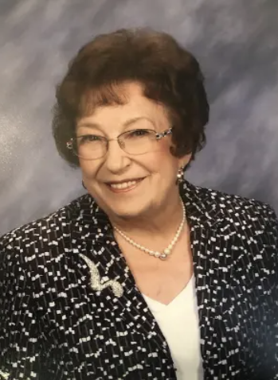
Jean M. Tommeraasen
May 8, 1929 - January 11, 2020
Jean Marie Tommeraasen (Buxengard), age 90, of Madison, SD passed peacefully surrounded by family on Saturday, January 11, 2020 at the Avantara Mountain View in Rapid City, SD. Memorial services will be 11:00 AM, Saturday, February 1, 2020, at Trinity Lutheran Church in Madison. Inurnment will follow at Graceland Cemetery.
Jean was born on May 8, 1929 to Knute & Esther Buxengard in Spring Grove, Minnesota where she was baptized & confirmed at the Trinity Lutheran Church, & graduated from Spring Grove High School in 1947. She was involved in many school activities such as choir, band, & plays, but her passion was her painting, & designing fashions for the Dixie Dugan & Jane Ardan comic strips which were published in the area newspapers.
After high school, she moved to Evanston, Illinois to be a governess for a couple & their four children, & met her future husband, Dr. Owen Tommeraasen while singing in the church choir. Owen & Jean were then married on November 21, 1948 in Spring Grove, Minnesota, & were married for 60 years until Owen’s passing in August of 2009. They moved to Madison, SD in 1949 where they opened up an optometric practice with Jean as the receptionist. She also worked at the Rexall Drug Store until their daughters, Anita & Holly were born.
Jean was an accomplished artist & received the Visitor’s Choice Award at the SD State Fair in Huron for her painting, “Blue Boy,” and the Visitor’s Choice Award at the Sioux Empire Fair in Sioux Falls for her portrait of Ernest Hemmingway. She also loved to write, & won an award for her short-story “The Garden” in Rapid City, SD, and wrote a book in memory of her Father, “I Give a Book to You.”
Both Jean & Owen loved to travel together, & visited the Orient, Europe, the Caribbean, & many US states such as Hawaii & Alaska. Jean was also involved in many organizations at Trinity Lutheran Church, at Dakota State University, PEO, Questers, SD Optometric Auxiliary Association, Community Arts Association, the country club, bridge club, & her Bible Study Group.
Jean is survived by her 2 daughters, Anita (Greg) Jung & Holly (Patrick) Moser; 2 grandchildren, Nick Jung & Mandy (James) Moisan; a great grandchild, Addy Moisan; a brother, Dr Dale (Sharon) Buxengard; & several nieces & nephews.
She was proceeded in death by her parents; a brother, Lyle Buxengard; & her husband, Owen Tommeraasen.

