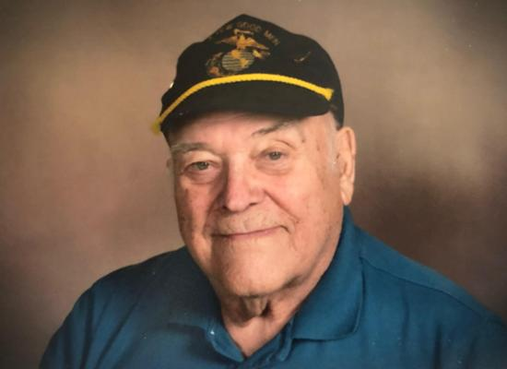
Leo Istas
November 5, 1923 ~ June 22, 2019
Leo Istas, 95, of Miller, passed away Saturday, June 22, 2019 at Southridge Healthcare in Sioux Falls.
Funeral Mass was held at 9:00 a.m., Thursday, June 27, 2019 at St. Ann’s Catholic Church, Miller with Father Paul Josten, celebrant. Burial with military honors followed at G.A.R. Cemetery, Miller. Visitation was held from 5:00 to 7:00 p.m., Wednesday, June 26, 2019 with a 7:00 p.m. celebration of life service, all at Reck Funeral Home, Miller.
Leo was born November 5, 1923 in Marshall, MN to Dora (LaPolice) and Charles Istas. Leo attended Catholic school through 8th grade and graduated from Marshall High School in 1941. He began his work in the Marshall bakery in the 6th grade and worked there until he enlisted in the Navy flight program, June 1942, for flight training. Leo was Commissioned 2nd Lieutenant United States Marine Corp September 1943 and graduated Pensacola FL Flight School September 1943.
Leo flew as a fighter pilot flying the loud thunderous Corsair in the South Pacific. He was assigned to Marine squadron VMF 313. He was promoted to 1st lieutenant in 1944 and discharged in November 1945. On December 11, 1944, Leo skipped a bomb across the fast-moving ocean to sink a ship that was bombing McArthur and his men inland; Leo was awarded the Distinguished Flying Cross for his bravery in battle.
Upon his arrival home Leo opened a bakery with his brother in Madison, SD from 1946 to 1951 and then expanded their operations to Miller on October 15, 1951; opening Istas Miller Bakery. He and Delores opened the Driftwood Café in 1963. He worked side by side with his wife until the sale of their businesses on September 15, 2001, which was just one-month shy of being open for business for 50 years! The café and bakery represent wonderful times and provide hundreds of stories for those that worked there or stopped by for fresh bread and donuts, homemade peanut brittle, cookies, soups, pies and the list goes on and on. The corner without them has never been the same!

Leo married Delores (Deide) Gussler May 3, 1965, and together they adopted three daughters. Sherri in October 1967, Shirley (Casandra) in January 1970, and Tamera in August 1970. Leo was a member of St. Ann’s church, the Knights of Columbus; where he served as a 4th Degree Knight, American Legion, and VFW, Disabled Veterans of America, and Marine Corp League.
Leo is survived by his sister, Angie (Istas) Nagy; two daughters: Casandra (Stephen) Scales and Tamara Enalls; six grandchildren: Erik Scales, Lindsey Scales, Mason Scales, Elizabeth Enalls, Michael Enalls, and Elijah Fenner.
Leo was preceded in death by his wife, Delores Istas; daughter, Sherri Istas; parents: Charles and Dora Istas; and siblings: Marie, Margarette, Lucile, Lena, and Melvin.
We wish to thank all of Leo’s friends and family in Miller, SD and the surrounding area for your love and support. Without you, he would not have been able to remain in the home he loved for so many years. Thank you for the visits, coffee, holiday and dinner invitations, basketball and football games, evenings out, food drop offs, trips to Huron, Sioux Falls and everywhere in between. Your generosity, love and support are truly appreciated and will never be forgotten.

