Black Elk Peak
Elevation: A Closer Look
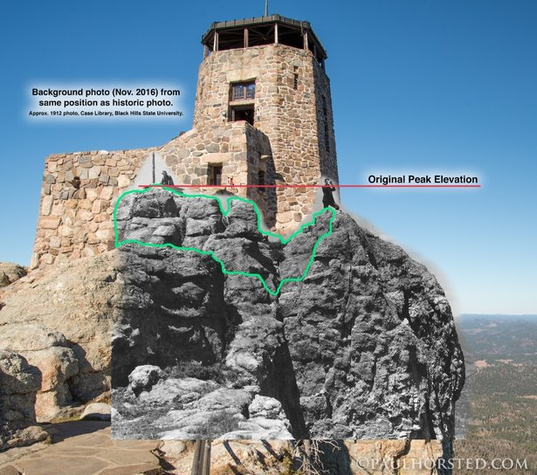
Still from Film

During this activity, your students will complete one or more tasks in which they will learn about elevation, how to estimate the height of a tall building, and how to design and construct a tower. Then, they will learn about the history of the lookout tower on South Dakota’s highest peak, Black Elk (formerly Harney Peak). They will also learn about a Native American ceremony that takes place every spring at the time of the Vernal Equinox, in which indigenous people gather at Black Elk Peak to welcome back the Thunder Beings.

Process:

Introduce the activity by reading the information and viewing the photos about the elevation of South Dakota’s tallest peak on the following blog.

Then, watch a video about the history and preservation of the lookout tower on the summit of Black Elk. (Note: The video references Harney Peak instead of Black Elk.) Quote from Black Elk about the summit.

Finally, listen to two SDPB radio stories; one story is about a Native American ceremony that takes place every spring, at the time of the Vernal Equinox, in which Indigenous people gather at Black Elk Peak (Note: The story references Harney Peak instead of Black Elk.) to welcome back the Thunder Beings. The second story is about the process of renaming the peak. (separate story about a ceremony marking the renaming of Harney Peak to Black Elk Peak)

Next, the students will use shadows and ratios to estimate the height of a tall object, like a flagpole, building, tree, etc.

- The students should view the following Cyberchase video about ratios and proportions.

- Another option is shown in the following video and guide.

The following is one possible solution to estimate the height of the Dignity statue located at the rest area near Chamberlain, SD, or any other tall object near your school. Use the same units.

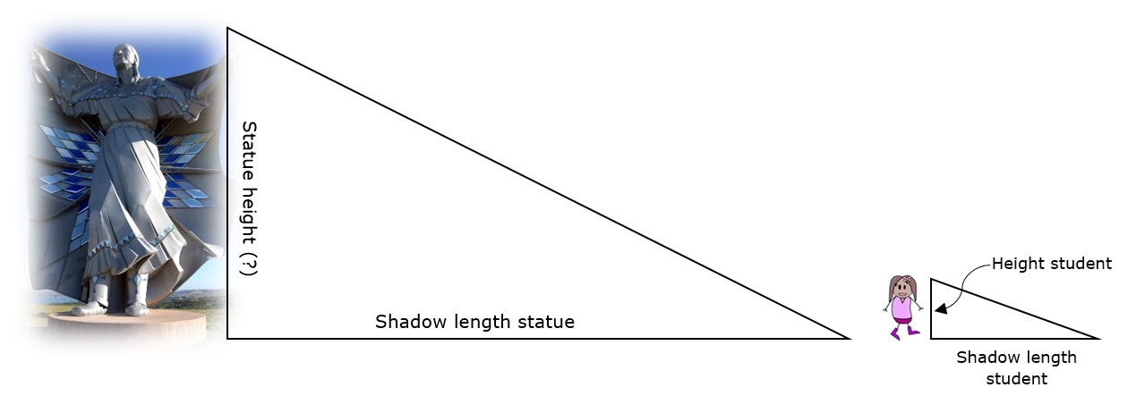

Solution: Solve for h

Height Student Height statue unknown (h)
__________________________________________ = _______________________________________________
Shadow length student Shadow length statue

Challenge:

The design-n-build activity below should be completed in groups of 2-3. The students should design, test, and redesign the tallest structure possible that will hold an egg using the materials listed below. The height of the tower will not be measured to the highest point on the tower but instead to the top of the egg (example below). The materials listed below are the maximum amount that could be used in the final structure. More should be available during the design and testing phases (to replace a damaged cup, etc.). Image 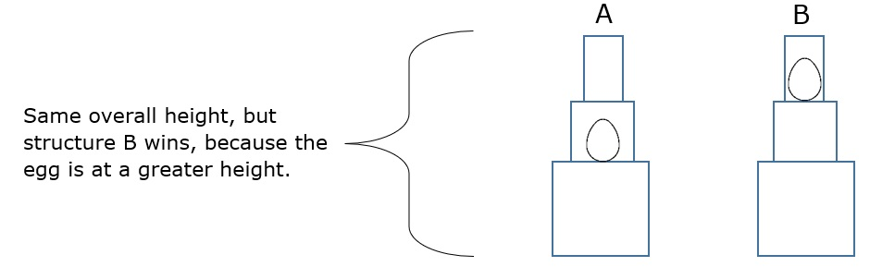

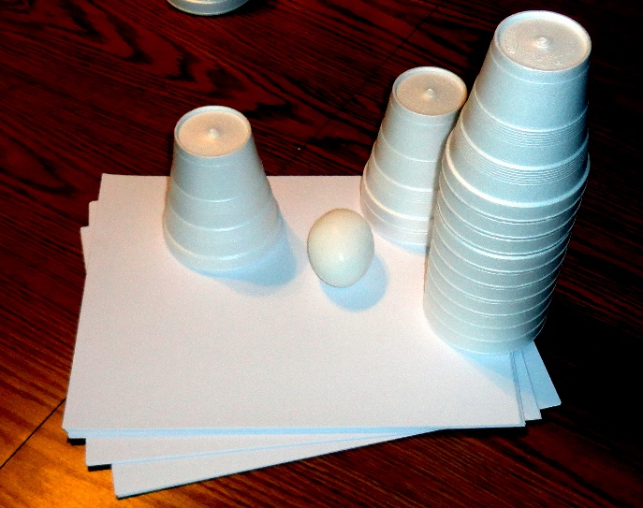

Materials in final structure:
- 20 - Pieces of computer paper
- 20 - Styrofoam cups
- 1 - Meter of tape for younger students (more challenging without tape)
- 1 - Egg
Example structure constructed without tape:

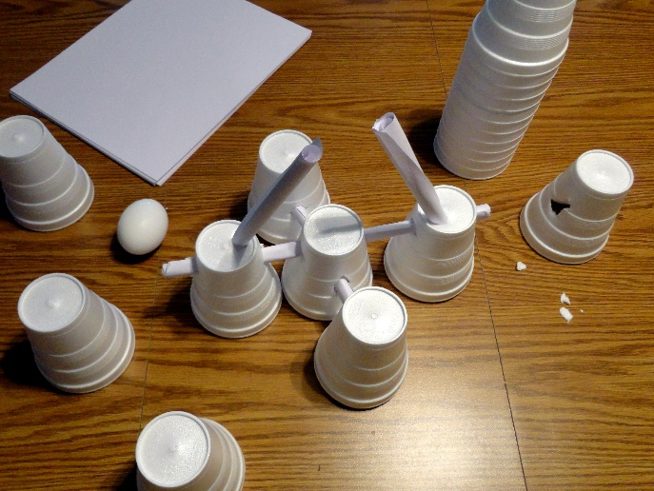

A solid base is shown.

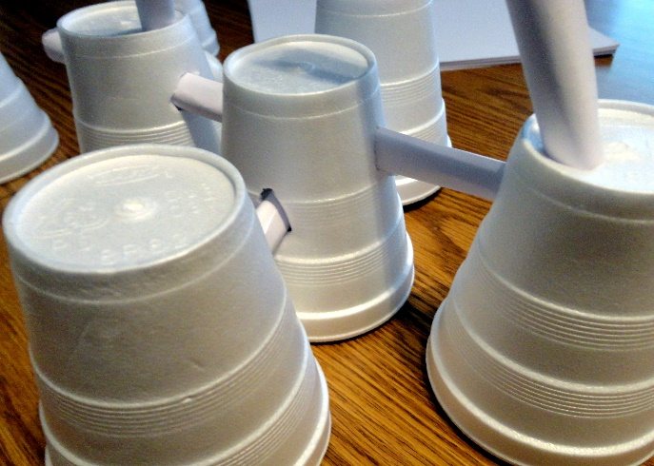

In this example, paper is used to connect cups instead of tape.

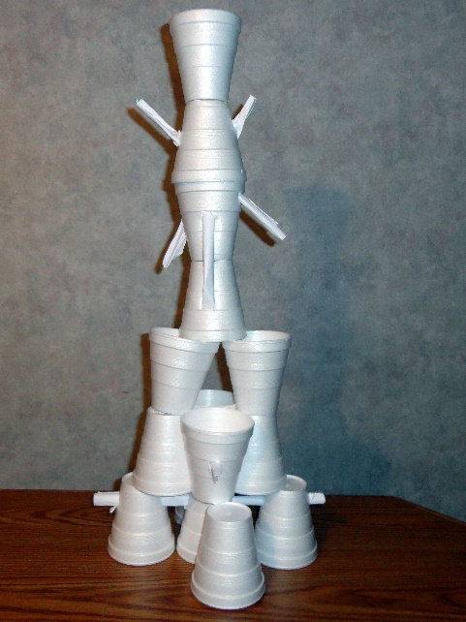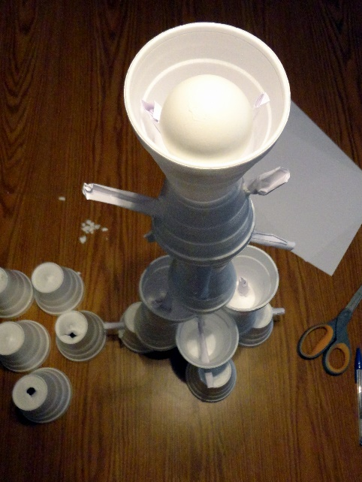
The example shown is 7 cups high.

Taking it to the Next Level:

A fan could also be used to increase the complexity of the challenge or to resolve a tie.
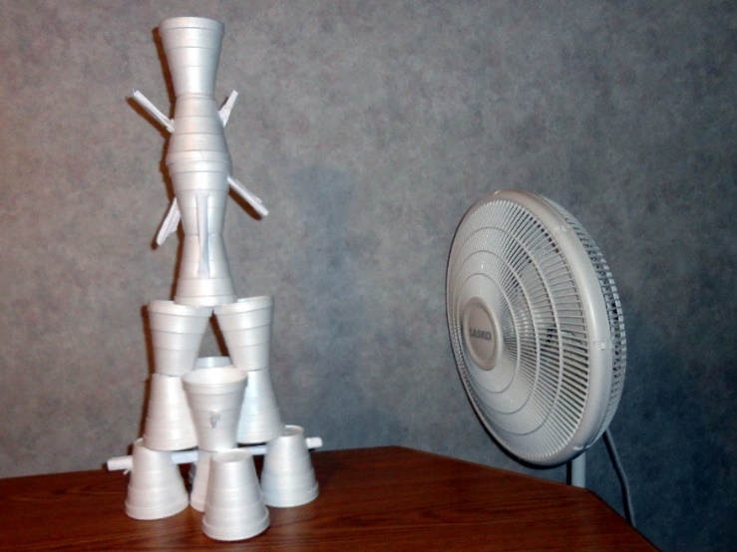

Your students will have an amazing time with this engineering activity; they will learn that it is important to have a solid foundation when designing a tower.



