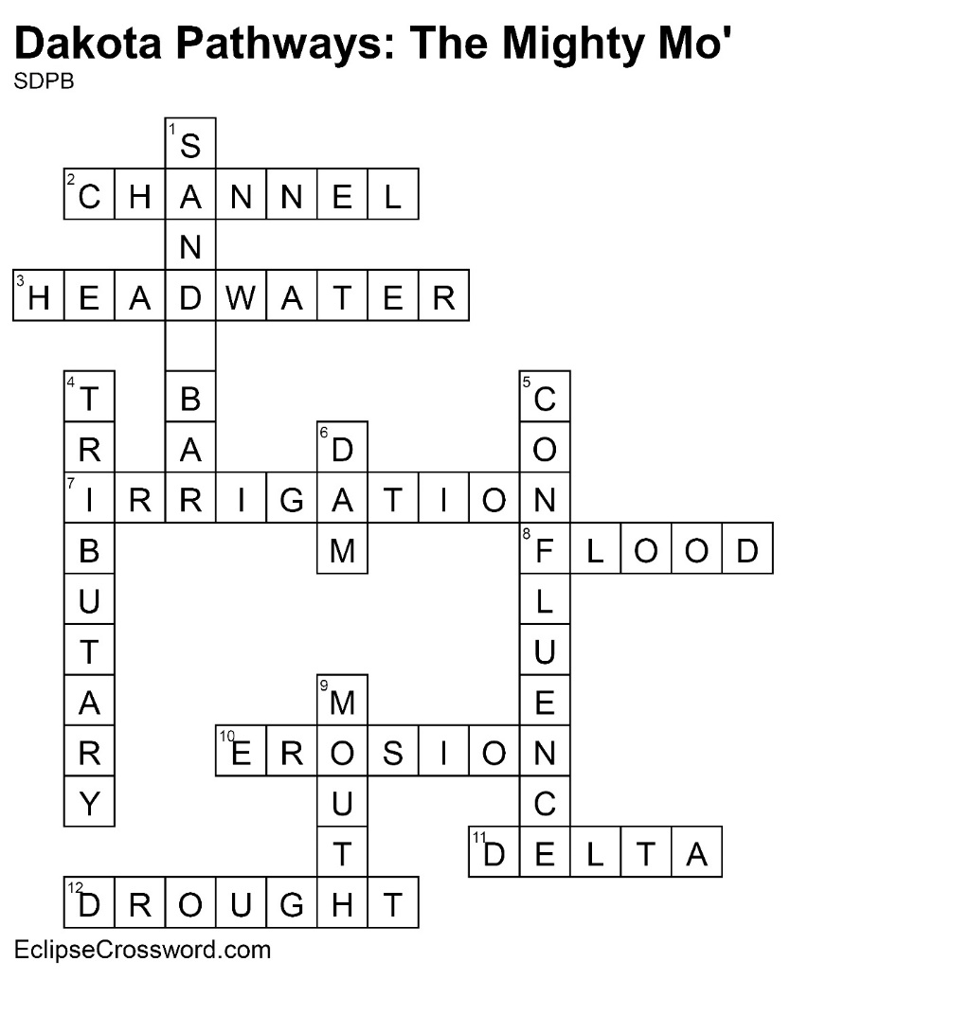

**Across**

2. CHANNEL — Deeper part of a river; usually more

navigable

3. HEADWATER — Where a river begins

7. IRRIGATION — Water used for farmland

8. FLOOD — When water flows across land that is

normally dry

10. EROSION — Process of wearing away

11. DELTA — Fan-shaped area of sediment at mouth

of a river

12. DROUGHT — Long period with little or no rainfall

**Down**

1. SAND BAR — Submerged ridge of sand or gravel

4. TRIBUTARY — Stream or river that feeds into a

larger waterway

5. CONFLUENCE — Place where two rivers come

together

6. DAM — Structure designed to hold back river

water, creating a reservoir

9. MOUTH — End of a river