Class Activity - Flag Design
Introduction:
Change can be good, especially when you are part of it. South Dakotans had the opportunity to be part of the selection process for the South Dakota State Quarter that was released in 2006.
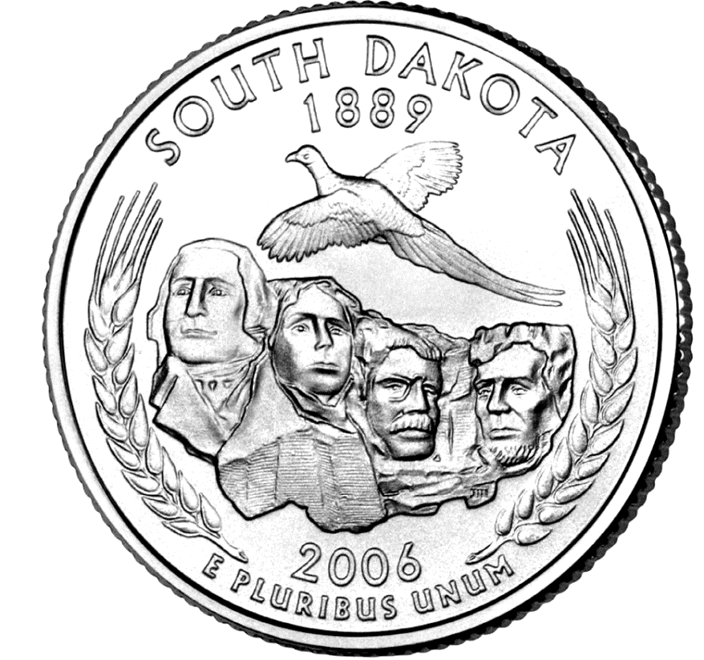

It would have been an amazing experience to be part of the original design process for the South Dakota State Flag and the United States Flag. Now, your students can be. The following activity will encourage students to learn more about the South Dakota State Flag and the United States Flag.

The students will make four flags. They will recreate the original state and national flags and include 2-4 interesting facts about each flag. The students will then design a new state flag and national flag. The new design should include 2-4 facts.

Materials:
- Internet/Library access
- Posterboard
- Pencil/eraser
- Markers/Colored Pencils/Crayons

- Have the students draw the original South Dakota State Flag and United States Flag. The drawings should include 2-4 facts about each flag.

- Research and design a new state flag and national flag. Include 2-4 interesting facts about the new designs.

- Students should present their new designs to the rest of the class.

- Related Video: How to Design a 51-Star Flag

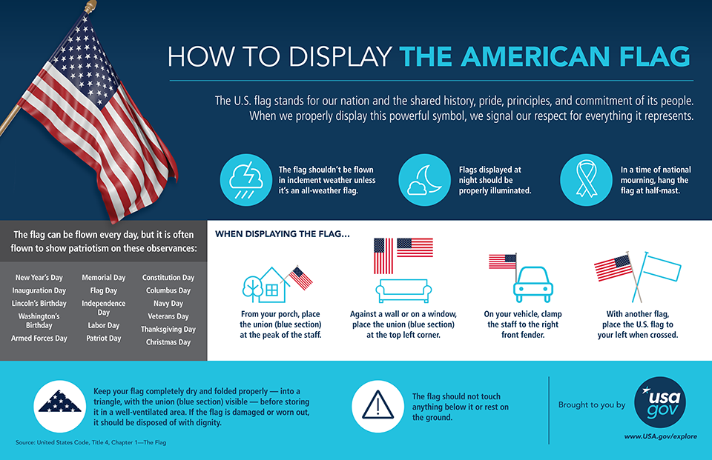
Graphic from USAGov, 2017, Facebook Post

Facts about the American flag (Image: USA.gov)


