Wind Speed Study with Household Objects
Your students will participate in a hands-on qualitative wind speed study during this activity. The students will use everyday household items to complete the study.
Your students will have a fantastic experience and improve their observation skills. One teacher commented, "Just letting you know the Stratobowl activity was a huge hit. The kids loved it and are still talking about it. I think they were most excited about the dollar bill and the garbage can. They couldn't believe I would risk the dollar blowing away. Thanks for another great activity!!"
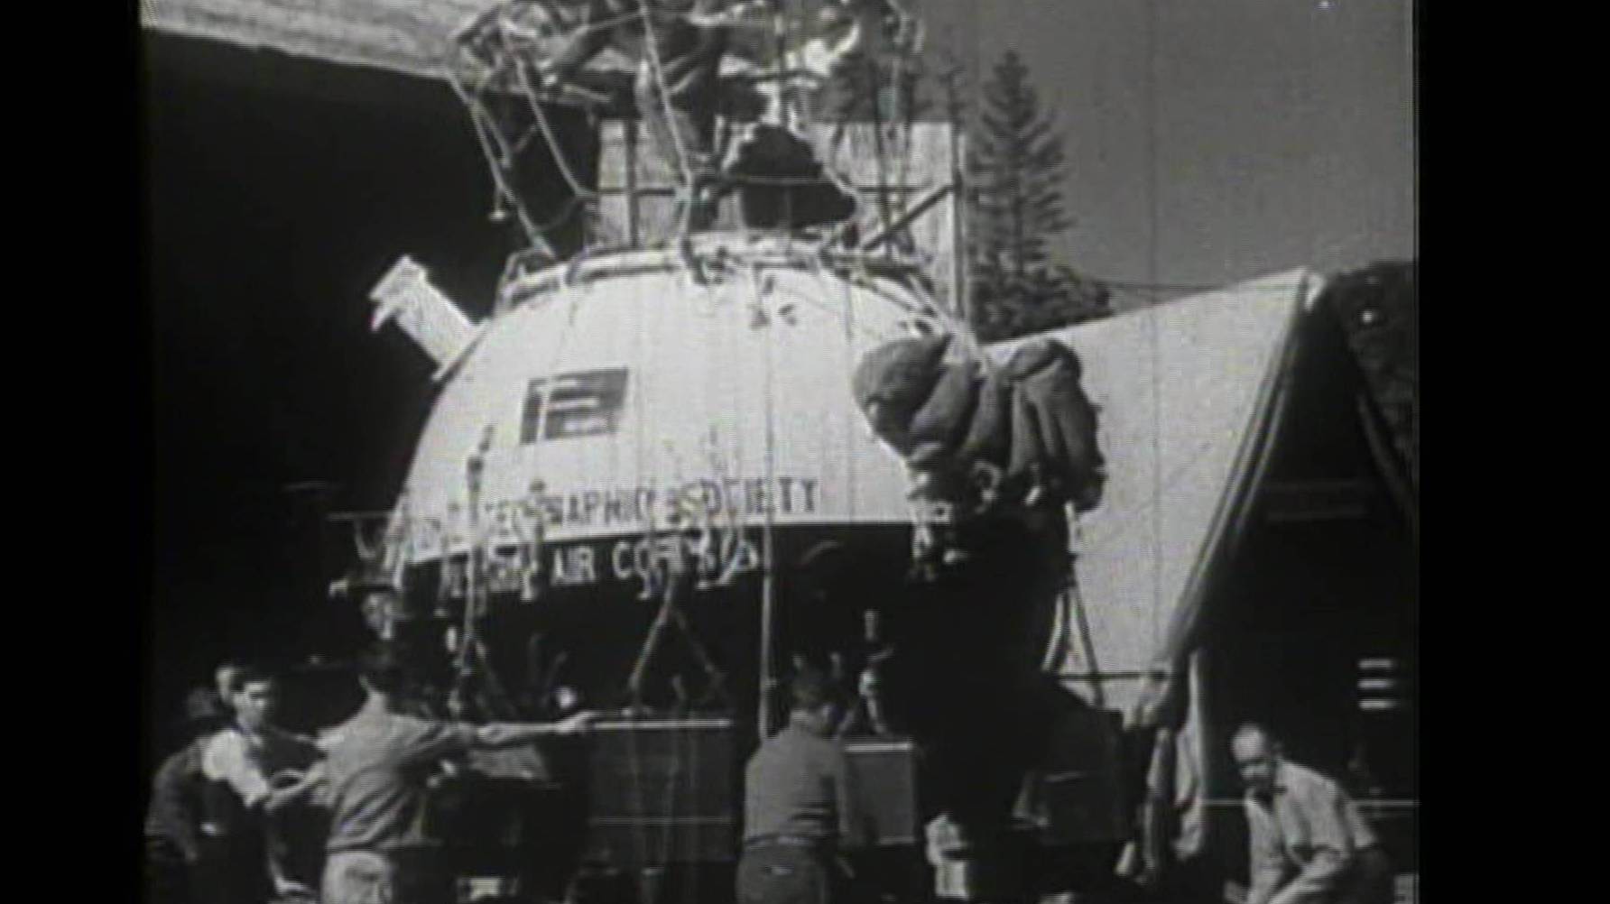

Lesson summary
During this activity, your students will learn about two 1930s balloon flights launched near Rapid City, South Dakota, that provided invaluable scientific data about the nature of the Earth's atmosphere at the edge of space, also setting an altitude record that would stand for 21 years. The students will then participate in a qualitative wind speed study.

Time allotment
- Initial class period - 50 min
- Data collection - 10 minutes per collection

Learning objectives
- Students will improve their observation skills.
- Students will collect and display data.
- Students will learn that an increase in wind speed results in a greater force.

Prep for teachers
- Gather materials for the activity in the Supplies section below.
- Make a class observation chart.
- Access a local weather station online for current wind speed.
- Access the video clips and additional information below.

Supplies
- Select 5-10 items to chart for the entire year (multiple years would be nice)
  - Possible Items:
    - A standard piece of paper
    - Egg carton
    - Garbage can lid (both up and down on the ground)
    - Garbage can
    - Dry leaves
    - Aluminum can
    - Piece of cardboard and a box
    - Plastic
    - Etc. (examples of items often seen blowing in the wind)

Introductory activity
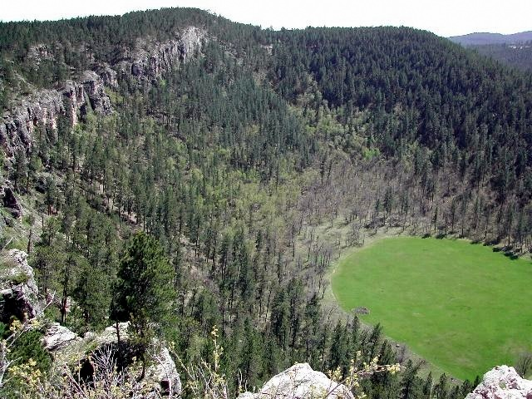
Courtesy: EPOD (Mike Barondeau), “The Stratobowl pictured above is located about 1.5 miles (2.4 km) off Highway 16 between Rapid City, South Dakota and Mt. Rushmore.”
During this activity, your students will learn about two 1930s balloon flights launched near Rapid City that provided invaluable scientific data about the nature of the Earth's atmosphere at the edge of space, also setting an altitude record that would stand for 21 years.
Both aircraft were assembled and sent aloft from an unusual bowl-shaped gorge in the Black Hills. A flat patch of land surrounded by steep cliffs provided shelter from wind and the best possible conditions for inflating and launching large, lighter-than-aircraft. The formation is now known as the Stratobowl. According to the USDA Forest Service, “The Stratobowl, a natural depression in the terrain of the Black Hills, has 300-to-500-foot sides combined of tree-lined banks and jagged limestone cliffs while the bottom is a flat plain of about 35 acres.”
The Explorer I flight launched on July 28, 1934, reached a height of 60,616 feet (11.5 miles) before a rip in the balloon's fabric allowed an uncontrolled release of hydrogen.
Explorer II was launched from the Stratobowl in frigid weather on November 11, 1935, with Captains Stevens and Anderson on board. It's estimated that between 35,000 to 40,000 people witnessed the launch. Explorer II reached a height of 72,395 feet (13.71 miles), an altitude record that would stand for 21 years. (Entire story and archival video footage of the launches)

Learning activities
- Introduce the activity by reviewing the information about the historical balloon launches. Discuss the importance of launching the balloons from the Stratobowl (natural windbreak).

Culminating activity
During this hands-on study, common household items (selected by the students) will be placed outside in a flat, open area. The items will be placed at the same location throughout the year at different known wind speeds.
- The known wind speeds should be found using the internet or a local weather station. Movements of each item will be recorded and charted over a period of many months to establish qualitative data of movement for each item at known corresponding wind speeds.
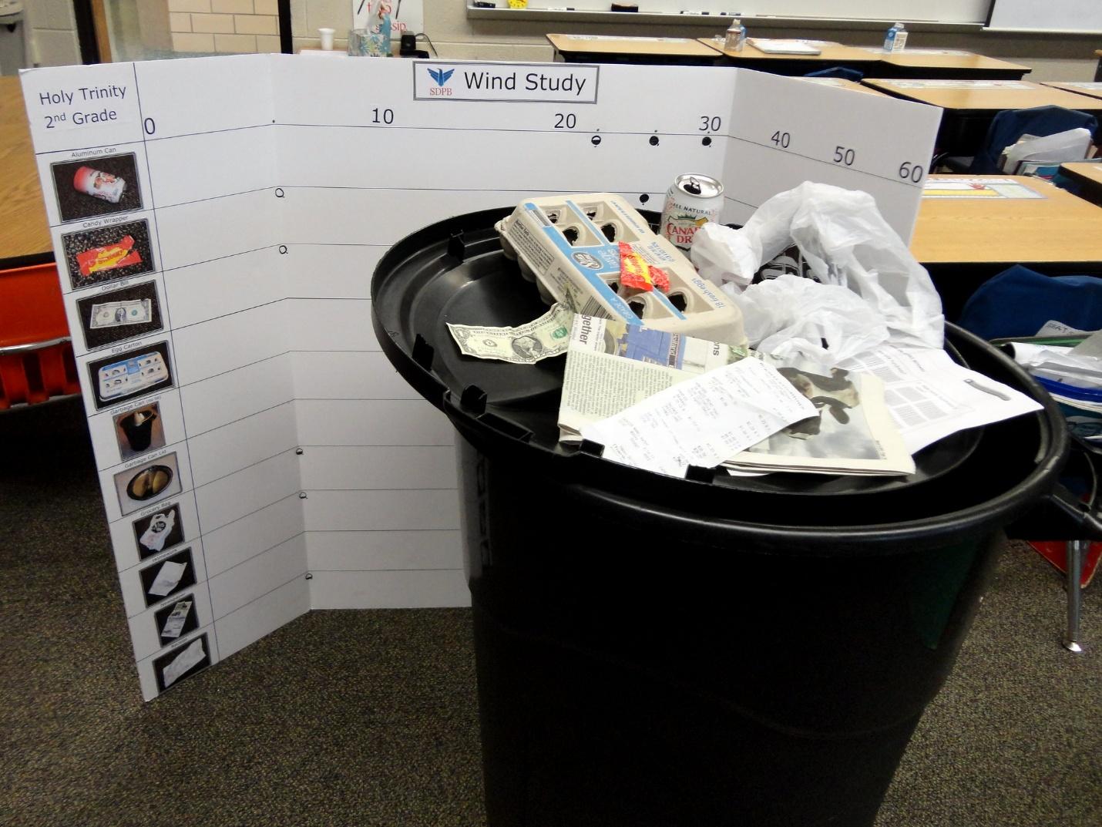
- Select 5-10 items to chart for the entire year (multiple years would be nice)
  - Possible Items:
    - A standard piece of paper
    - Egg carton
    - Garbage can lid (both up and down on the ground)
    - Garbage can
    - Dry leaves
    - Aluminum can
    - A piece of cardboard and a box
    - Plastic
    - Etc. (examples of items often seen blowing in the wind)
- Make a class observation chart. Record the movement (qualitative data) of each item selected at specific wind speeds (quantitative data). (Photos of an example chart - the front of the board, in the photos, has an example chart that includes photos of the items used in the study. The back of the board displays the key for the bubbles used on the chart.)
- What to expect: Your students will have an amazing experience and improve their observation skills. Have you ever seen a cardboard box, garbage can lid, or piece of paper blowing down the road and wondered how fast the wind was blowing? Now you and your students will know. You will also notice an increased interest in windstorms/tornados.
- Related Activity from Cyberchase: Wind Gauge
  - Video
  - Activity



