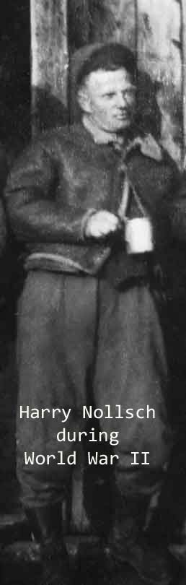

Reluctant Heroes Plus One Harry Nollsch And the Third Infantry Division
By Dean O. Muehlberg

Thin, stooped with age, slowed by a stroke, face sharply defined by the lines of his bone structure, Harry Nollsch’s eyes still burn bright with pride. Born in 1919, he spent three years of his young life in the service of his country, traveling a good part of three continents in the war that throttled the hegemonic daydreams of Japan and Germany. He has spent the remainder of his life thanking the fates that set him up to get plucked from the infantry machine gun crew that had him written in as a member.

Instead, he was sent to an aircraft maintenance school, and though he knows well the terror of incoming artillery having been wounded in France, he wouldn’t trade his fate for anything. He knows well the tribulations and depravations of those grunts and is eternally grateful.

As preparation for interviewing Harry Nollsch I borrowed and read from cover to cover the History of the Third Infantry Division In World War II, edited by Donald G. Taggert, and published by the Infantry Journal Press. This is an all-encompassing, move by move, operation by operation summery of the unit’s contribution in WWII. Ninety-five per cent of it was not a good read, but I read it anyway because it provides as good a sense as you can get of the extent of the unit’s and men’s sacrifice over three years time, covering a great part of three continents. The sheer length of time, the ground covered, and number of day-after-day operations is covered in monotonous but awe-inspiring detail. The action accounts of the record number of Medals of Honor were welcome breaks in this amazing history, but it was the drudgery of the continuous movement and conflict over so long a time that truly explain the courage and sacrifice of the men in this war.

Harry Nollsch was there for all of it. He wasn’t on the very front line but close enough to it to be wounded and see friends die from artillery. He is a remarkable human being, not only for his sacrifice and persistence so long ago, but also for his ordinariness, surviving to live a life after extraordinary experiences, living a long and fulfilling life, defying the laws of nature that brought him to life from taking him before his time.

Harry spent his early years following his family around South Dakota engaging in attempts to make a go of farming. He remembers his father having a Watkins route that was covered in a horse and buggy, trying to make ends meet.

In 1936 Harry went away for some months to the Civil Conservation Corps, a social program under President Franklin Delano Roosevelt that allowed young and poor men to join a para-military organization in the vicinity that put them to work on public projects for $30 a month. $25 of this went home to assist those at home, $5 left to the worker.
Outside of that small stipend the men got room and board, not a bad thing in those difficult times.

In 1941 Harry got the chance to go away to the National Youth Administration for some training in aircraft maintenance, the move that later saved him from the fate of the machine gun crew. It was another move to survive and to better himself, and little did he know how much it would mean for his future.

Nollsch was drafted in June of 1942. He traveled from Sturgis, SD to Ft. Cook, NE to Ft. Leavenworth, KS to Camp Pickett, VA. It was while training as a basic infantryman in a machine crew that he was called out and told he was going to Ft. Sill, OK for field artillery observation school. He trained there in the L-2, L-3, and L-4 planes. The L-4, the Piper Cub, was America’s most used observation plane, and the one he became the most acquainted with as a crew chief, responsible for its maintenance and readiness for scoping out enemy artillery.

On completion of the course he was assigned to the 2nd Armored Division at Ft. Bragg, NC. He remembers a frigid trip in the fall of 1942 accompanying self-propelled 105 artillery pieces on open-bedded rail cars to Ft. Dix, NJ. He had to wear everything that he had available or could scrounge up to keep warm.

By November of 1943, the 2nd Armored Division had landed in Morocco in North Africa where Harry began his trek across the northern tier of the continent, the allied forces driving back the enemy, their eyes on Sicily.

Harry continued the long trek to Anzio, with intermediate trips through Sicily and southern Italy. Somewhere along the line he was assigned to the 9th FA Battalion, an element of the US 3rd Infantry Division. He was part of the landing in the south of France in August of 1944. He recalls seeing Winston Churchill passing the craft of the landing force, waving to the men on the various boats and ships.

He has several memories that stick in his mind. He remembers men in Sicily hiding in grain shocks next to the airstrip as protection from strafing by German planes, as if that would do them any good! He remembers the people in Sicily asking him to stay for lunch and in Palermo the population holding out bottles of wine to the passing troops. He remembers seeing an Italian fall off a two-wheel cart, the horse continuing on and the driver running after the animal and cursing. He also remembers, with a smile, the three-inch-deep foxhole that a man used to try to escape German fighter planes, two more men piling on top of the first in a vain attempt to gain safety from the rounds. Heavy caliber machine gun rounds will do that to men.

He recalls observing the devastation caused by an allied strafing run on a several mile long column of German soldiers, their equipment, and their horses. It was a view into a holocaust that stays in his mind.

It was also in Sicily that an unexpected customer showed up in a jeep at his unit, wanting to go up in Harry’s L-4 to observe the progress of the battle. That person was General George Patton. Of course, the General got what he wanted and the respect of Harry for wanting to go into the immediate area of conflict.

There weren’t a lot of real good memories of his time but he does remember that in France he was picked to drive a jeep for some officers that were on a trip to Grenoble for a break. His uniform and that of the officers were basically the same so he was treated like an officer for those couple of days. He didn’t do much there except to enjoy the break from the hostilities. He didn’t want to learn to ski because he didn’t want to take the chance of being injured and separated from his buddies.
Somewhere in the Vosges mountains in France, Harry and his friends were invited by a French family to dinner. While sitting down a neighbor to the family came by and upbraided the head of the family for what Harry took to be for treating the American soldiers with respect. The family patriarch proceeded to take the intruder outside and cuff him up quite well.

In October of 1944 Harry was wounded in France while waiting in line in a tent to get his hair cut. An enemy artillery round landed just outside the temporary barbershop. He was hit in the arm and the man in the chair in the side of the head. Later, in April of 1945 at Salzburg, Austria, he received a purple heart for the wound and was awarded the medal on the same stage that famous 3rd Infantry Division infantryman, Lt. Audie Murphy, was receiving one of his many medals.

This story was to include a picture of Harry with a towel that came from the Obersalzberg near Berchtesgaden. While bivouacked outside Salzburg in the days of the immediate end of the war, a GI came down a road pushing a cart loaded with a huge silver bowl filled with linen taken from Adolf Hitler’s mountain home, the Berghof. He asked Harry if he wanted a souvenir and gave him a towel with the initials AH embroidered on it. Unfortunately, the towel has been misplaced somewhere in the moves he and his family made over the years.

Harry Nollsch saw Dorothy Cady, sixteen years old in 1941 in Rapid City, South Dakota. He knew she was the one. He borrowed an automobile from his pastor and took her out on their first date. The rest is history. She wrote to him during his time away. On 24 January 1947 they wed and on 24 January 2007 celebrated their 60th wedding anniversary. In the 1950s they adopted two children, a boy and girl, and are proud of the people they have become. Harry and Dorothy both attended North Central Bible College after the war and had congregations in Minnesota and South Dakota. In the fifties they moved to Rochester, New York where they spent the greater part of their years before retiring back to Rapid City, South Dakota.

Harry has been a constant attendee at local writing groups during the last few years. He has written a short vignette about an incident in North Africa called Taps Delayed, a touching glimpse into his conscience, the sweetness of his soul, and the lack of necessity for excess verbiage in telling an evocative tale.

It is difficult avoiding gaining a true affection for men like Harry Nollsch after spending some time with them. To look into the pictures of his youth, to know the trials of that youth both on the economic front at home and the stages of the battlefield, is to see courage and the raw determination to survive in a world where the soft and the plenty and the excess were not expected and only to be enjoyed on very rare occasions. It is this grit and determination that we honor. It is this grit and determination that we respect and that we seldom see now, except for those few we expect to bear the burden of today’s conflicts, or those destitute enough to seek out this country for the true benefits that they can still see. Harry Nollsch is a hero.

Postscript: Harry Nollsch does not have a computer nor the ready access to the endless amounts of history and photos that are available over the internet. During the course of interviewing him I did some searches and came upon Rich Heller’s wonderful site on the US 3rd Infantry Division that is dedicated to Rich’s father, Bill Heller, a photographer.

The site has hundreds of photos and links. One section of the site was about the planes of the US 3rd Infantry Division, and more specifically, observation planes. It was here I found reference to the book Janey: A Little Plane in a Big War, written by Alford Schultz and Kirk Neff. The name Schultz bothered me but I didn’t know why. Finally, on the last interview with Harry it all came together. Harry had given me that very name on one of our first meetings as the pilot of the plane he cared for. Harry was the person responsible for putting “Janey” on the plane at Schultz’s request. Harry was shocked and pleasantly surprised to find out that a book had been written about “his” plane. I then began a search to find out if Schultz was still alive in hopes of getting he and Harry together.

Unfortunately Alford Schultz passed away a few years ago.

I ordered the book for Harry and he has read it and remembers all of the things in it. It also filled him in on some things he didn’t know at the time, such as the circumstances in which some air crews died. The enlisted men sometimes only knew that some didn’t come back.

Harry was a little disgruntled, as was I, that he wasn’t mentioned in the work, considering the long period of time he was associated with the author, but says it is still the best account he has seen of what his personal history in the war was like and of the planes he worked on. We don’t know the history of the writing of the book but since it wasn’t published until 1998, the author probably wrote it a half century after the action. Leaving Harry and others out of it was probably just a result of the passing of time alone.

Harry vividly remembers being up for a ride with Schultz over Italy in “Janey”. Suddenly, German fighter planes were approaching, Harry observed a German pilot turning his head to look at the vulnerable men in the little plane. Speechless, Harry just tapped Schultz on the shoulder and pointed. Schultz spiraled down and away. The enemy planes were after other prey that day and it is why Harry is still with us today. For Harry it was one of the most frightening moments of his life.

PHOTO DETAIL:
Photo of Harry Nollsch in 2007 (HarryNollschA.tif)

Photo of Harry and Dorothy Nollsch in June of 2007. (HarryNollschB.tif)
Photo of five men standing: From left William Baker, Harry Nollsch, Alton Schnettler, Charles Croal, John Edkins. (HarryNollschC.tif)
Plane Photo: Grinding the valves for an L-4. William Baker on the left and Morris Gunderson. (HarryNollschD.tif)

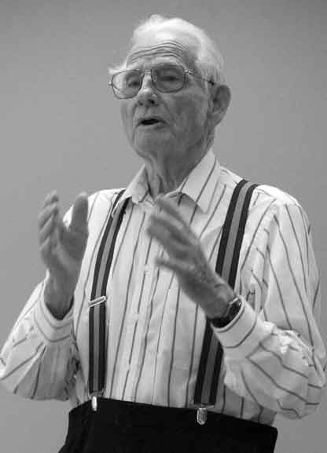

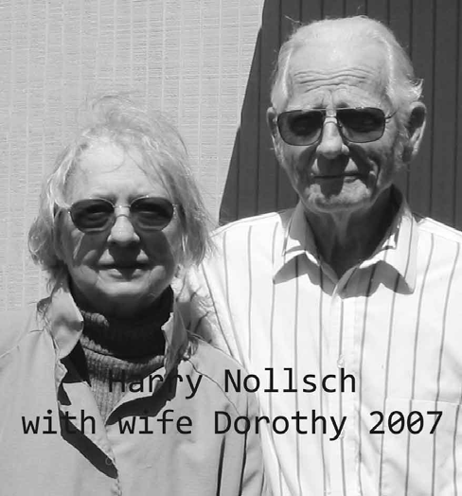

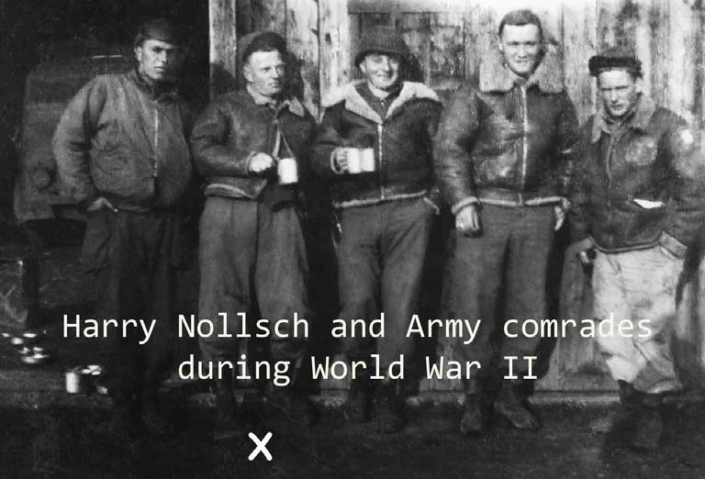

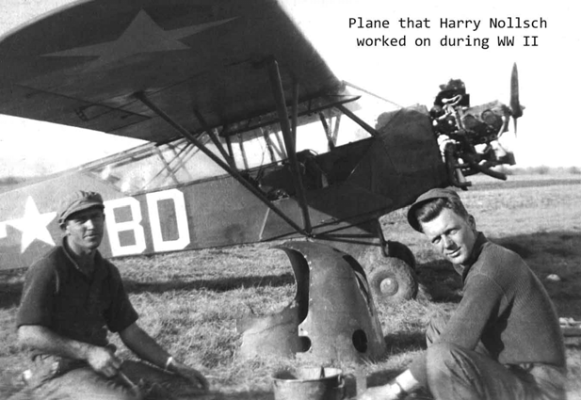

FOR QUESTIONS:
Author Dean Muehlberg’s e-mail address: bearmakker@rap.midco.net
Phone (605) 342-4297

