Wind Cave

The Senses: Smell, Touch, Hearing and More!

During this lesson, your students will participate in a hands-on activity to explore their senses, including touch, smell, hearing, sight, and taste. Your students will also learn about the formation of Wind Cave in the Black Hills.

Lesson Summary

This activity could introduce a unit on the senses or serve as an entertaining and educational capstone activity. The activity aims to help the students understand that their senses work together and that prior experiences influence them.

Time allotment
50 Minutes

Learning objectives
- Students will learn about the senses of hearing, touch, smell, and sight.
- Students will learn how their senses work together.
- Students will learn how prior knowledge helps identify objects when using their senses.

Prep for teachers
- Gather materials for the activity in the Supplies section below.
- Access the video clips and additional information below.

Supplies
- Video clips about Wind Cave
  - Wind Cave: Formation Video
  - Wind Cave: History Video
  - Additional Information about Wind Cave
- Materials (will vary depending on if you use this as a demonstration or a lab activity)
- Containers that are not transparent (Hint: the holiday containers shown were purchased after the holiday season, so they were less expensive)
  - Unknown Items:
    - Macaroni
    - Flower
    - Rice
    - Marshmallows
    - Cheerios
    - Chips
    - Etc.
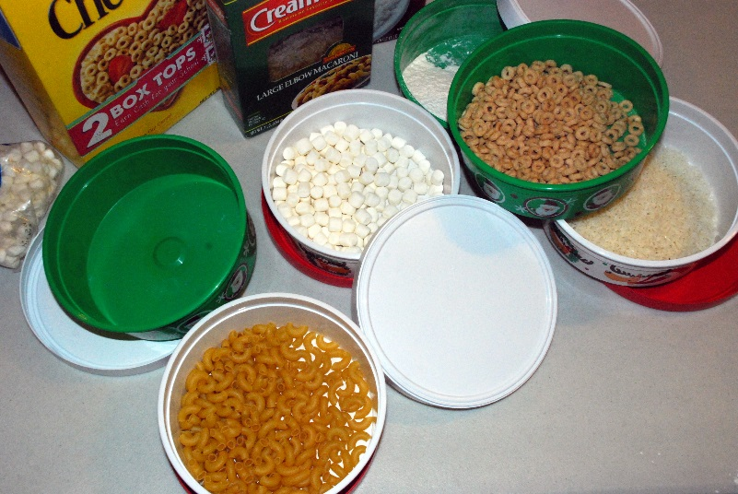

Introductory Activity

- Introduce the senses activity by viewing the following video clips about Wind Cave.
  - Wind Cave: Formation Video
  - Wind Cave: History Video
  - Additional Information about Wind Cave

Learning Activities
When viewing the clips above, the students should notice that a light source is needed to see in the cave.
Ask the students if they have been in a location where there was no light. Maybe they were in a basement with no windows or a cellar, or their car broke down on a country road at night with cloud cover. How did it make them feel? Did they notice an increased awareness of other senses like hearing or smell?
Take the students outside and have them cover their eyes with a dark cloth. Encourage the students to use their sense of hearing to listen for natural and artificial sounds. Is it easier for them to hear sounds with their eyes covered? What do they hear? Are they noticing sounds that they usually do not?
Find a location in the school with no light. A basement or interior room with no windows would work well. Shut off the lights and have the students sit quietly. Please encourage them to use their sense of hearing to listen to sounds from within the school. Is there an increased awareness of sounds?

Culminating Activity
The goal of the activity is to help the students understand that their senses work together and that they are influenced by prior experiences.
The procedure below is described as a demonstration. The class could be divided into groups of 2-4 students if you would like to complete this as a lab activity or center. Additional materials would be needed.
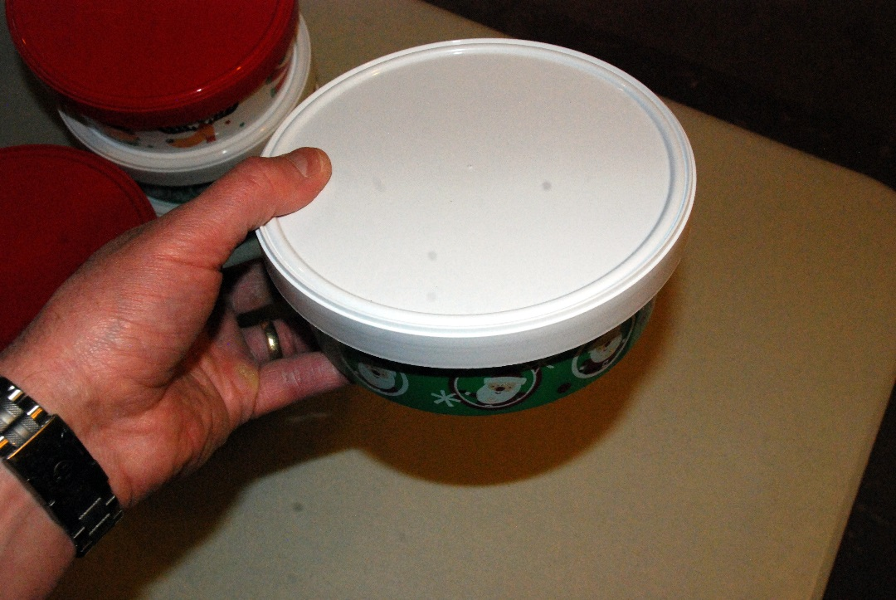
- Have one student come to the front of the room and sit in a chair.
- Select one of the bowls and shake it. (testing sense of hearing)
- The test student should use prior experiences to make an educated guess about the item. Encourage the rest of the students to guess, also.
- The following process (using additional senses) can be used if their guess is incorrect.
- Have the student shake it. (sense of touch)
- Have the student close his/her eyes and smell the unknown. (sense smell)
- Display the original packages that the unknowns came in. This will narrow/focus the choice. (sense of sight – for younger students)
- Open the containers and have the student feel the contents. (sense of touch)
- Optional – Have the student taste the contents if it is appropriate. Reinforce the fact that eating during a science experiment is usually not accepted. (sense of taste)
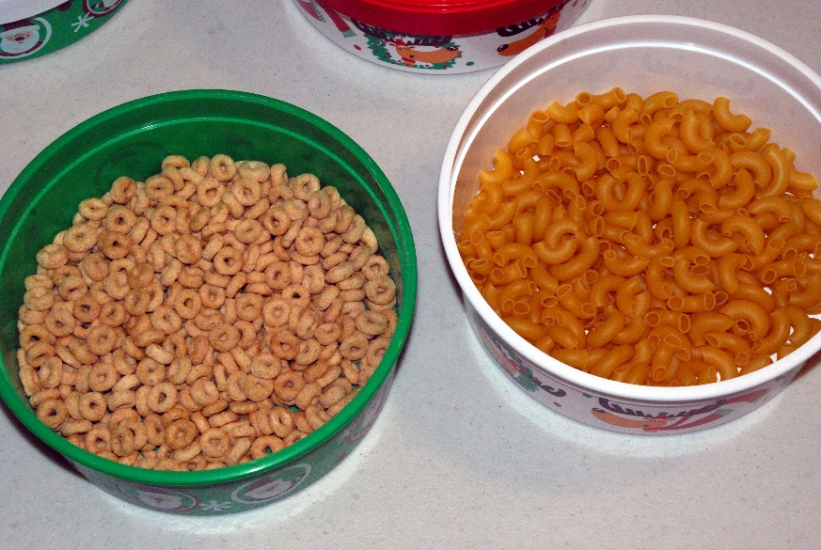
It will be shocking to the students when they can hear the density difference between Cheerios and macaroni…
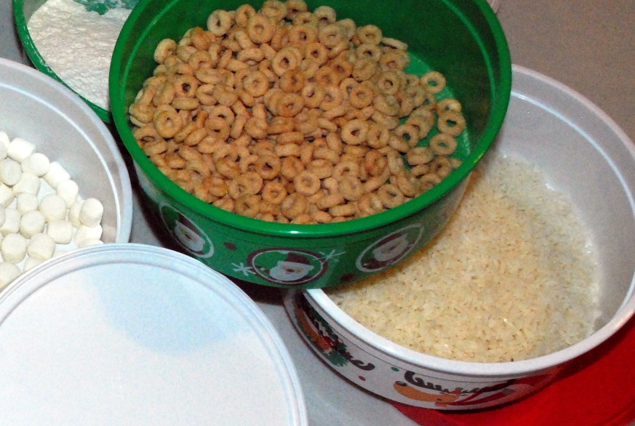
or the size difference between rice and Cheerios.
Continue to test additional unknowns; this activity is educational and entertaining, and your students will enjoy it.

In addition to Wind Cave, the Black Hills region of South Dakota is home to many other caves, large and small. Jewel Cave, west of Wind Cave, is another very large cavern that continues to draw cavers from around the world. With 173 miles of known passageways and ongoing discovery and mapping efforts, Jewel Cave is currently the third-longest cave in the world.



