Images of the Past | The Respiratory System: Iron Lung
During this lesson, your students will complete one or more activities in which they will learn about the surface area of their lungs and how air moves in and out of the lungs during respiration.

Lesson summary
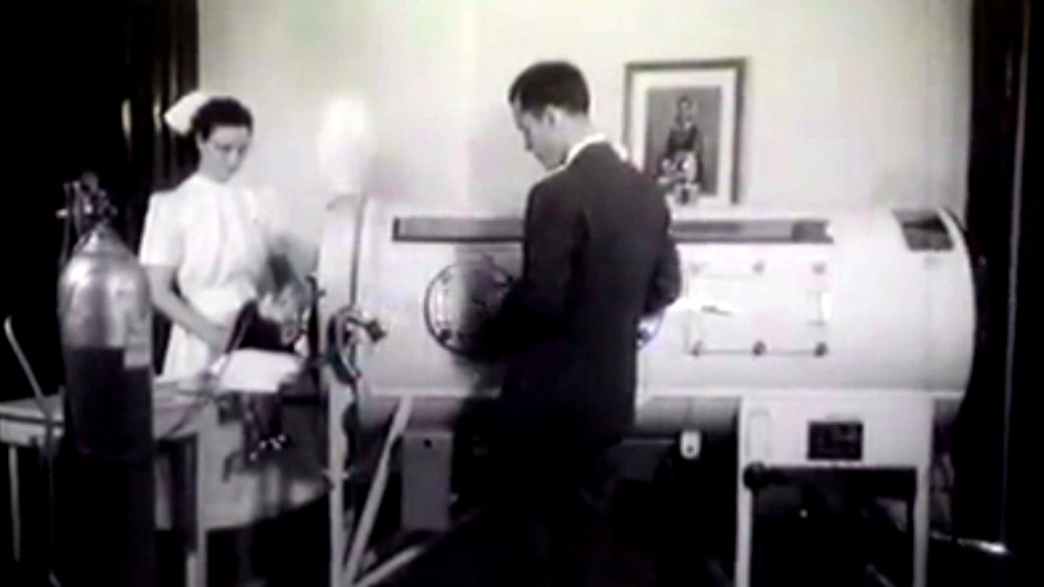
They will also gather data to understand how exercise affects respiration rate. Then they will learn about a medical device called the iron lung, which was used to treat many polio patients. Finally, they will understand the difference between negative and positive ventilation.

Learning objectives
This lesson will focus on three specific areas of respiration, including surface area, respiration rate increases with activity, and the difference between negative and positive ventilation.
NOTE: There are three different activities in this lesson. You do not have to complete all the activities if time does not allow.

Introductory activity
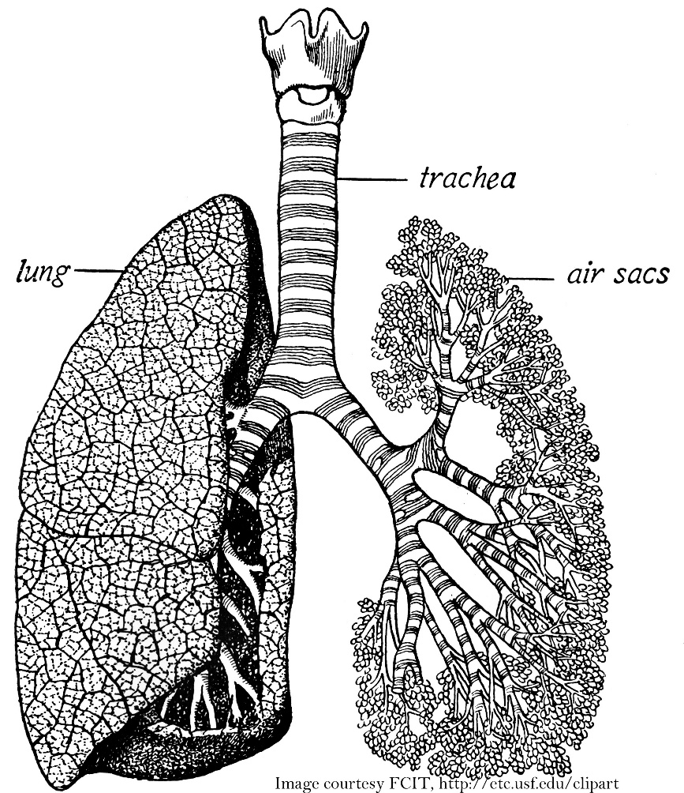
Surface Area During this activity, your students will learn about grape-like structures in the lungs called alveoli and their essential function of increasing the surface area of the lungs to maximize gas exchange. The surface area within the human lungs is estimated to be between 75-100 meters^{2,} which is approximately one side of a tennis court. The activity is found in the Lungs: Alveoli (Increased Surface Area Activity Idea).

Learning activities
Respiration Rate Increase with Activity During this activity, your students will exercise for specific intervals, assessing changes in heart rate and respiration rate.
- Note: Make sure your students do not have pre-existing conditions preventing them from exercising, are healthy, and can complete the exercises safely. Ensure the area is free of obstacles that could lead to accidents/injuries.
- You are responsible for the safety of the children in your care.
- The students should work in groups of 3: One student will perform the exercises, one will assess heart rate using the radial pulse, and the third will assess respiration rate (chest rise and fall). (The students should change duties if time allows.)
- The students should draw a chart like the following in their science lab notebook - Respiration Rate Increase with Activity Chart. Adjust exercise intervals to meet the needs of your class. Share data with groups.
- The activity should be completed in a large room like a gym.
- The class should select an exercise of choice. The same exercise should be used for the entire activity for all the students in the class. Rest between exercise intervals.
- The students should graph the results using a line graph or equivalent for easy comparison.
- Discuss the results: The discussion should include heart rate and respiration rate increases (possible reasons for increase), leveling of increase, etc.

Culminating activity
Negative and Positive Ventilation During this activity, your students will learn how air moves in and out of the lungs during respiration. They will also learn about a medical device called the iron lung (negative ventilator), which was used to treat many polio patients in South Dakota and across the Nation.
- The students should view the following video, which explains the movement of air in and out of the lungs and negative and positive ventilation. (Med School Made Easy - Negative vs. Positive Pressure Ventilation)
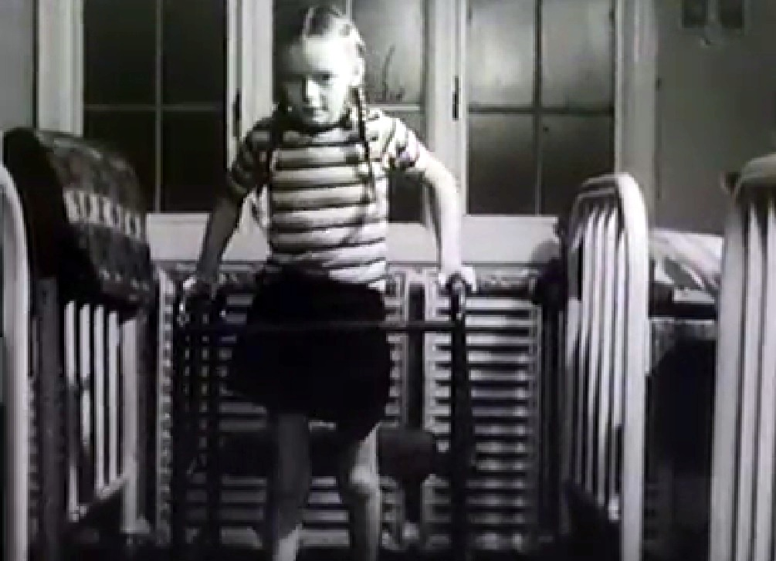
- Next, your students will learn about poliomyelitis, or polio, a highly contagious viral disease more common in children than adults. 1916 saw the first major polio epidemic in the United States. The disease hit hardest in New York City. Nationally, there were 27,000 cases and about 6,000 deaths. From the late 1940s through the mid-1950s, polio cases in the U.S. again rose to epidemic levels, with 35,000 cases annually. The number of polio cases dropped sharply in 1955 following the discovery and distribution of an effective polio vaccine. The U.S. has been considered polio-free since 1979.
- Your students will watch two films about polio, which include the iron lung. The iron lung was a negative-pressure ventilator used to inflate the lungs during paralysis. The videos are available on the following Images of the Past blog called West River Children's Hospital & Polio Center - 1949.
- Use the demonstrations described below to help explain the expansion of the chest/diagram and its relationship to negative pressure in the area around the lungs and the movement of the lungs in response.
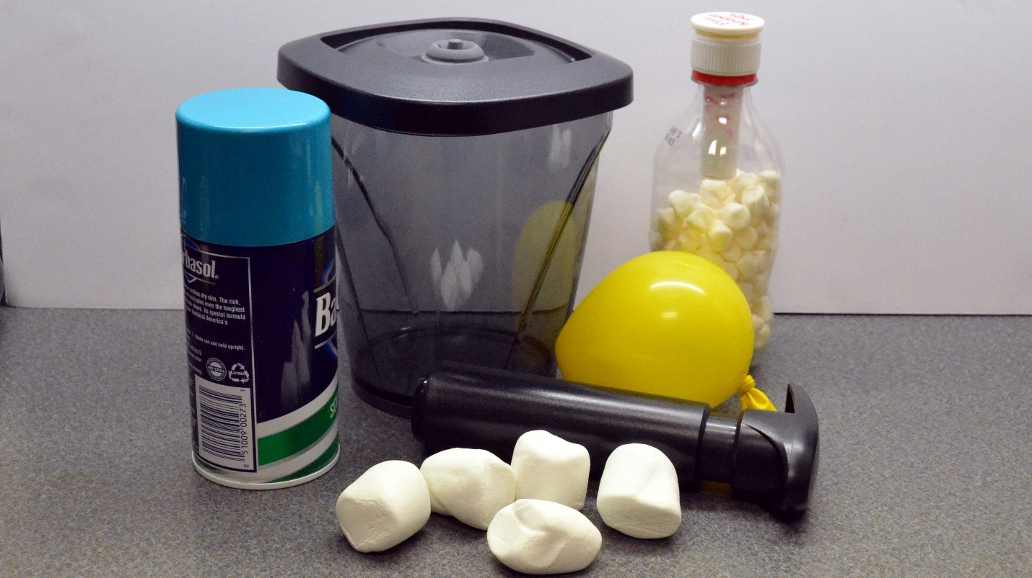

  - Materials
    - Vacuum canister (Internet search – “vacuum containers with pump”)
    - Large marshmallows
    - Balloon
    - Shaving cream
    - Fizz Keeper (Internet search – “fizz keeper”)
    - 20-ounce pop bottle
    - Small marshmallows
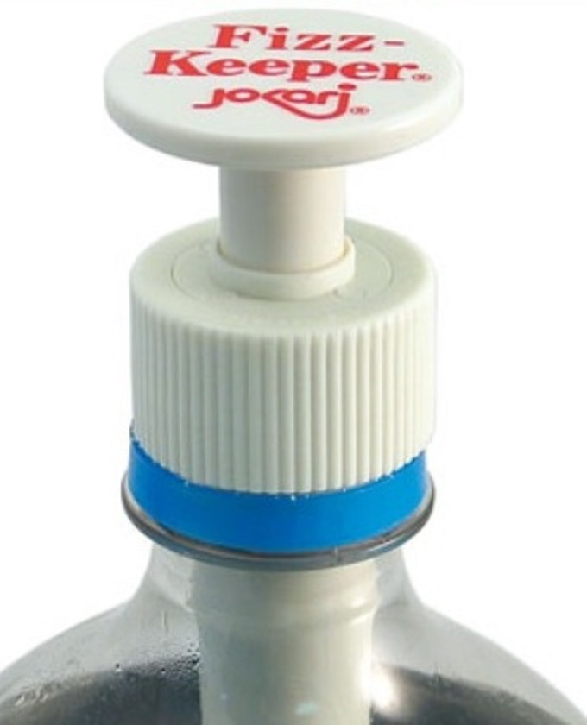
- Before you place the balloon in the coffee canister, demonstrate the difference between the Fizz Keeper (increase pressure) and the vacuum canister (decrease pressure) by filling a 20-oz. pop bottle ½ full of marshmallows and then pumping the fizz keeper. Discuss with your students why the marshmallows decrease in size.
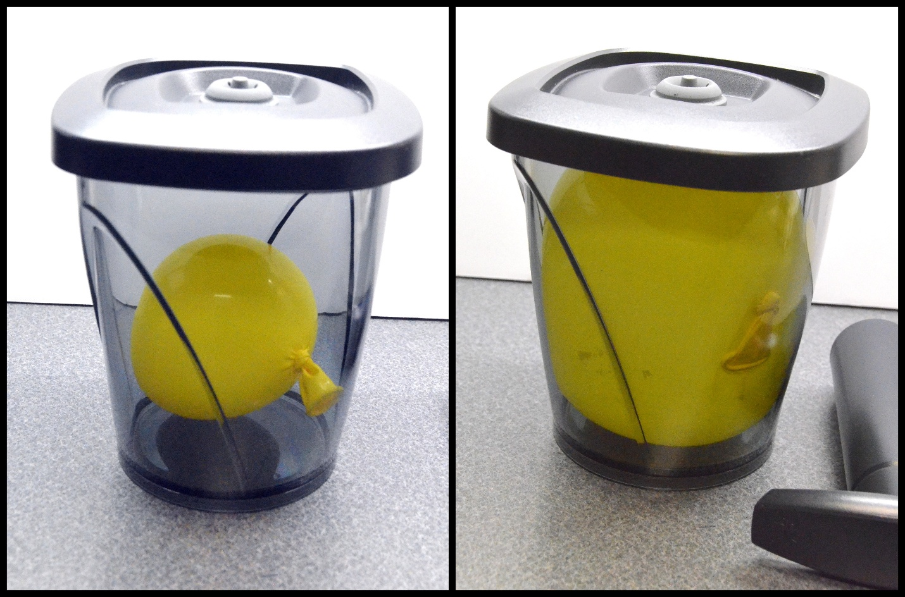
- Place a balloon in the canister and remove the air with the hand pump. This will reduce the pressure in the canister, causing the balloon to increase in size. The inside surface of the canister represents the parietal pleura membrane, and the surface of the balloon represents the visceral pleura membrane. The space in the canister represents the intrapleural space. The balloon (like the lung) expands and contracts in response to pressure differences.
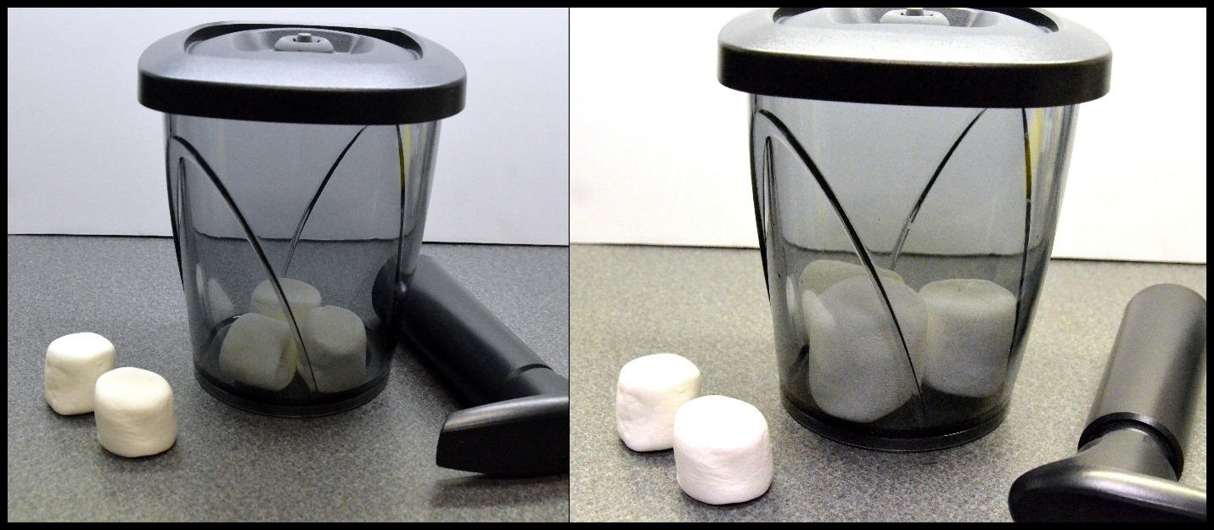
- Place 2-3 large marshmallows (marshmallows contain small air pockets, like many small balloons) or Peeps in the canister and remove the air with the hand pump. The marshmallows will get larger in size.
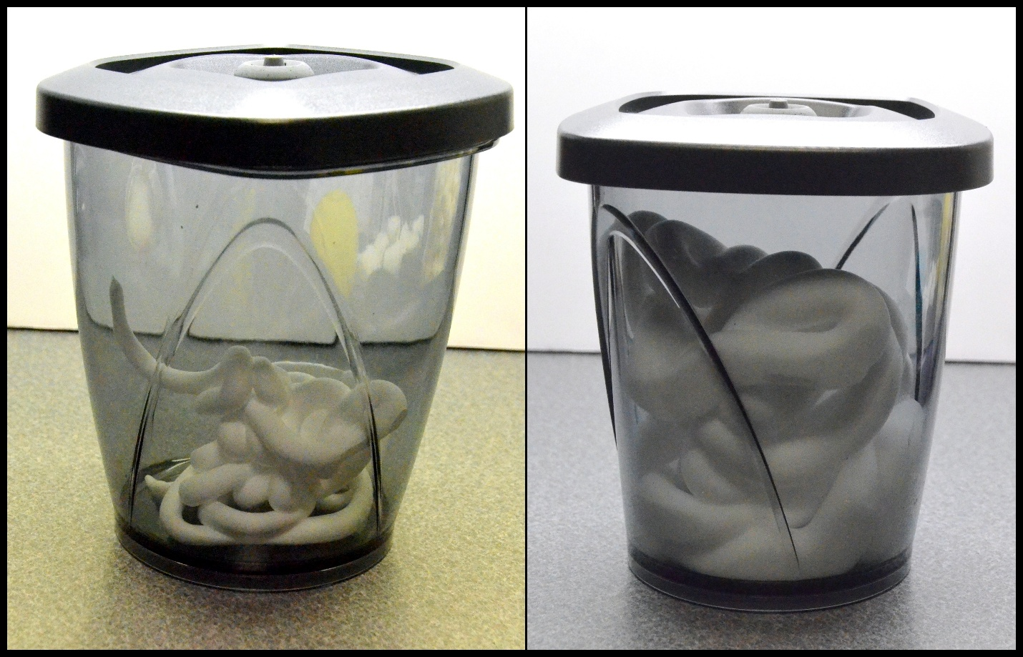
- Shaving cream also works very well for this demonstration (shaving cream also contains many small air pockets). I find it best to show this example last because the canister must then be cleaned.
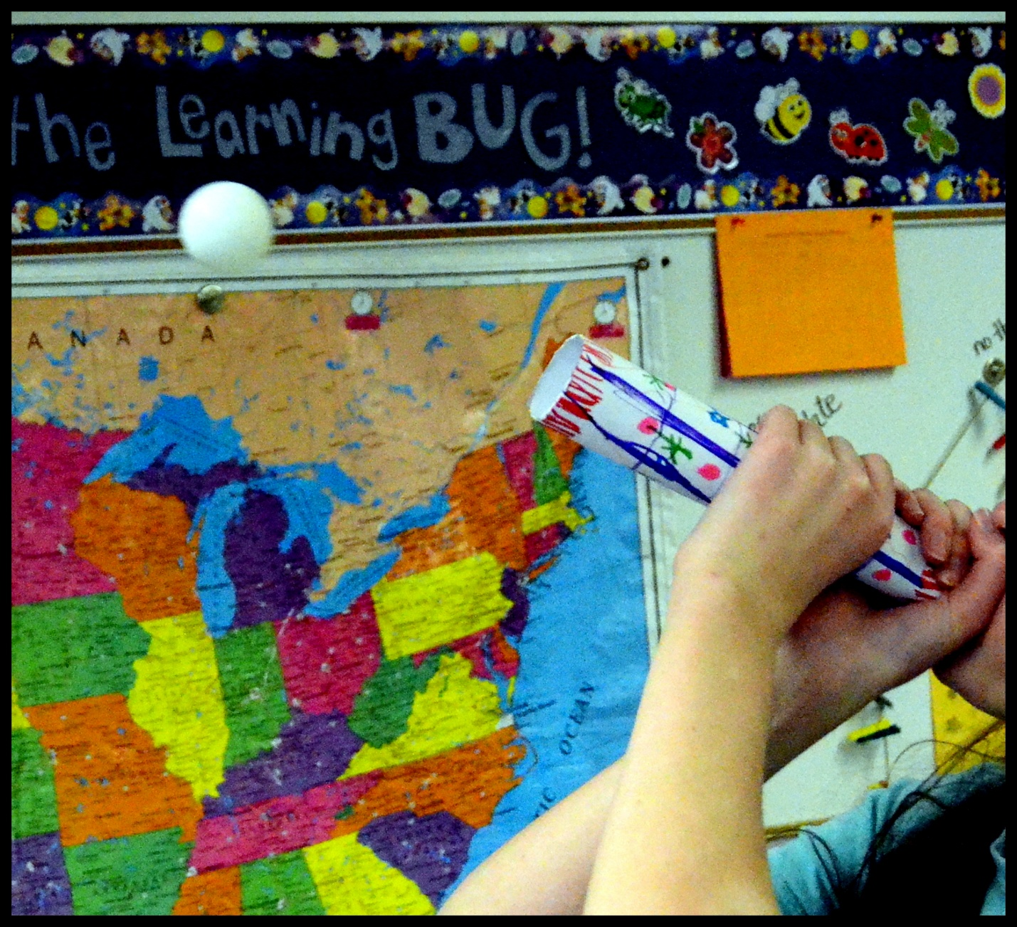
Challenge (Respiration: Spirometer) The volume of air entering and leaving the lungs of each student should be measured using a student spirometer. If a spirometer is not available, especially for younger students, the following simple challenge will reinforce respiration in which the expansion of the chest cavity volume results in inhalation, and the reduction of the chest cavity volume results in exhalation. The students should use computer paper/cardstock, tape, and markers/crayons to design, construct, and test a simple Ping-Pong launcher in which they will use the process of respiration to propel the ball. Allow time to construct and test their designs. Each student is then given three chances to launch the Ping-Pong ball the farthest distance they can using their vital capacity (VC), which is the maximum amount of air that can be exhaled after maximum inhalation.



